# OCR A LEVEL COURSEWORK – WEBSITE FOR FINANCIAL ADVISOR

BY SERGEY SHKOLNIK

CONTENTS

Contents

OCR A LEVEL COURSEWORK – WEBSITE FOR FINANCIAL ADVISOR 1

ANALYSIS 4

Description 4

Why is the problem solvable by a computational approach? 5

Stakeholders 6

Interview with stake holder 7

Research of existing solutions 8

Essential features of my project 21

Potential limitations of the proposed idea 22

Requirements for solution 23

Success Criteria 24

Development 25

ER Diagram 25

Tables 26

Top Down Design Diagram 31

Test Data 33

Book Meetings 33

33

33

Page Design 35

Development 48

Creating install.php 48

Creating users.php and addusers.php 50

Creating the log in page and login process 52

Adding some CSS 55

Creating the Freetimes.php page 56

Creating the Freetimesprocess.php page 57

Creating the bookmeeting.php for users 59

Creating bookmeetingsprocess.php 62

Creating meetingrequests.php 65

Creating the Meetingrequestsprocess.php page 66

Creating the usermeetings.php page 72

Creating viewevents.php 78

Creating coachmeetings.php 82

Creating viewcoachmeetings.php 85

Creating a chat system 90

Creating messageprocess.php 91

Creating coachmessage.php 96

Creating searchforpeople.php 97

Creating coachmessageprocess.php 99

Creating displayusermessages.php 100

Creating displaycoachmessages.php 104

# ANALYSIS

## Description

My project is a website for a financial advisor that will help them manage their timings and client bookings. The website will give a description about what services are offered by the finance advisor and it will allow the admin (the finance coach) to manage their timetable of meetings with their clients. The website will allow a user to create an account, login and request times for a meeting. Whereas the admin will be able to post free time slots for the day which will be filled up by their clients. The website will then send a reminder to the user and the admin about their scheduled appointment. Furthermore, the website will have a billing system so the clients can view different prices and it will also have a chat system between the client and the finance coach so that plans about meetings can be further discussed.

## Why is the problem solvable by a computational approach?

* The given problem is amenable to a computational approach because it requires the management of large amounts of data from different clients. This can be solved using a database which is able to store different types of data safely and this data is protected and can be fetched at any time by the permitted user. Whereas without the use of a computational method, the user would have to remember their timings for their meetings on their own or use paper to write down their timetable which has a risk of being lost or misplaced.
* Furthermore, to help the user remind themselves of the timings, a computational method can be used to send the user automatic reminders about their scheduled meetings. This will reduce the risk of missing a scheduled meeting as action from the user is not required to remind themselves.
* The use of computational methods also allows the finance coach to keep in touch with their clients with a chat system integrated into the website. This way the user doesn’t have to find the contact of their client elsewhere and can keep all their work-related communications in one place.

## Stakeholders

1. My mum – my first stake holder for this project is my mum as she works as a finance advisor and a finance coach. She has a growing number of clients and meetings getting booked. My mum will represent the admin side and the experience of a finance advisor using my website. The ways in which she will use my website include logging in and creating an account, allocating free time slots during which she can take meetings, manage her schedule and contact her clients. This is appropriate for her as this will replace a physical diary and save her from scrambling around pieces of paper while trying to keep organised with her tight schedule.
2. Alua An is one of my mum’s clients who has meetings with her and other financial coaches. She will represent the user of the website from a client’s perspective. The ways in which she will use the website includes logging in and creating an account, booking meetings with the finance coach, using the chat system to contact her finance advisor about a particular topic and organise and manage her meeting schedule. This is appropriate for her needs as she has a very busy schedule with work and other commitments and my solution will help her keep her meetings organised on top of her daily life.

## Interview with stake holder

1. Do you have any struggles with organising your meetings and schedule?

No, there are not many struggles at the moment. However the number of my clients is rising and I would like a more efficient system to help me organise my consultation as well as other study materials.

1. How often do you use a diary for planning your schedule?

Everyday, because I have different types of meetings everyday: meetings with clients and I’m also a co-trainer in business training courses. So I have to attend different types of meetings with different people, therefore a diary is essential for me.

1. How many clients do you currently have?

I currently have 6 clients but I am planning to expand in the coming months because I am finishing my training in financial service.

1. Do you ever find it hard to keep track of your schedule?

Not at the moment, but since I am expanding my services, I would like to be on top of all the things that I have to do. In doing so, I would like to avoid hiring an assistant and having an automated system that can effectively manage my busy schedule.

1. What key features do you look for in the project?

Easy to use and user friendly so that an average person can sign up for a meeting with me.

I want the website to attract clients instead of scaring them away by the complexity.

## Research of existing solutions

**Example 1- Microsoft Outlook**

**Viewing Timetable**

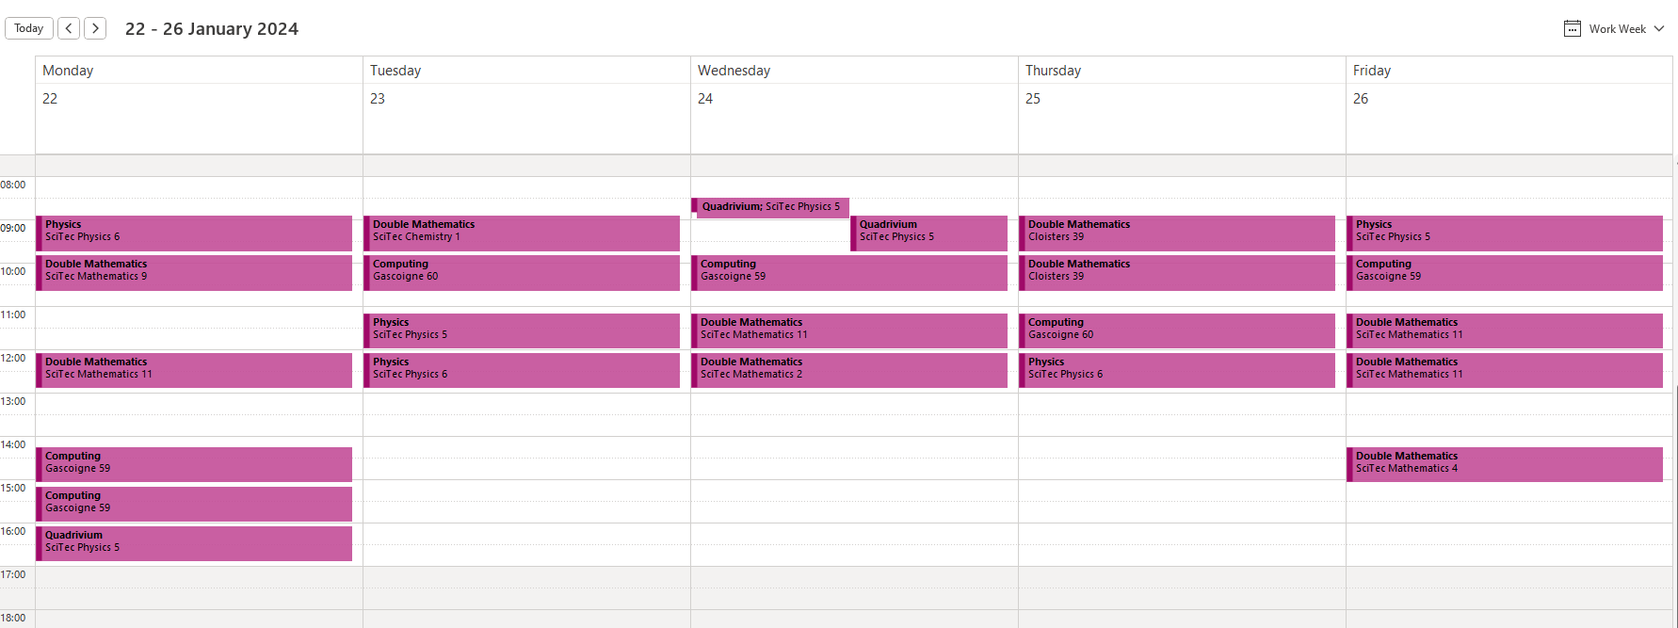

Microsoft Outlook allows a user to view their schedule with a clear visual representation. There are options to change the view from ‘Work Week’ to ‘Day’ to ‘Month’ which allows the user to view their schedules in the distant future. The format of the timetable is in the form of a diary which gives an ‘easy-to-read’ experience for the user.

The scheduled meetings are arranged in chronological order so the timing of the meeting can be easily read and in the Work Week option the days are displayed as columns so different days are clearly separated.

The arrows at the top of this online diary allow you to flick through consecutive weeks and view your schedule in a month’s or a year’s time. Meetings are furthermore clearly highlighted with a different colour, again, allowing the user to clearly visualise and not miss any scheduled meetings.

**Booking Appointments**

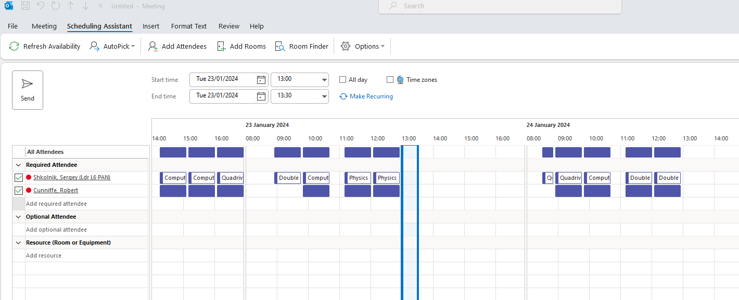

Outlook also allows their users to create their own appointments at a specific time. Users also have the option to make the meetings recurring or singular which is convenient for weekly/ daily meetings.

When adding a person to a meeting, the user can view their participants’ schedule and take into account any conflicting meetings. This is useful because the meeting can be booked at a comfortable time for both the admin and the user.

Again, the schedule is presented in chronological order so it is easy to navigate through the booking screen. And you can select the timing of the meeting via the dropdown menu and a visual calendar which displays different dates.

This clear visual representation of the calendar and different times makes Microsoft Outlook one of the best platforms for creating and scheduling meetings.

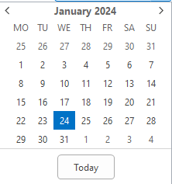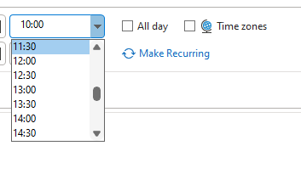

Another useful feature of Microsoft Outlook is the ability to click a free time slot in your schedule which will automatically direct you to the page that allows you to schedule a new meeting.

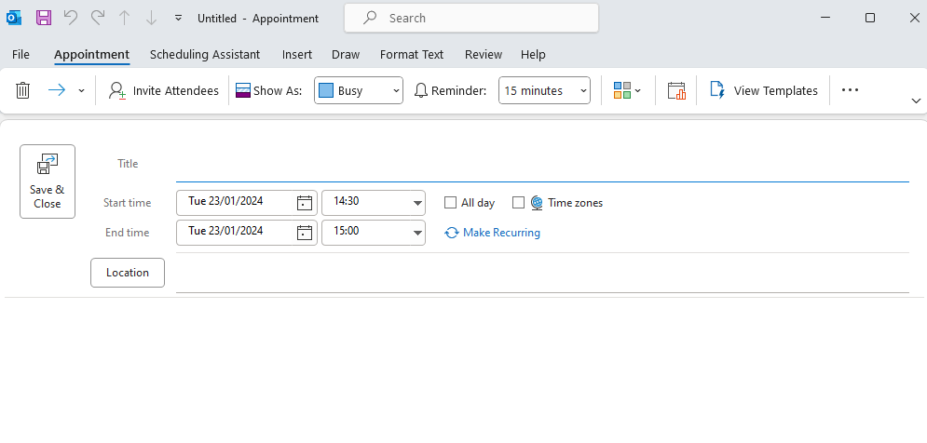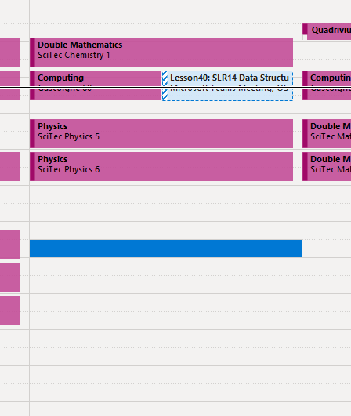

**Microsoft Outlook – Meeting Reminders**

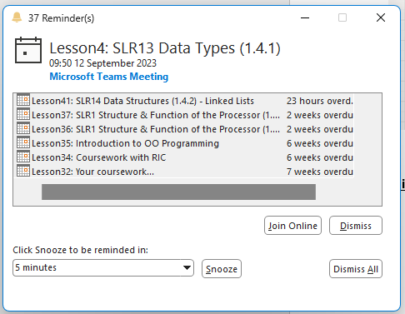Microsoft Outlook sends automated reminders to meeting participants and the timing of the reminders can be set by the creator of the meeting.

This is a good way to ensure that meeting participants don’t forget about their scheduled meetings as the reminder window pops up at the bottom of your screen and makes a distinct sound.



The menu bar, as well as allowing the admin to set reminder timings, also has a scheduling poll which uses analysis of schedules to suggest a comfortable time for all members of the meeting.

The menu bar also allows the admin or user to set their availability status to let all of their teammates know how occupied they are at different times of the day.

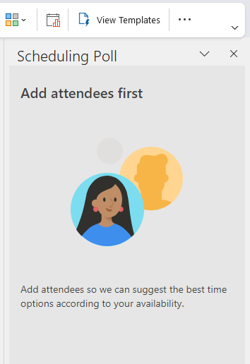

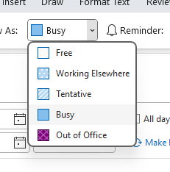

**Example 2 – Microsoft Teams (chat system)**

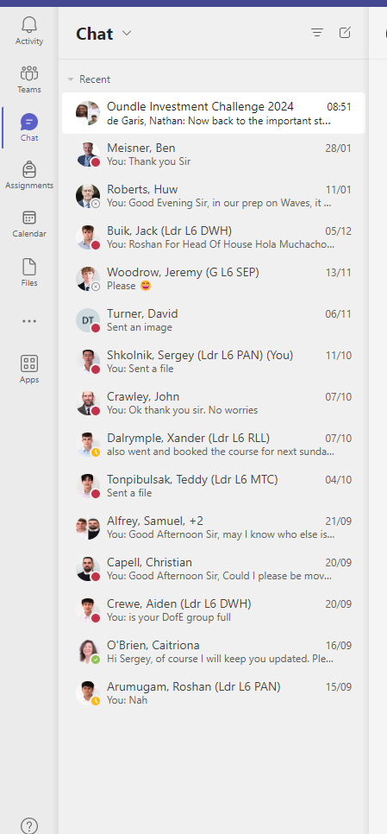Microsoft Teams allows the user to be able to live chat with any member of the company/team. The chat page is accessible via the nav-bar on the right which makes it easy to access for the user of Teams. There is the option to hide each chat by clicking the drop down arrow at the top.

You can also view the status of each user to see if they are available or ‘Out of Office’ so you can contact them accordingly.

**Examples of different status’**



Busy Offline Away

The user can manipulate their visual layout of their chats by being able to ‘Pop out chat’, ‘Mark as unread’, ‘Pin’, ‘Mute’, ‘Hide’. This gives the user an opportunity to manipulate their personal messages screen to either make it look aresthetically pleasing or have all of their work chats visible on the page.

Microsoft Teams also allows users to send messages of high importance by making them highlighted so that the receiver of the message can take particular notice of them.

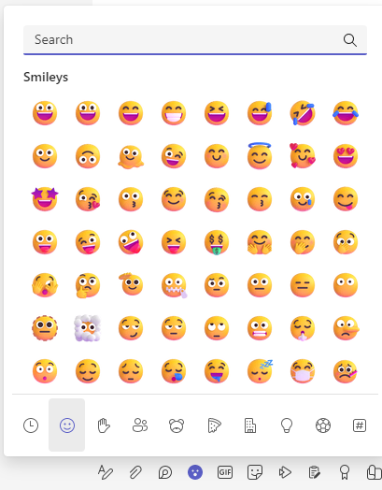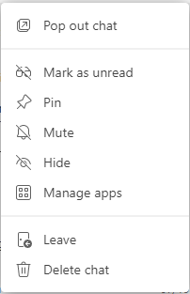The Microsoft Teams chats are extremely versatile as users are able to send each other many things such as files, pictures, text and emoji’s.

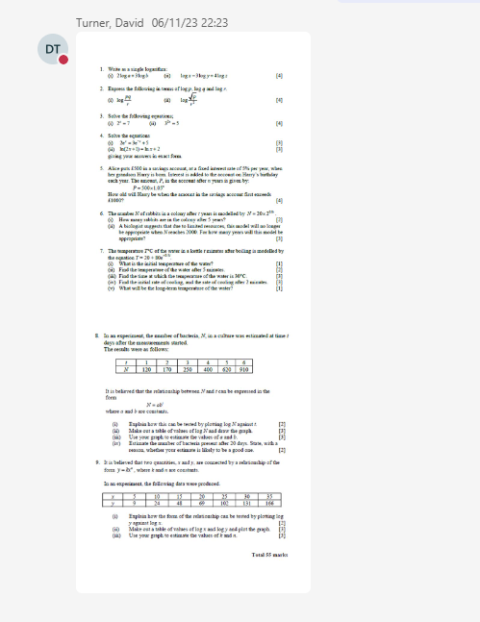

**Microsoft Teams – Channels and Teams**

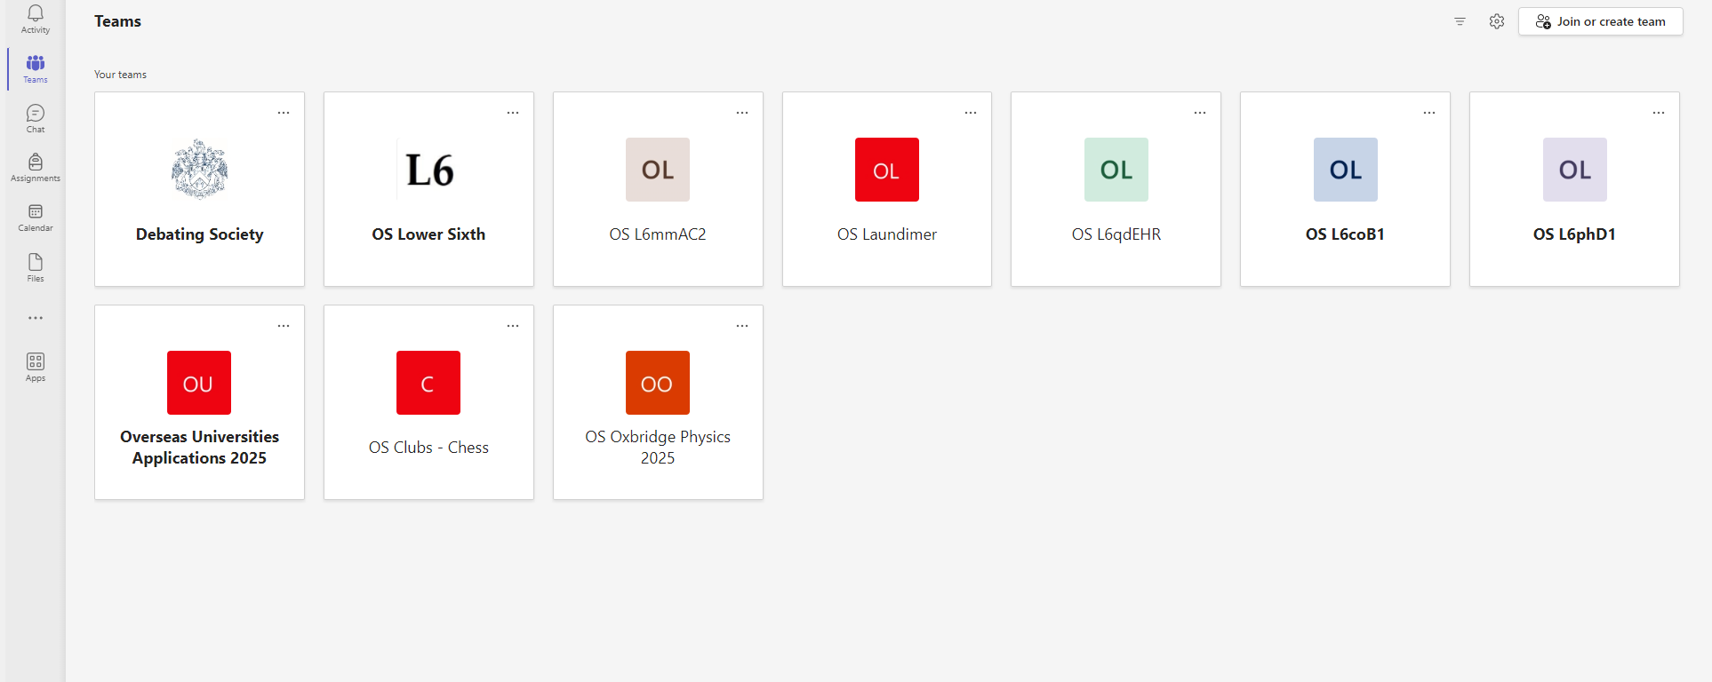

Microsoft Teams allows users to be a part of a team where admins can post relevant information to their class and this material can be accessed by all members of the class. Messages such as reminders, assignments and files can be sent to the whole class. Members can reply to the messages and interact with each post for example liking or reacting to the message.

Members of each team can start their own conversations in each team so separate conversations can be made for each topic of discussion. Messages can be marked as ‘Important’ if they are of high importance and members of each team can be mentioned in the messages so if someone hasn’t done their assignment, the admin or anyone else can follow up on that.

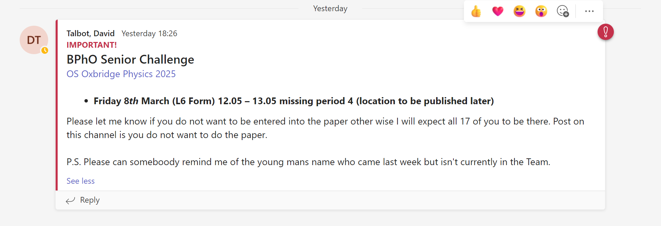

Microsoft Teams has a separate section for files where all relevant files for the gives group/ class can be stored. The file system operates in the same way as a normal file explorer where files can be organised in different folders. File types that can be stored in Microsoft Teams include Microsoft Word, Power Point presentations, Excel spreadsheets and PDF files and many more.

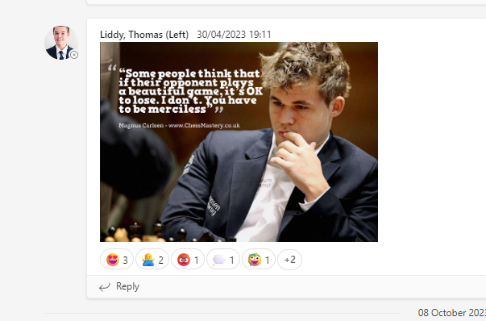

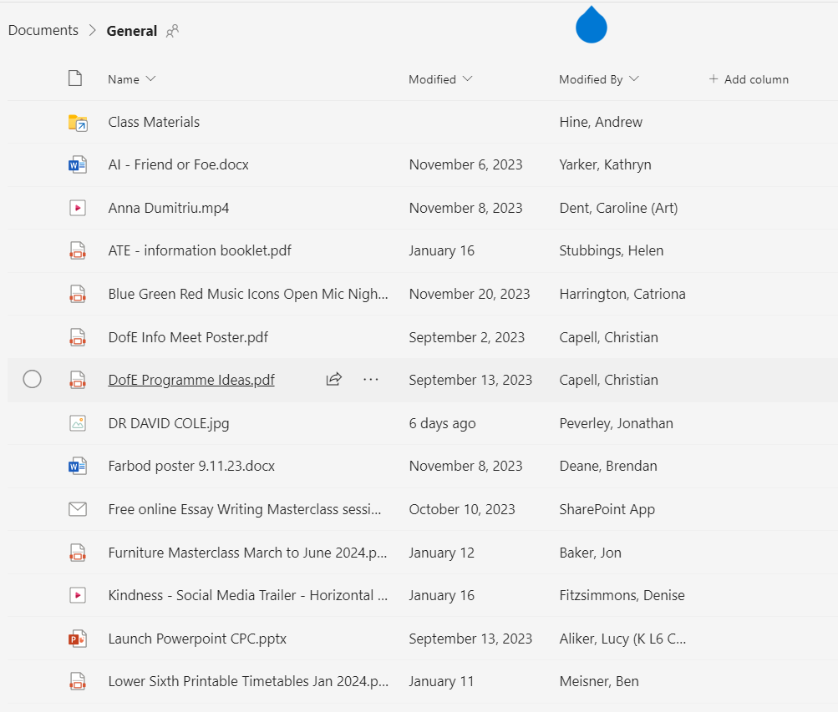

Here, a user can find all the files that have been posted to the general channel and they can see what date they were posted and by whom. This is very convenient for users to navigate through any prior files that have been posted if they need to catch up on any work they haven’t done or a presentation they might have missed.

**Example 3 – Google Calendar**

**Scheduling Tasks**

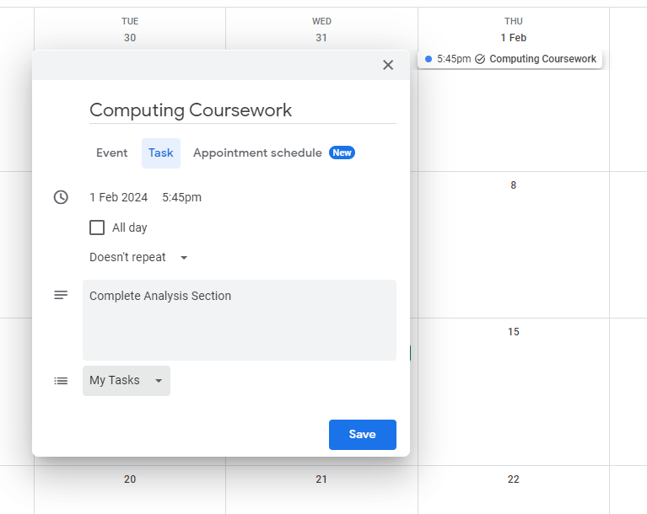

The Google Calendar allows the user to schedule tasks for themselves at any date or time with the user having the option to give a description of their task and set the task for the whole day instead of a specific time.

**Scheduling Events (7.99$ a month)**

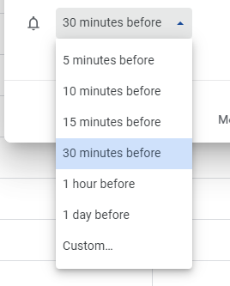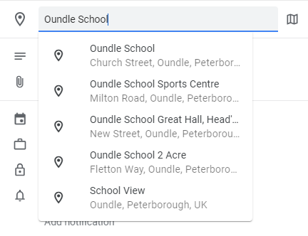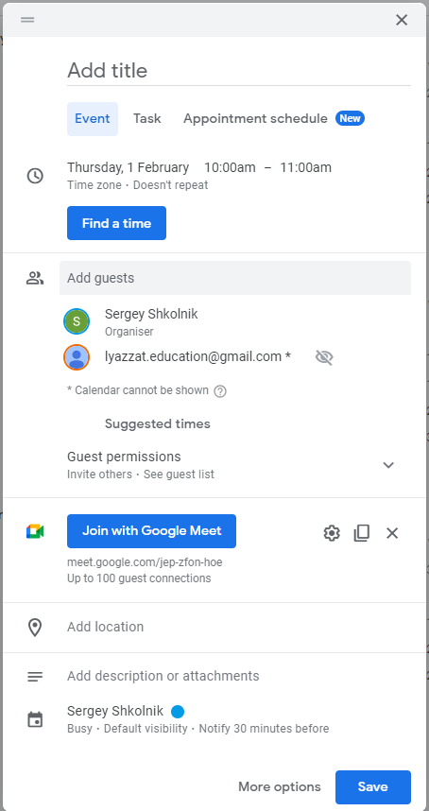The ‘Scheduling Events’ option in the google Calendar allows the user to schedule a meeting/ event with other people. By clicking the find a time button, the program suggests a free time slot to the user in which they can schedule their meeting. The user can also set a location for the meeting if they want to do it in real life to let the members know the meeting venue. Furthermore the user has the ability to choose the time period to set the reminder for the meeting for e.g. 30 minutes or 15 minutes.   
**Scheduling Appointments – Setting up meetings**

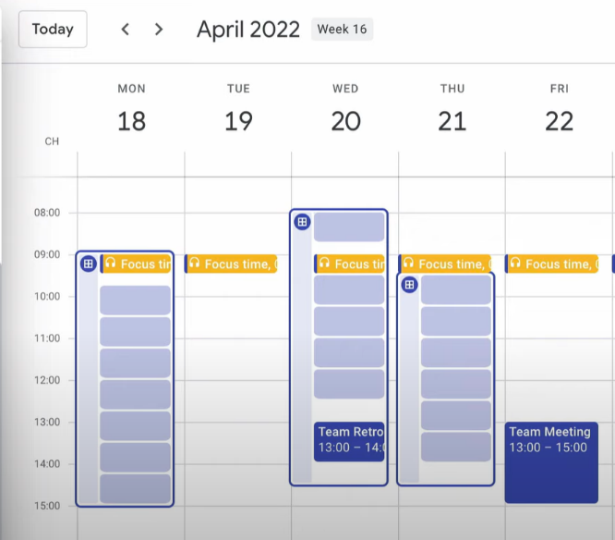In order to create an appointment schedule Google Calendar has a drop down menu in which you can find the Appointment schedule option. From there, you are redirected to create your own booking page where you are able to see your timetable and create booking slots accordingly. This is a simple and aesthetically pleasing feature which makes the option to create meetings and schedule appointments very easy and simple for the user.

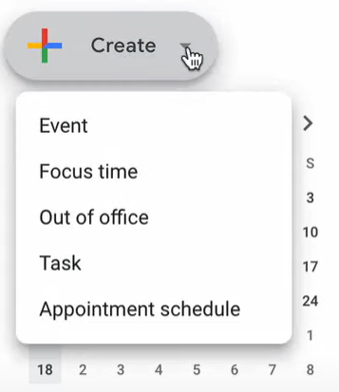

Once you are on this page, you are given the option to set up time slots during which you are available throughout the week. In the example it can be seen that the user is only available from 0900 to 1700 on Monday, Tuesday and Wednesday. After setting up the times during which the admin is available, they can then customise the length of their consulting sessions with pre-set options ranging from 15 minutes to 2 hours, however there is also the option to customise the duration of the meetings. This makes the program adaptable to different types of meetings, for example if it is a lesson, the length can be set to 1 or 2 hours whereas if it is a catch up business call the duration can be set to 15 or 30 minutes.

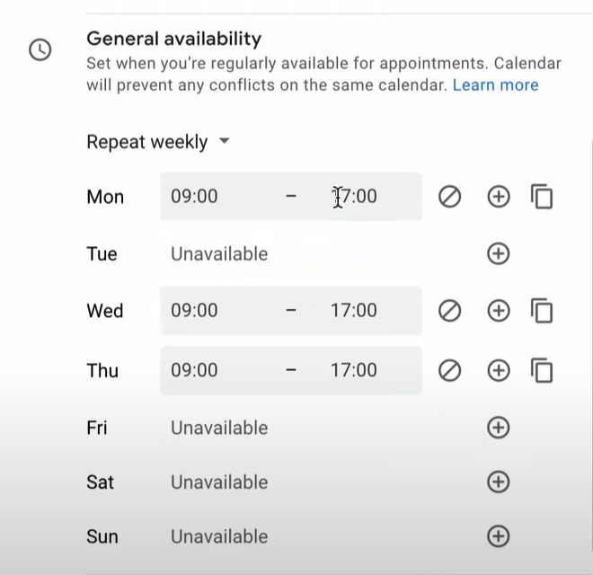

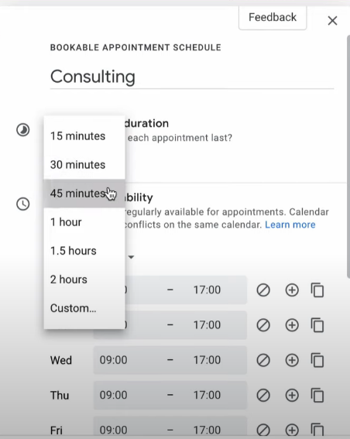

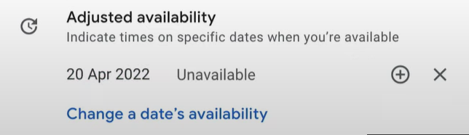In case the admin has had a change of plans or their schedule has changed, they have the option to edit their availability slots during the day. In the example below, the admin has realised that they wont be able to meet on the 20th of April so they changed their availability status to ‘Unavailable’. This is a useful feature because it allows the admin to adapt for their flexible time schedule and edit their ‘online diary’ whenever they need to.

Google calendar also allows you to set up the minimum time that the user must book the appointment for before it starts. It also lets you set up the maximum time period for which you can pre-book your meetings with the consultant. This is convenient for the admin because if they don’t know their schedule well enough in advance and if they aren’t sure if they are available in the future, they can’t get pre-booked too far ahead of time.

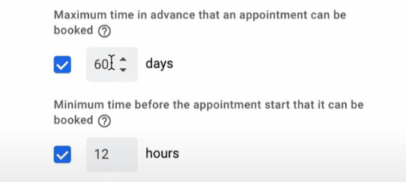

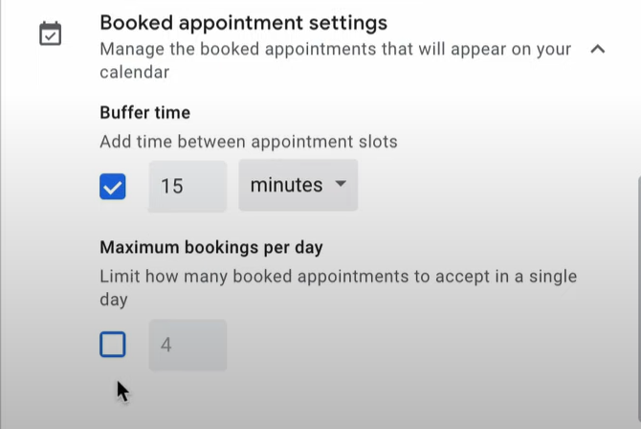The admin can add a buffer time between each meeting and can also set a maximum amount of meetings that they can do per day. This gives the admin complete control over their diary schedule so that if the admin requires a break or time between each meeting to prepare their material for their next meeting, they have the ability to do that.

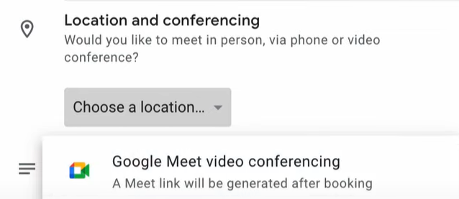The admin can also set the location of the meeting and link in a Google Meet link so that the participants are directed straight to the meeting. This provides more information about the logistics of the meeting that is being scheduled and makes it very practical for finding the physical or online location of the appointment.

**Sharing the appointment with others – Google Calendar**

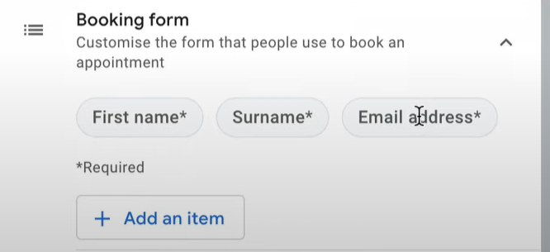First, in order to gather some extra information about the recipient of the meeting the admin can create a form for the participants of the meeting to fill in. These include first name, surname and the email address as well as any other relevant information such as their phone number which could be useful for the admin. This allows the admin to know a little bit about their student/ the participant prior to their meeting which will help the flow of the lesson.

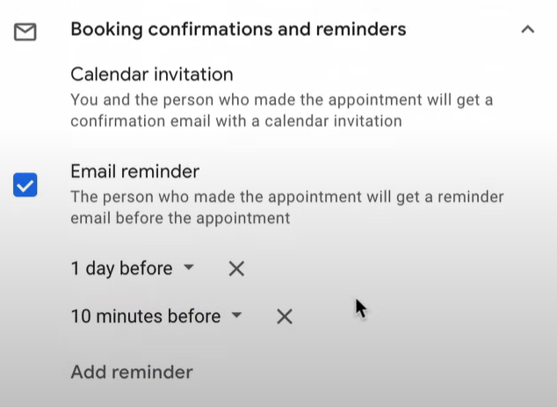Yet again, just like in scheduling events, the admin can set reminders for each meeting with different time periods before each meeting. These reminders would be sent on email to the recipient of the meeting with a specified period of time before the meeting. This is efficient because it prevents the participants from forgetting about the scheduled meeting.

The link to the booking page can be shared via email or other methods and once it is accessed, the user is directed to the following page, where they choose one of the available times that was set up by the admin.

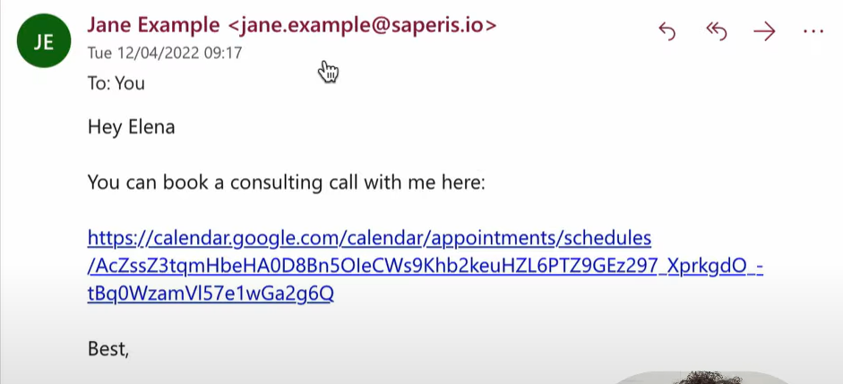

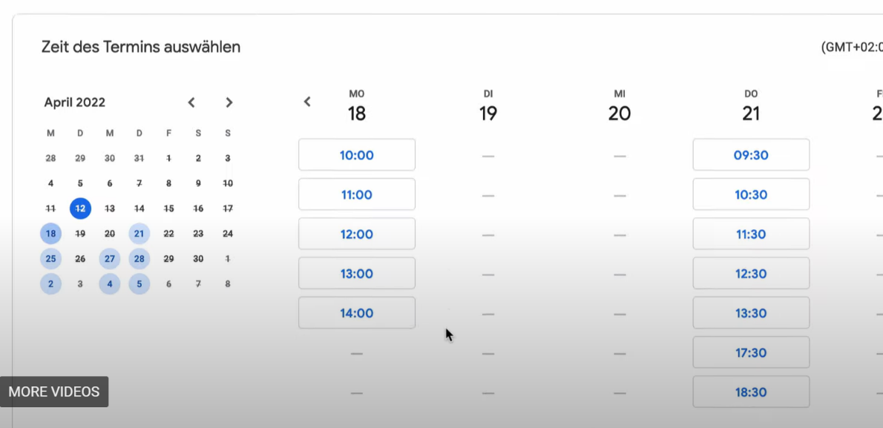

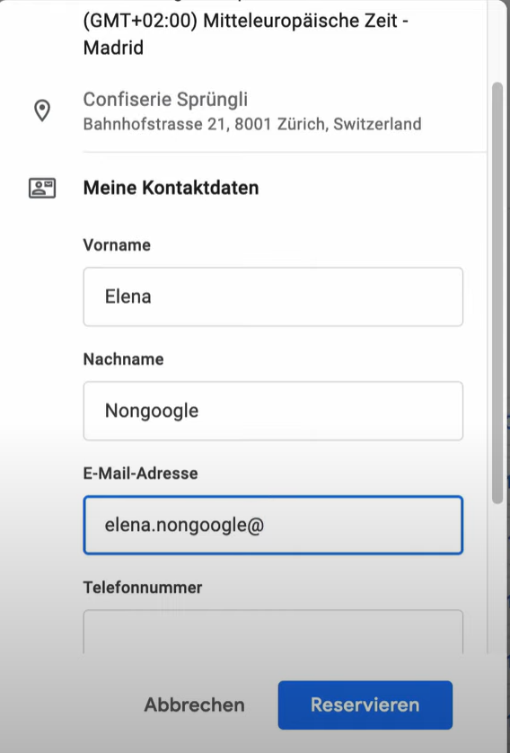Once the user selects one of the times for the meeting, they are directed to the form that was set up earlier to fill in their information. Once they have filled in their details their appointment has been scheduled. This is an effective way for users to book meetings due to the easy to read visual layout of all the available time slots and the accessibility they have by the admin sharing the booking page link with them.

## Essential features of my project

1. My website will allow the admin to allocate free time slots during each day. For example, if the times during which the admin is free are from 9am to 5pm they can allocate free time slots anywhere between these times so that the users can book these free slots.
2. The admin and user will be able to view their schedule and change the view of their schedule between day, week, and month. Their schedule will be laid out.
3. The admin will be able to cancel scheduled meetings. For example, if the admin has a scheduled meeting at a certain time and their plan changed so that they can no longer attend the meeting, they will be able to cancel this meeting.
4. The website will be personalised for my mum and will have the description of her services and other relevant information about meetings and pricing.
5. There will be a chat system between the client and my mum so that any relevant information and lesson material can be sent between them.
6. The client will be able to book meetings during the allocated free slots that the admin (my mum) has assigned.
7. There will be an automated reminder sent via email to the participant and the admin at a set time before the meeting.

## Potential limitations of the proposed idea

1. The first limitation for my proposed idea is that my website won’t be collecting any credit or debit card information from its users. This is because this feature could have risks associated with it such as malfunctioning could cause unwanted transfer of money which would be a big problem.
2. Another limitation is that my website will not offer a calling or video calling service for the finance coach to have the meetings with their clients. Instead it is suggested that the users of my website will use an external service such as Skype or WhatsApp for their meetings. This is because such platforms will provide better and more stable calling quality than one that I could make.
3. My website’s calendar will be a stand alone system therefore a person’s meeting calendar cannot be copied into other platforms like Outlook. This is because it will be too complex to enable such a function to work.

## Requirements for solution

**Developer requirements (my requirements)**

Software: The software requirements for the developer include having access to an IDE such as VS code. This will be used to write and debug the code. Being able to run and test the website with a suitable browser such as Google Chrome so that I can perform development and final testing on my code. Having a suitable method to host the website on a server so that at the end of the development, I can host the website locally or publicly so that people can view it and use. This will involve using XAMPP for hosting the website and creating the databases on a local device and once the development of the website is complete a suitable website hosting platform which will be determined later. The programming languages that I will use will be HTML and CSS for designing the webpage, Bootstrap for adding custom design features to the website, MySQL to manage and create databases and tables, and PHP to manipulate databases.

Hardware: All I will need for the development of the website is a computer that can run VS Code and Google Chrome. A mouse and keyboard may be needed (optional).

**Requirements for the finance advisor**

Software: My mum will require access to a web browser and access to the internet so that she can get onto the website to view her online schedule and manage her classes. An email address so that she can receive meeting reminders which will prevent her from missing a meeting.

Hardware: A computer or a phone so that she can get onto a web browser and access the website.

**Requirements for all website users**

Software: All users will need to have access to a web-browser to be able to access the website. An email address so that they can receive meeting reminders which will prevent them from missing a meeting.

Hardware: A computer or a phone so that they can get onto a web browser and access the website.

## Success Criteria

1. Upon completion, users will be able to create an account and be able to login to the website.
2. The users will be able to book meetings with the finance advisor in one of the free slots that was allocated by them.
3. The users will receive emails with reminders about their meetings at a certain period of time before the meeting.
4. The users will be able to use a chat system to communicate with the financial advisor.
5. The users will be able to see their calendar within a month, a week and a day.
6. The admin will be able to create free time slots during the day during which the users can book their meetings.
7. The admin will have the option to set a minimum time between the bookings so that they can have a break and prepare material for their next meeting.
8. The admin will be able to view their calendar within a month, a week and a day.

# Development

## ER Diagram

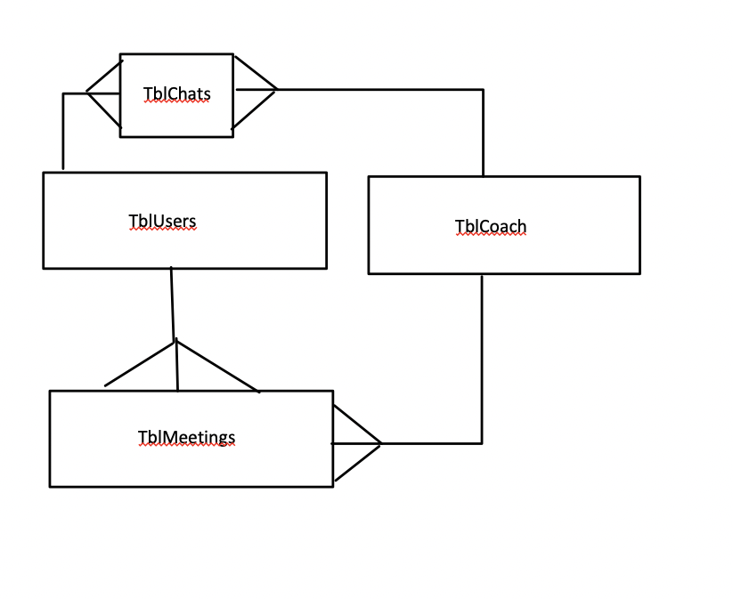

TblFreeTimes

## Tables

**TblUsers**

|  |  |  |  |  |
| --- | --- | --- | --- | --- |
| **Field Name** | **Data Type** | **Validation** | **Typical Data** | **Justification** |
| Surname | VARCHAR(20) | Presence Check (required) | Smith | For User identification |
| Forename | VARCHAR(20) | Presence Check (required) | Michael | For User identification |
| UserID | INT(3)  Auto- Generated | Required | 007 | Auto-incremented automatically. Used as primary key for users |
| Password | VARCHAR(50) | Hidden | Password123 | Hidden so that people can't look at your password |
| Email Address | VARCHAR(50) | Required | craigndave@gmail.com | Email is required so that reminders can be sent to you. |
| Phone Number | INT(20) | Optional | 07774172654 | Phone Number is optional so that users have the option to receive potential calls if they like. |
| Comments | VARCHAR(100) | Optional | Hello! My name is Michael Smith I would like to use your services | Comments are optional so users can give more information about themselves. |
| Coach | TINYINT(1) | REQUIRED | 1 | Required to distinguish between coach and user |

This table will store data about each user of the website who wants to schedule meetings with my mum. Data will be inputted into this table during the sign-up processes.

**TblMeetings**

|  |  |  |  |  |
| --- | --- | --- | --- | --- |
| Field Name | Data Type | Validation | Typical Data | Justification |
| UserID | INT(3)  Auto-Generated | Presence Check  (required) | 023 | The User ID is the primary key in the linking table between users and admins |
| Meeting Time Start | Date and Time | Presence Check (required) | 1900  11.03.24 | In order to store a meeting, storing a start time is required. |
| Agreed_by_coach | Boolean | Default value- False, not applicable as the coach will do it in her own time | True (approved) or False (denied) | The meeting will be either approved by the coach or denied. |
| Meeting_desc | VARCHAR(2000) | Presence Check  (required) | I would like to discuss... | The meeting description is required for the finance coach to know the topics to discuss |
| Notes_of_coach | VARCHAR(10000) | Optional | 1.notes  2.more notes… | The coach will be able to write down the notes associated with the meeting here. |

This table will store data about each individual meeting request made by each user. The Boolean field ‘Agreed_by_coach’ will have two possible values: True or False in order to store whether the request has been approved by the coach and the meeting can be added into the appropriate people’s schedules.

**TblChats**

|  |  |  |  |  |
| --- | --- | --- | --- | --- |
| **Field Name** | **Data Type** | **Validation** | **Typical Data** | **Justification** |
| UserID | INT(3) | Required  (presence check) | 078 | In order to know which user the coach is chatting with. |
| CoachID | INT(3) | Required  (presence check) | 001 | So that the coach’s details can be accessed by user. |
| Date/time | DATE/TIME | Automatic | 11.03.24 15.28 | The date and time of the message will be picked up automatically by the computer |
| Message | VARCHAR(65535) | Required  (presence check) | Hello! | In order for the message to be sent it must be typed by the sender. |
| Message_senderID | INT(3) | Presence check  (required) | 083 | So that the sender of the message can be known to the recipient. |

TblChats will be a table used to store the chats between a user and my mum so that the chat function of the website will be able to display the message and the date and time at which it was sent.

**TblFreetimes**

|  |  |  |  |  |
| --- | --- | --- | --- | --- |
| **Field Name** | **Data Type** | **Validation** | **Typical Data** | **Justification** |
| Freetime | DATE/TIME | Optional | 19.03.24 | This field allows the admin to input date and time of when they are free |

TblFreeTimes is a table which will store the times during which my mum is available. The 3 different time slots allow her to allocate free slots during the day in case she is busy for some part of the day e.g. the afternoon. Then she will be able to enter her availability into two time slots: the morning being TimeSlot1 and the evening being the TimeSlot2. If she is available for the whole day or only 1 to 2 hours per day she will only have to use one time slot field.

## Top Down Design Diagram

Website for a finance coach

Login and Signup

Chat System

Sending automated emails at a desired time before the meeting.

Sending Reminders

Log into your account as a user or an admin (coach)

Write a comment about their preferred topic of discussion.

Create an account as a user.

View the description of my mum’s services.

Sign Up and Log in.

View timetable of meetings with the finance coach. Day/week/month.

Have a description of their services on the main page.

Agree/Disagree to meetings with users.

View Timetable of Meetings with the users. Day/Week/Month

Request meeting with the finance coach

Users can send messages to the finance coach.

Finance Coach can send messages to users individually.

User

Coach

I have split up the problem into 5 main categories:

1. Creating a chat system between each of the users and the coach so that a private chat could be kept.
2. Having a coach which will be my mum who will be able to view the timetable of her approved meetings, have a main page with the description of her services and mainly, she will be able to accept or deny meetings requested by the users.
3. Having the users that can create an account and log in. The users will be able to request a meeting with the finance coach and write a comment about their preferred topic of discussion. The users will also be able to view their timetable with different time periods ahead. The users will also be able to view the main page with the description of my mum’s services.
4. Logging In and Signing Up- Users will be able to create an account and log into their accounts. My mum will have a preset account of an admin who will operate as the coach.
5. Sending Automated reminder emails 15 minutes before the meeting to the coach and the users.

## Test Data

Log In page

In the log in page the user will have to input their log in details in order to access the system. Both admins and users of the systems will be able to log in hence I will need two sets of test data for this page. Therefore the data that I will use for this page will be as follows:

Admin (Finance Advisor):

Surname: Lyazzat

Forename: Zhunisbekova

Password: Password321!

User:

Surname: Smith

Forename: Michael

Password: Password123

## Book Meetings

In the book meetings page the user will be able to request a time for the meeting as well as a duration and provide a description for what their desired topic of conversation is. The coach will be able to accept or decline the meeting request and during the meeting write notes about the meeting. However, I will consider overlapping meeting requests and the scenario of the admin declining a meeting.

## 

User:

Meeting Start Time: 9:00 am

Duration: 15 minutes

Description: I would like to have a meeting with you.

Admin (Finance Advisor):

Verify: Agree

Meeting Notes: blah blah blah

Another user:

Meeting Start Time: 9.00am

Duration: 30 minutes

Description: I would like to have a meeting with you

## 

This input should not be an option on the drop-down menu of available times as this time is already booked and confirmed by the other user.

My Schedule (user and admin)

Another User:

Meeting Start Time: 10.00 am

Duration: 30 minutes

Description: I would like to have a meeting with you

Admin (Finance Advisor):

Verify: Disagree

In this page the user and the admin will be able to see their schedules.

Admin:

Meeting Start Time: 9.00 am

Duration: 15 minutes

Meeting member: Michael Smith

User:

Meeting Start Time: 9.00 am

Duration: 15 minutes

Meeting admin: Lyazzat Zhunisbekova

## Page Design

Main/Home Page (homepage.php)

Book Meeting

Home Sign up Log In

Picture of my mum

Description of my mum’s services

**Algorithms associated with Main/Home Page:**

**Clicking ‘Home’ button:**

when click (“Home”):

redirect to “home.php”

**Clicking ‘Book a meeting’ button:**

When click (“Book a meeting”):

Redirect to “booking.php”

**Clicking “sign up” button:**

When click (“sign up”):

Redirect to “signup.php”

**Clicking “log in” button:**

When click(“log in”):

Redirect to “login.php”

**Usability features of the page**

1. The scroll bar allows a user to easily scroll down the page to read all the information on the page.
2. The nav bar will be constantly visible so the user will be able to return to the home page via the home page button at any time.
3. By clicking the home page button the user can also instantly scroll to the top of the home page if they would like to return to the top.

Log In Page

Menu Bar

Home Book a Meeting Sign up Log In

Redirects back to the home page.

Background Design or Image

Back

Log In

Password

Forename

Surname

Log In

**Algorithms associated with Log in Page:**

**Inputting fields:**

Surname = str(input(“Surname”))

Forename = str(input(“Forename”))

Password = str(input(“Password”))

**Processing the inputs:**

SELECT*FROM TblUsers WHERE Surname = Surname and Forename = Forename

If password_verify (Password, hashed_password):

Then location header(“user.php”)

Else:

Location header(“login.php”)

**Creating the session variables:**

$_SESSION[‘surname’] = Surname

$_SESSION[‘forename’] = Forename

**Usability Features of Log in Page**

1. The ‘Back’ button allows the user to be redirected back to the home page.
2. The input fields are large and dominate the majority of the screen, so they are instantly noticeable by the user.
3. The navbar is still accessible so the user can go back to the home page via it.

Sign Up Page for Users

Book Meeting

Home Sign up Log In

Create an Account







Create Account

Comment/Description

Phone Number (Optional)

Email

**Algorithms associated with the sign-up page for users**

**Inputting fields:**

Surname = str(input(“Surname”))

Forename = str(input(“Forename”))

Password = str(input(“Password”))

Email = str(input(“Email”))

Phone Number = str(input(“Phone Number”))

Comment = str(input(“Comment/Description”))

**Processing the inputs:**

Hashed_password = password_hash(“Password”)

INSERT INTO TblUsers (Surname, Forename, Password, email, phone_number, comments) VALUES (Surname, Forename, Password, Email, Phone Number, Comment )

#This adds the inputted values into the table TblUsers.

**Usability Features of Sign up page**

1. The ‘Back’ button allows the user to be redirected back to the home page.
2. The input fields are large and dominate most of the screen, so they are instantly noticeable by the user.
3. The navbar is still accessible so the user can go back to the home page via it.

Book Meeting Page For User

Home Book a Meeting User



Choose a date and time:

|  |
| --- |
| 15/04/2024 0900 |
| 15/04/2024 1000 |

**Each Meeting will be one hour long.**

Meeting Description:

Type here…

Request Meeting

**Algortihms associated with Book Meetings Page**

**Taking the inputs:**

SELECT ALL*FROM TblFreeTimes

Date_and_time = input_from_options(“SELECT A DATE AND TIME”)

Meeting_description = str(input(“Meeting Description”))

**Processing the inputs:**

INSERT INTO TblMeetings (UserID, Meeting Start Time, Meeting_desc) VALUES ($_SESSION[UserID], Date_and_time, Meeting_description)

DELETE*FROM TblFreeTimes WHERE Freetime = Date_and_time

**Usability Features**

1. The navbar is still accessible so the user can go back to the home page via it.
2. The selection of the date and time utilizes a drop-down menu which allows the user to see the available times for their meeting.

Timetable Page of the Finance Advisor

Home Timetable Meeting Requests (8) Lyazzat Zhunisbekova

]

|  |  |  |  |  |  |  |
| --- | --- | --- | --- | --- | --- | --- |
| Monday | Tuesday | Wednesday | Thursday | Friday | Saturday | Sunday |
|  |  | 08.00-09.00  Meeting  With… | 08.00-09.00  Meeting  With… |  | 08.00-09.00  Meeting  With… |  |
|  | Free Slot  16.00-17.00 | 09.30-10.30  Meeting with… | Free Slot  16.00-17.00 |  |  |  |
| 19.30 – 20.30  Meeting with... | Free Slot  18.00-19.00 | 19.30-20.30  Meeting  With… | Free Slot  18.00-19.00 | 21.00 - 22.00  Meeting  With… | 19.30-20.30  Meeting  With… |  |
| 20.10-21.10  Meeting with… |  |  |  | Free Slot  22.00-23.00 |  |  |

Day View Mode

Wednesday

|  |
| --- |
| 08.00 Meeting with …….  1 hour |
| 09.30 Meeting with …….  1 hour |
| 19. 30 Meeting with …….  1 hour |
|  |

**Algorithms associated with the timetable page.**

**Weekly timetable**

SELECT*FROM TblMeetings WHERE Agreed_by_coach = True and UserID = $_SESSION[‘UserID’]

SELECT From Day A to Day B:

Display the timetable between Day A and Day B

**Daily Timetable**

Now = current day

SELECT*FROM TblMeetings WHERE Agreed_by_coach = True and UserID = $_SESSION[‘UserID’] and Day = current day

Display the timetable WHERE now = current day

**Deleting from TblMeetings**

DELETE *FROM TblMeetings WHERE Now> Date_and_time

**Usabiliy features**

1. The navbar is still accessible so the user can go back to the home page via it.
2. Free Slots are highlighted in green which makes the free slots easy to see for the coach and will help them to prepare for a potential meeting.
3. The time of the meetings is shown in chronological order so that users and the admin know the order of their events in the day.
4. The user and coach will be able to switch between day and week view mode which will allow them to visualise their whole week or the current day.

Meeting Requests Page of the financial advisor

Home Timetable Meeting Requests (8) Lyazzat Zhunisbekova



Verify

Yes No

Requests

Name: Michael Phone Number: +44 49 2534 2345

Surname: Smith Duration: 2 hours

Email: [michaelsmith@gmail.com](mailto:michaelsmith@gmail.com) Date and time: 19.00 04.04.23

Name: Michael Phone Number: +44 49 2534 2345

Surname: Smith Duration: 2 hours

Email: [michaelsmith@gmail.com](mailto:michaelsmith@gmail.com) Date and time: 19.00 / 07.04.23

Name: Mohammed Phone Number: +44 49 2534 2345

Surname: Hussein Duration: 2 hours

Email: [michaelsmith@gmail.com](mailto:michaelsmith@gmail.com) Date and time: 19.00 05.04.23

Name: Michael Phone Number: +44 49 2534 2345

Surname: Smith Duration: 2 hours

Email: [michaelsmith@gmail.com](mailto:michaelsmith@gmail.com) Date and time: 19.00 06.04.23

**Algorithms associated with Meeting Requests Page**

SELECT*FROM TblMeetings WHERE Agreed_by_coach = null

Agreed = Boolean(input(Agreed/Disagreed))

INSERT INTO TblMeetings (Agreed_by_coach) VALUES (Agreed)

Num_requests = number of meeting requests

Display(num_requests) in nav bar

**Usability features**

1. All details about the users that are making the meeting requests are shown so the admin can see relevant information about the users prior to accepting the meeting.
2. The number of meeting requests is shown in the nav bar so the admin knows how many people would like to have a meeting.
3. The admin must simply tick a box to accept or deny the meeting request which is very easy and convenient.

Usability Features of the website

1.One feature that will be present on all the pages of my website will be the nav bar on the top which will be used to access the different pages from any current page with ease both for the user and the admin.

2. Another usability feature of my website will be the ability to view your own schedule easily being able to switch between the option of viewing it for the current week or just the day.

3.Free slots will be coloured in green and the times during which you are not available are marked by the crossed-out time slot which will make it easy to visualise the times that can be booked and those during which you are out of the office.

4.When booking a meeting, the user can use the dropdown option to select one of the times that is available.

## Development

## Creating install.php

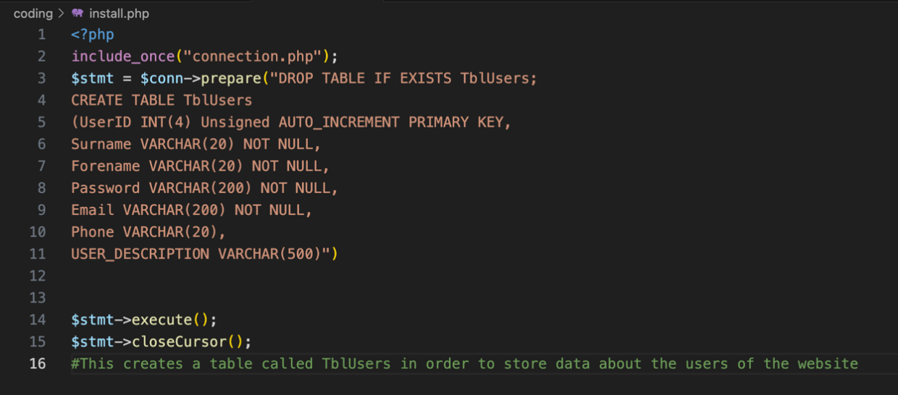 After I ran the code shown on the picture I at first got an error message, however after correcting the syntax of the code, it worked and allowed me to create a table in my database.

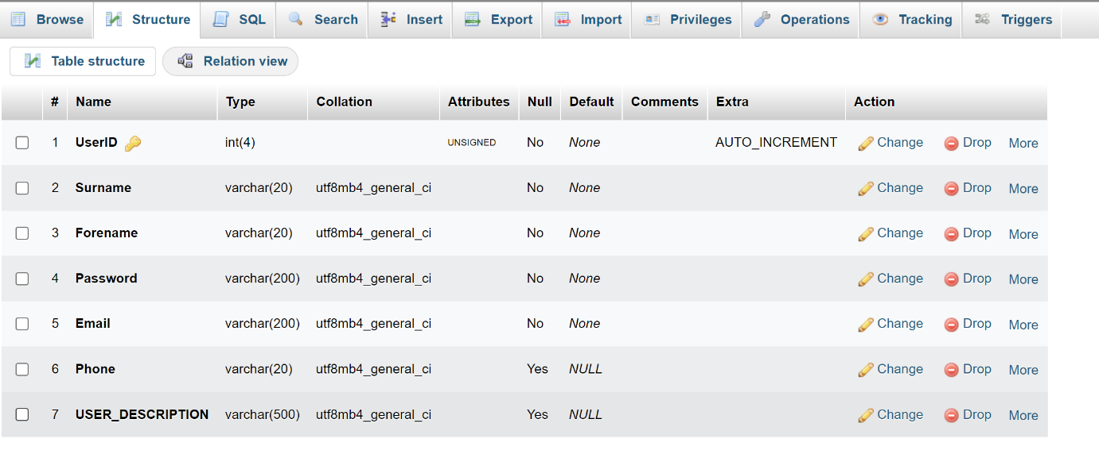I then wrote the code for the rest of my tables. However, I have encountered an error.

However, after fixing some syntax in my code and trying again, I managed to run the install.php page and create all the tables on the database. 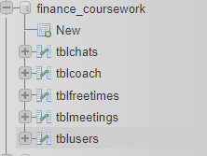

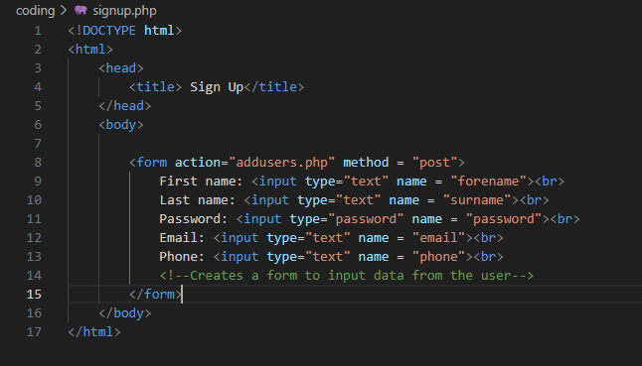

## Creating users.php and addusers.php

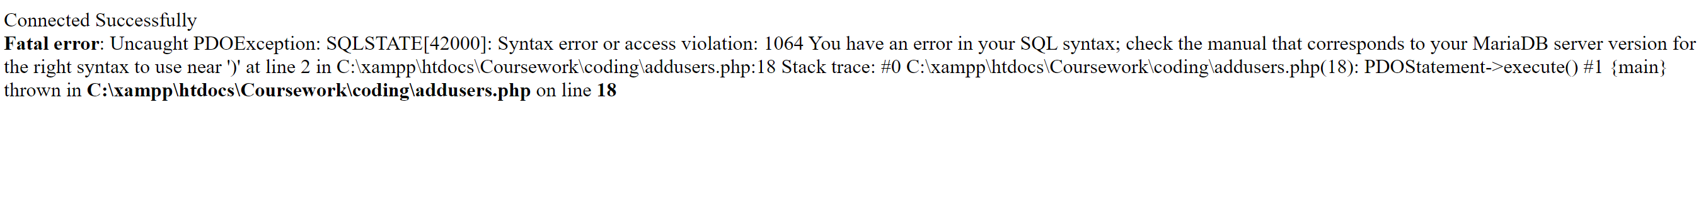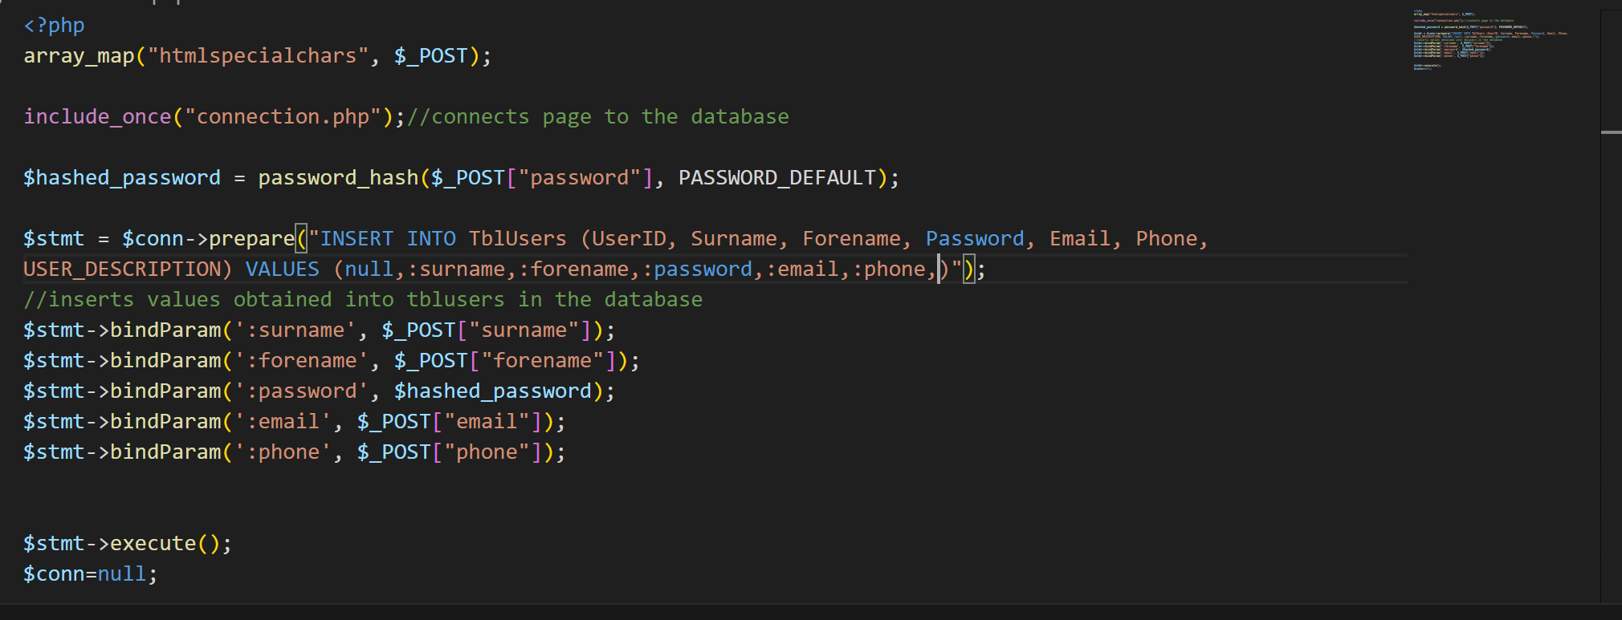After running the code shown, I created a form allowing the user to input their details and pass them onto the next page called addusers.php. The addusers.php page binds the values that have been posted from the form to the fields in the database. After testing the code for the addusers.php page shown below I encountered an error.

After reviewing my code I realised that I didn’t give enough parameters to insert into the database as I skipped the user_description. After adding that in the code was up and running and I was able to add myself into the database.

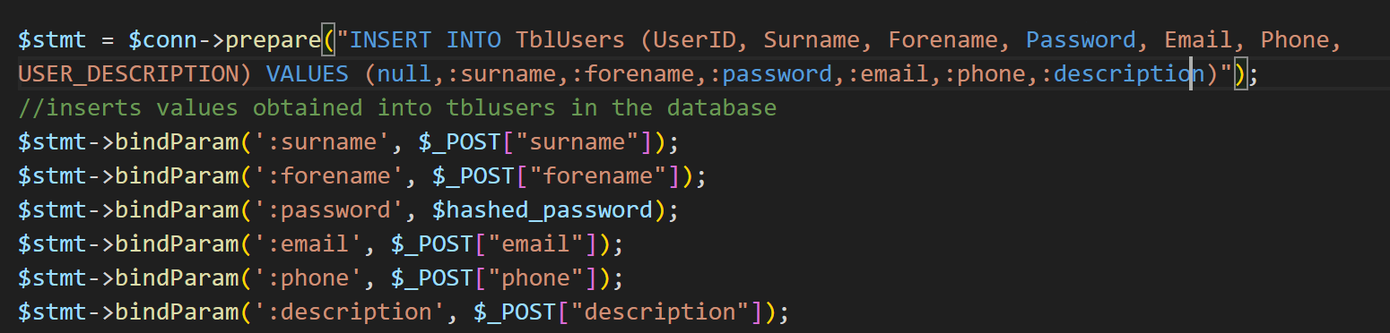

`

At this point I decided to hard code a part of the coach’s details into the system straight away so that they can log in straight away and have the option to change some of their details as they wish. I hard coded the coach’s details in the install.php page.

After checking the database, the coach was successfully added into the users table.

# Creating the log in page and login process

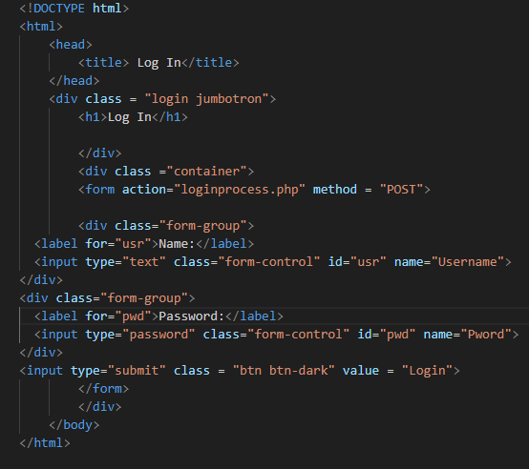

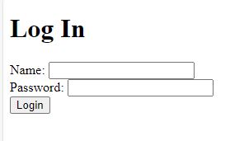After creating this page, I needed to make a page that would process the inputted data to check it with the username and password stored in the database

The log in process page:

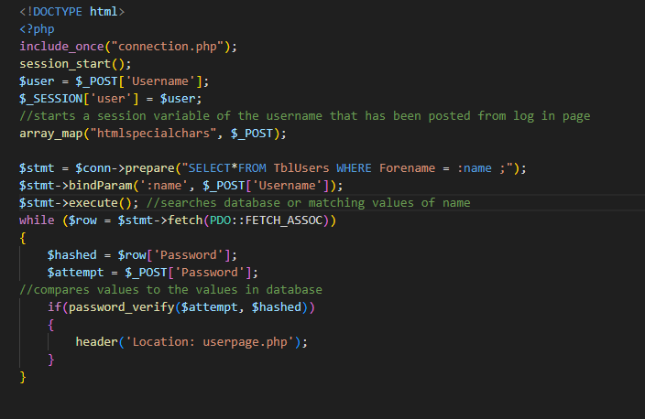

After trying to log in with a user I have encountered an error where the array key Password did not match the variable from the log in page.



However after reviewing my code I managed to find the error in the code and made my variable from login and loginprocess match. I could now log in with a users login details.

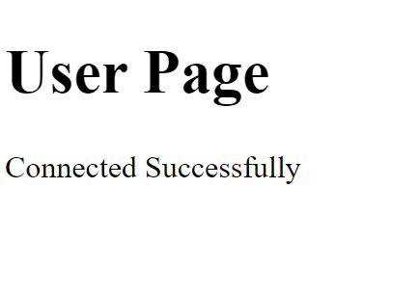

However I encountered a problem when trying to log in with the coach’s details as the password that I hard-coded was not hashed hence it did not match the output of the unhashing algorithm. Therefore I added the hashing password algorithm into the install.php page in order to fix the issue. After running the code, I was successfully able to log in as a coach.

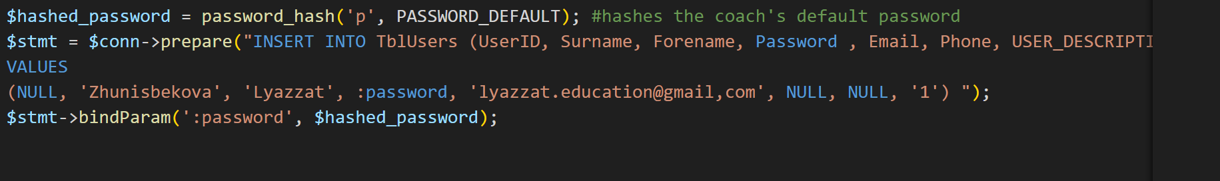

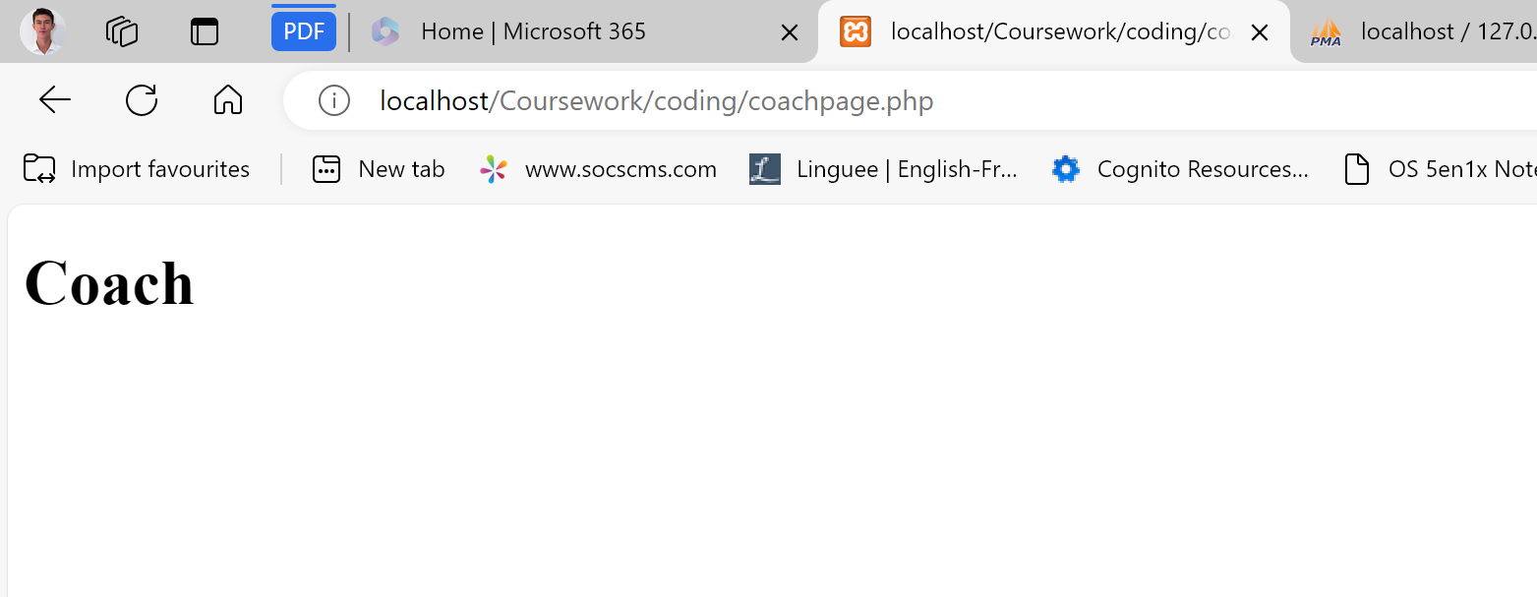

## Adding some CSS

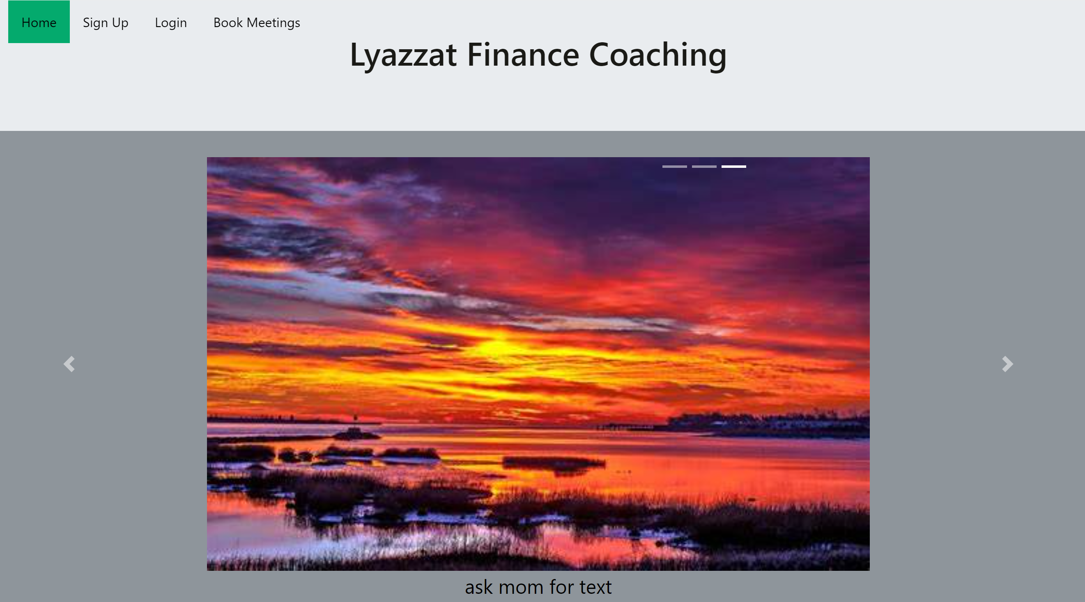

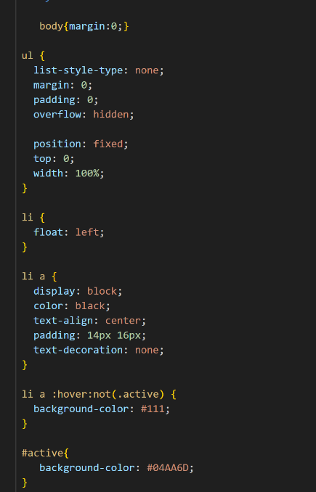 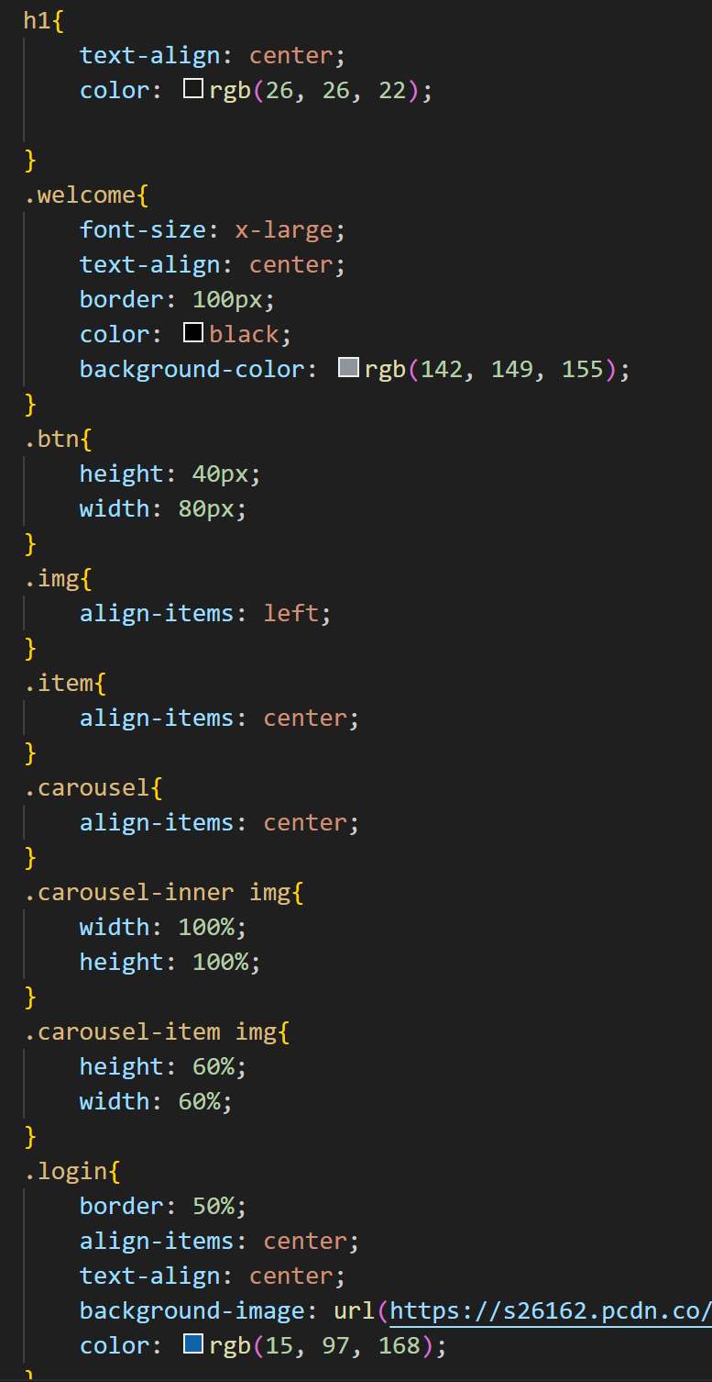  
After writing some CSS for my main page, I managed to create a carousel with multiple pictures that I will edit later as well as a navigation bar to allow the user to jump to whichever part of the website that they want.

## Creating the Freetimes.php page

The free times page will allow the coach to assign the times during which she will be free for a meeting. I will also make an algorithm to check for duplicates to avoid repeated meeting times.

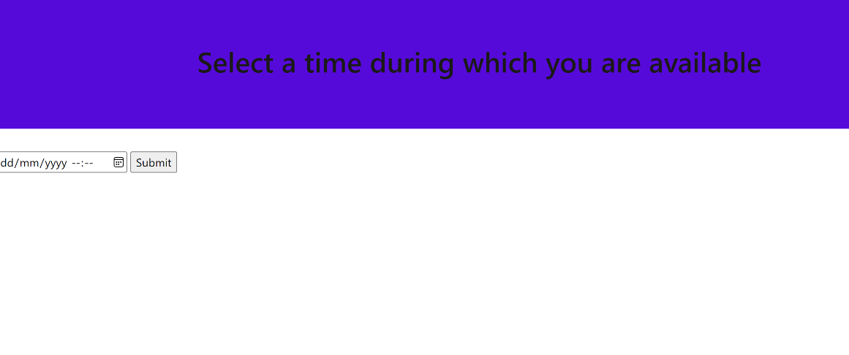

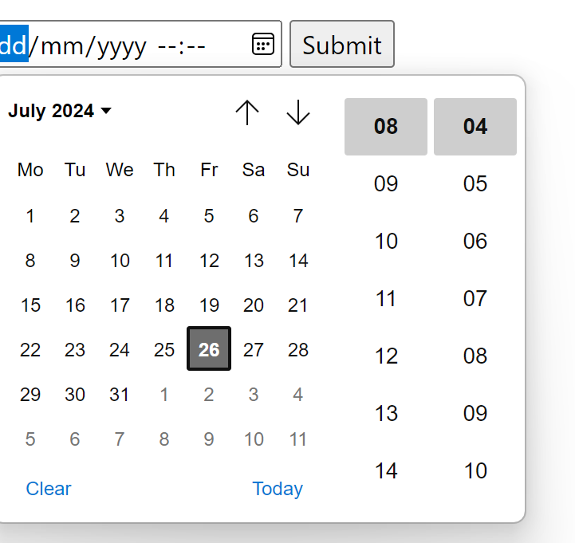

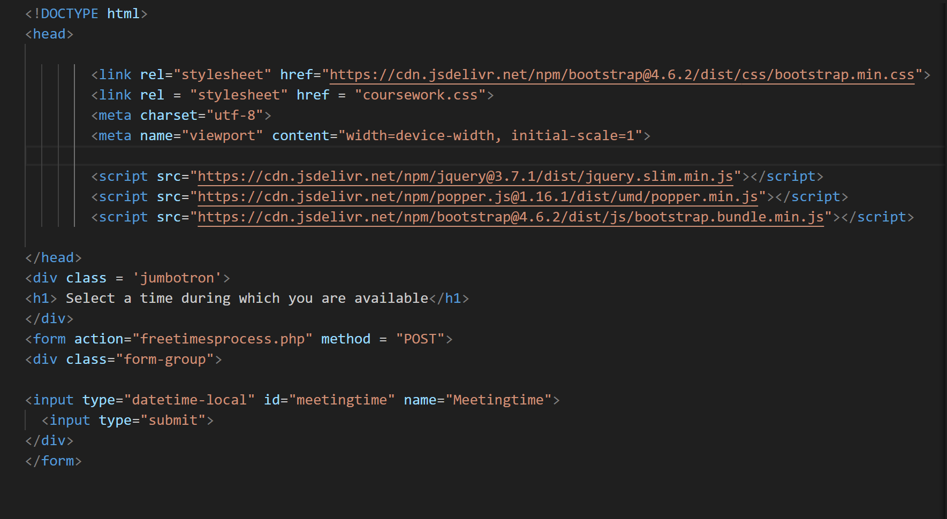

## Creating the Freetimesprocess.php page

The freetimesprocess.php page is the page that will process the input from freetimes.php and add it to the table Freetimes. It will also check for duplicate entries to avoid two meetings happening at the same time.

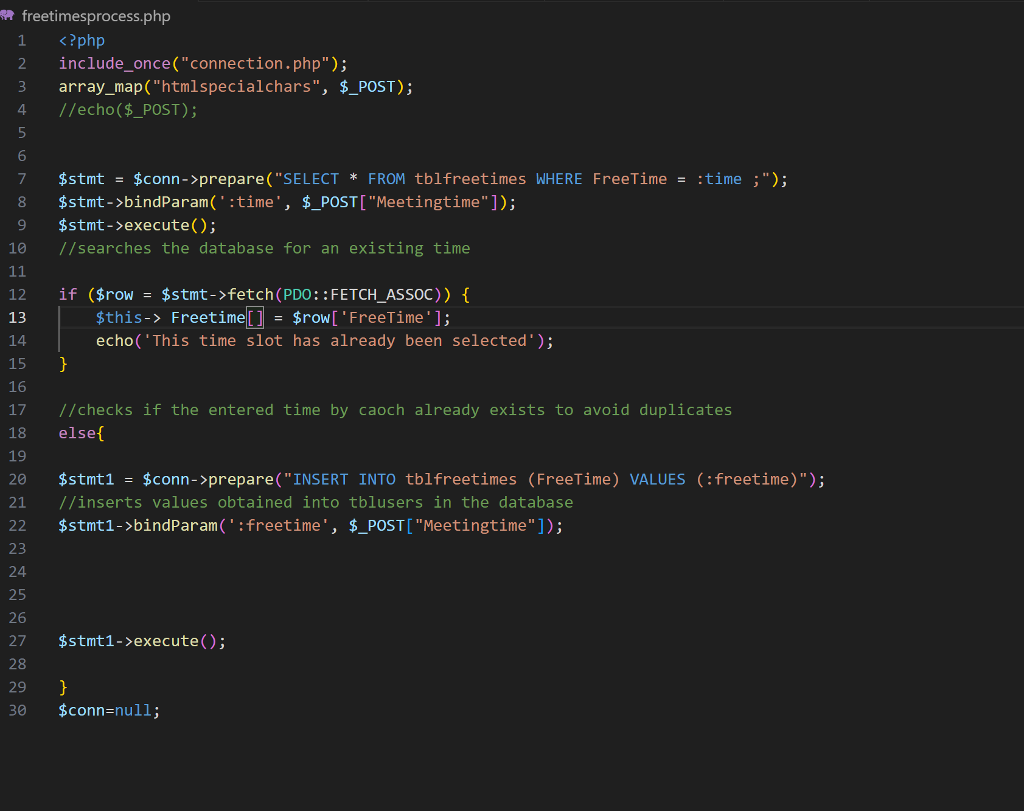

After running the shown code I received an error message:

After checking my code with accordance to the error message I changed line 13 from object context ($this) to $_POST['Meetingtime'] and after running the edited code, I was able to successfully add times to the Freetimes table.

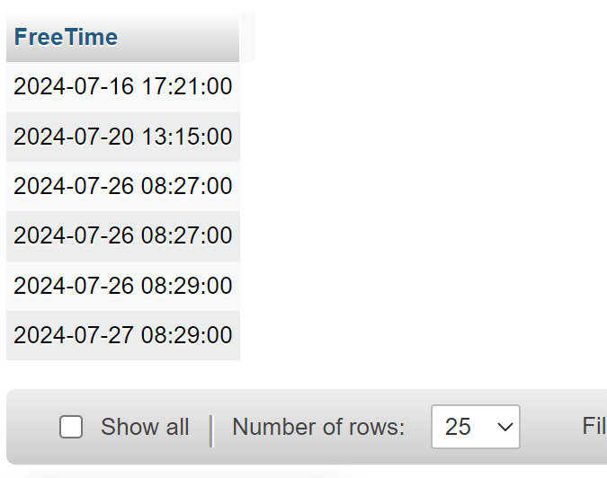

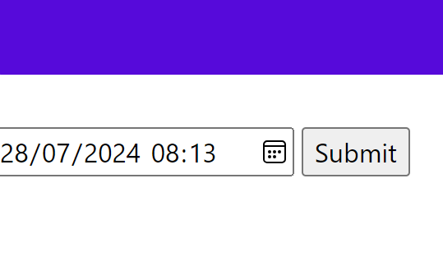I also checked if the code would react to two of the same inputs which it did.

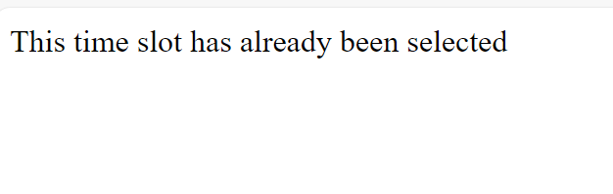

## Creating the bookmeeting.php for users

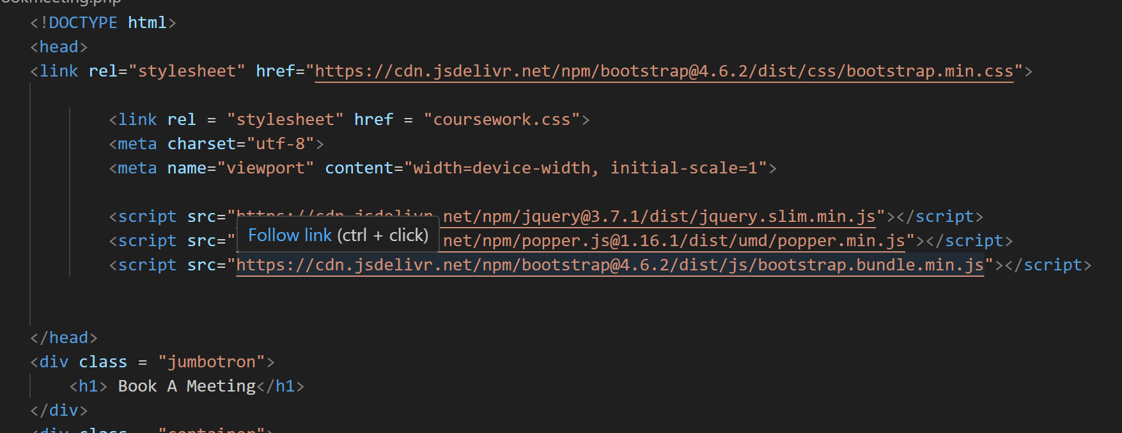

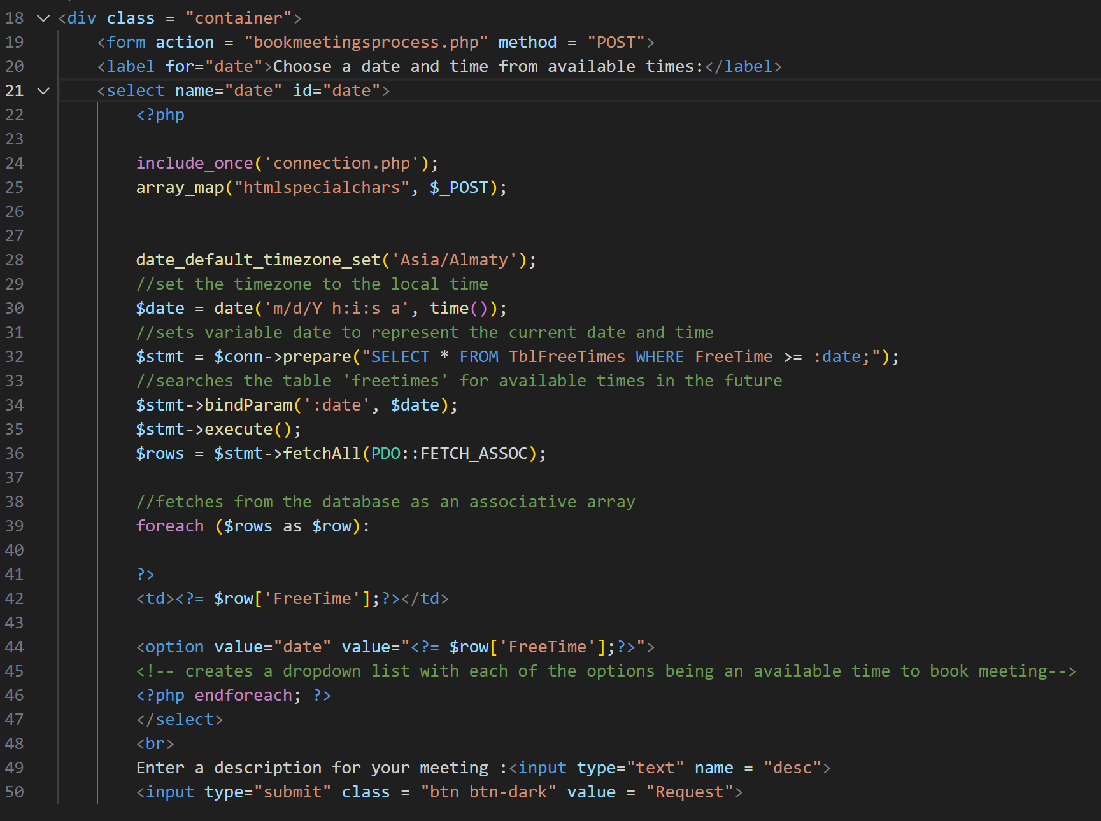

This page will allow the user to submit details when booking a meeting. It includes a form where SQL, I fetched the list of available times that have been submitted by the coach. During the development of this page, I did encounter problems with the syntax and methods to represent the fetched dates and times on a drop-down form. However, after researching online I found a solution and managed to represent the available times for a meeting in a drop-down list.

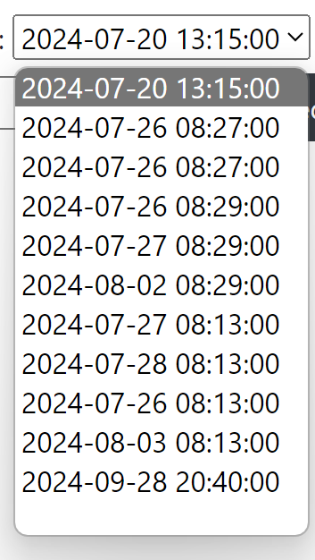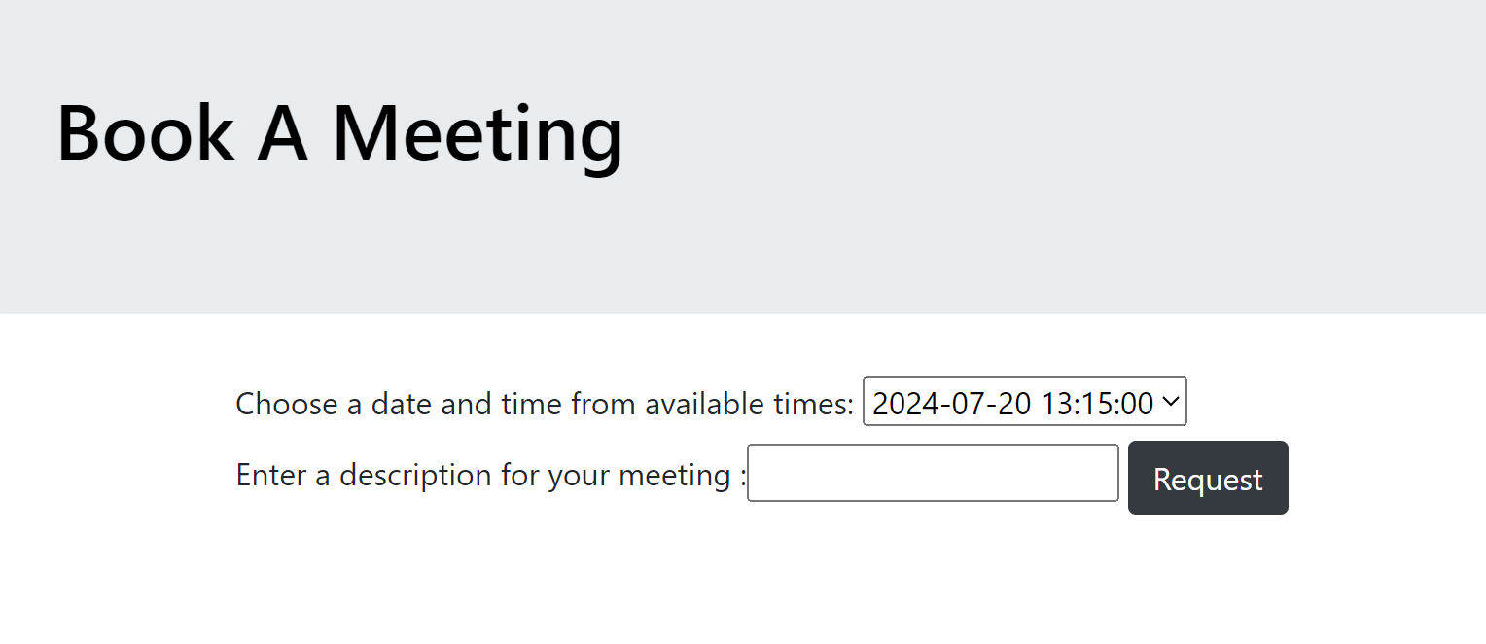

However there was still a problem because the dates that were displayed as the options were not limited to the ones in the future. So my current date variable was not working and was not being compares with the values in the table. Therefore I edited the code and started to use the SQL built in ‘CURRENT_DATE’ variable.

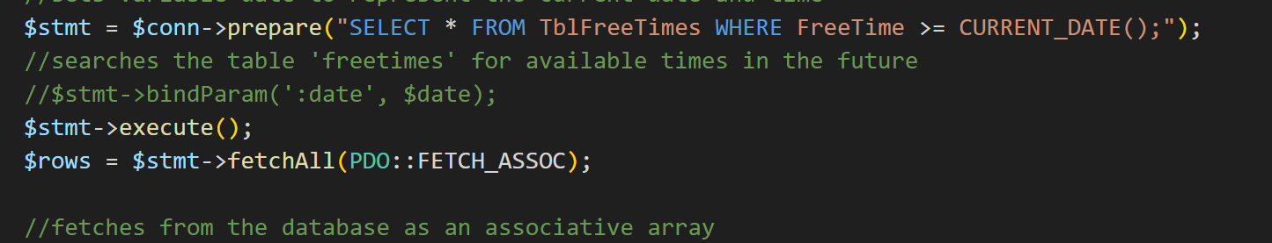

This made only the future dates visible as options for free times.

After I had completed the bookmeetings.php page, I needed to create the bookmeetingsprocess.php page which will add the submitted data to the TblMeetings table in the database. However, one of the columns in TblMeetings was the UserID which I did not have the details of currently.

In order to resolve this issue, I had two options, either find the UserID of the logged in user in the loginprocess page then using a session variable post it to the bookmeetingsprocess.php page, or change the structure of TblMeetings itself so that it only requires the name of the logged in user to be stored.

However the second option would not be a valid solution because if there are two people with the same name the coach would not be able to differentiate between them.

## Creating bookmeetingsprocess.php

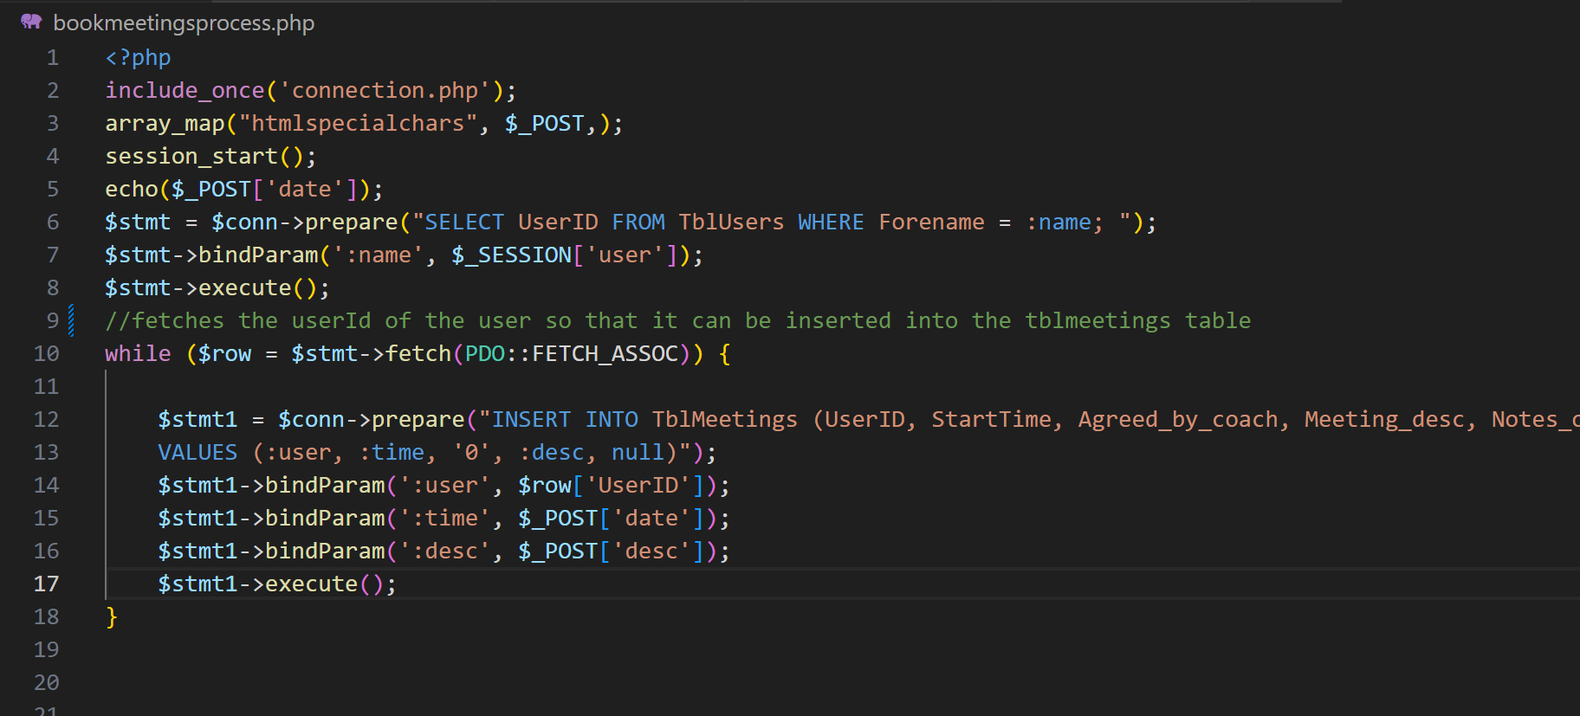

After trying this code by inputting a new meeting request, all seemed to work apart from the date which was not being inputted.

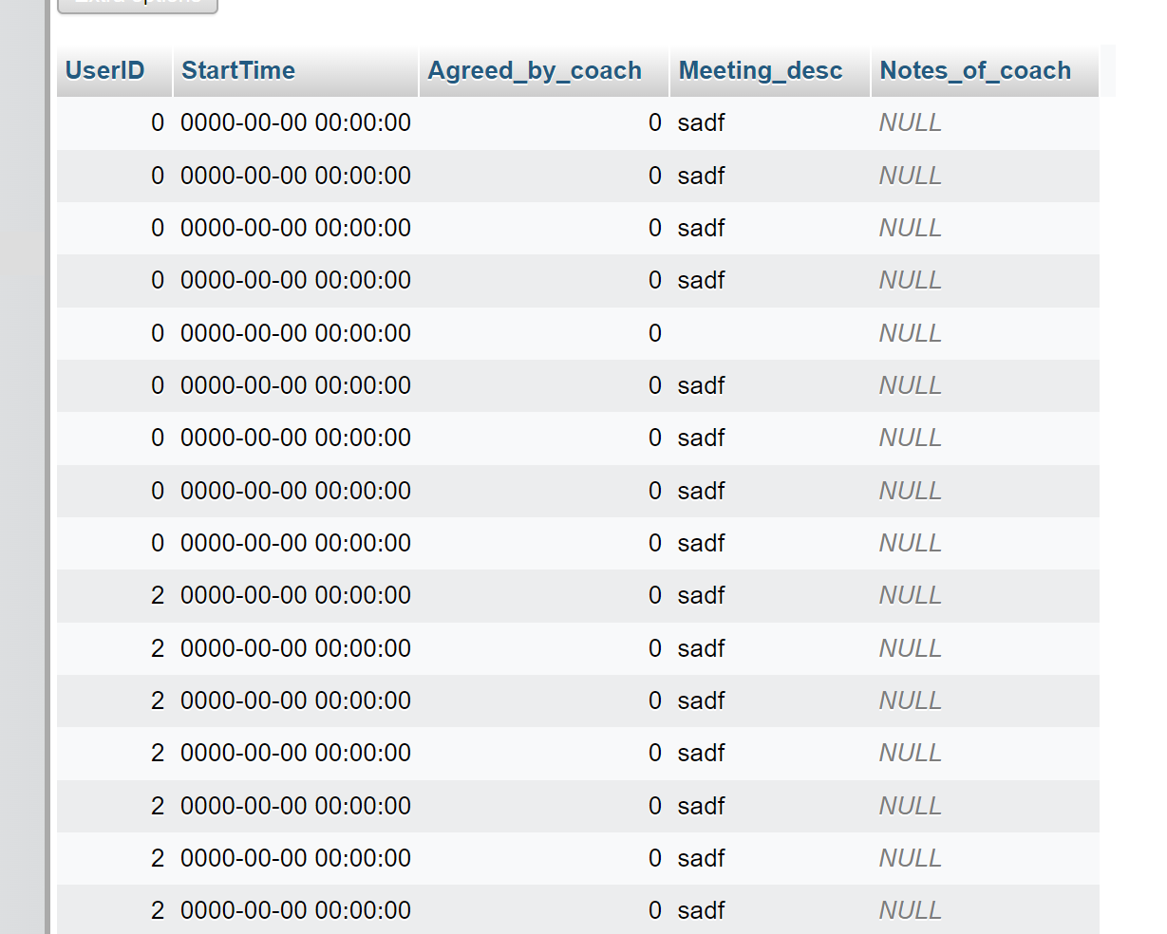

After reviewing the code, on the bookmeetingsprocess.php page I was not able to find the error which made me conclude that the value for the date was not being posted onto the page correctly so I decided to print the posted array to see what value of the date was being posted.

The output turned out to not be a specific date like one of the options on the previous page however it was outputting the word ‘date’. This made me turn to the code on the previous page to find the error that was causing this.

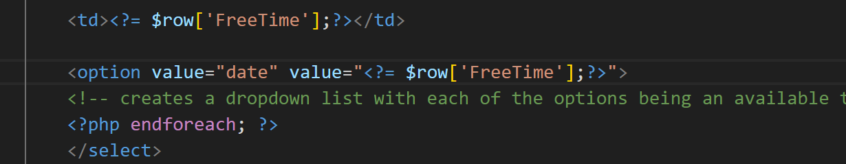

It turns out that I inputted two entries for ‘value’ in the form which was causing it to store the string value. Hence I changed the code from what is above to this…

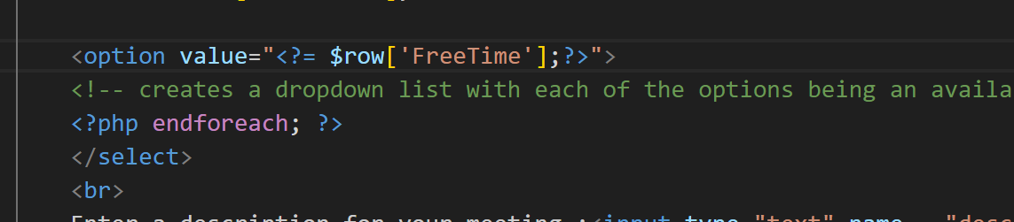

And after testing this with a date input, it appeared that the date that was being stored was incorrect and the that it was being stored twice.

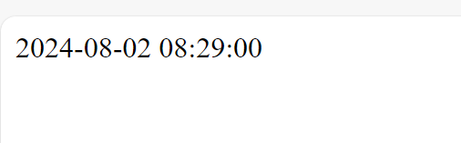

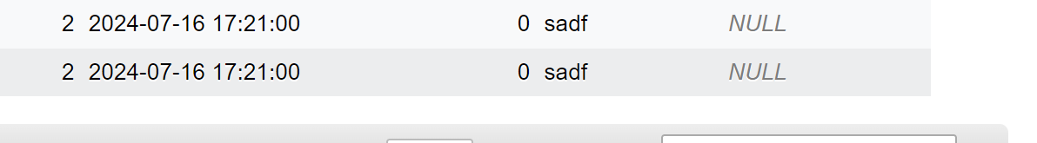

In order to remedy this problem I looked back over the bookmeetingsprocess.php page and found no obvious error which made me deduce that the error was somewhere in the previous page and that the posted date was wrong. To confirm my assumption I used the print_r(array) line in order to see what was being posted from the previous page.

**Correcting bookmeetingsprocess.php**

Firstly, I cross checked the listed available free times in the form with the ones stored in the table in order to make sure that the correct dates were being displayed. This proved to be all correct.

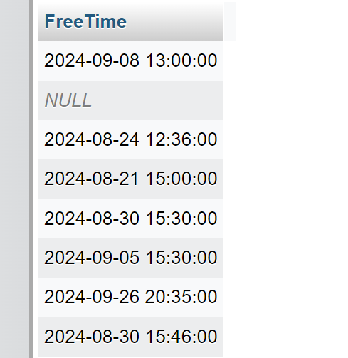**In database table** **In the form of website**

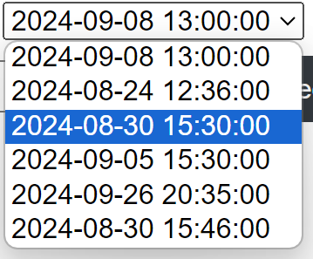

The dates all seemed to match up (apart from the one that was already in the past as of the time of me writing this 2024-08-21 15:00:00, the code rules out dates in the past) which made me conclude that it was a syntax error or error in the html code.

So I changed some of the HTML and PHP syntax from this:

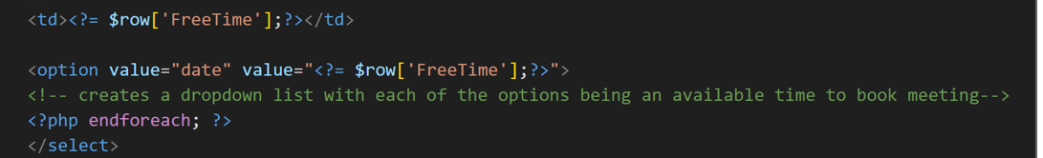

To this:

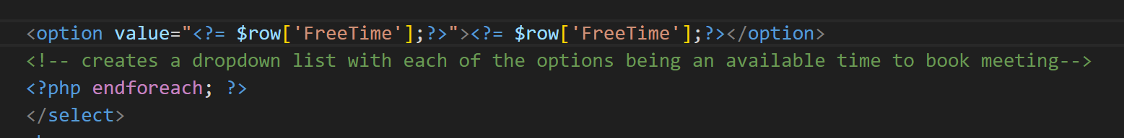

which changed the values in the input options to be precisely the date that was being shown on the form. And after running this the correct date was successfully being posted to the bookmeetingsprocess.php page and being added to the Meetings table.

## Creating meetingrequests.php

After making a way to book meetings with the coach, the coach would need to be able to view and either accept or deny meeting requests. This is going to be the purpose of the meetingrequests.php page.

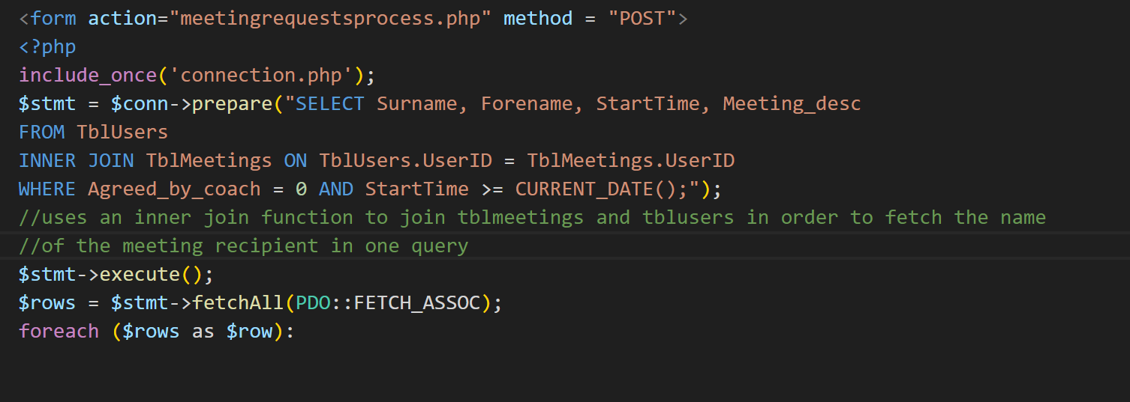

This SQL query joins the two tables TblMeetings and TblUsers in order to get the name and surname only using the userid from the meetings table.

I then used html to display the fetched results.

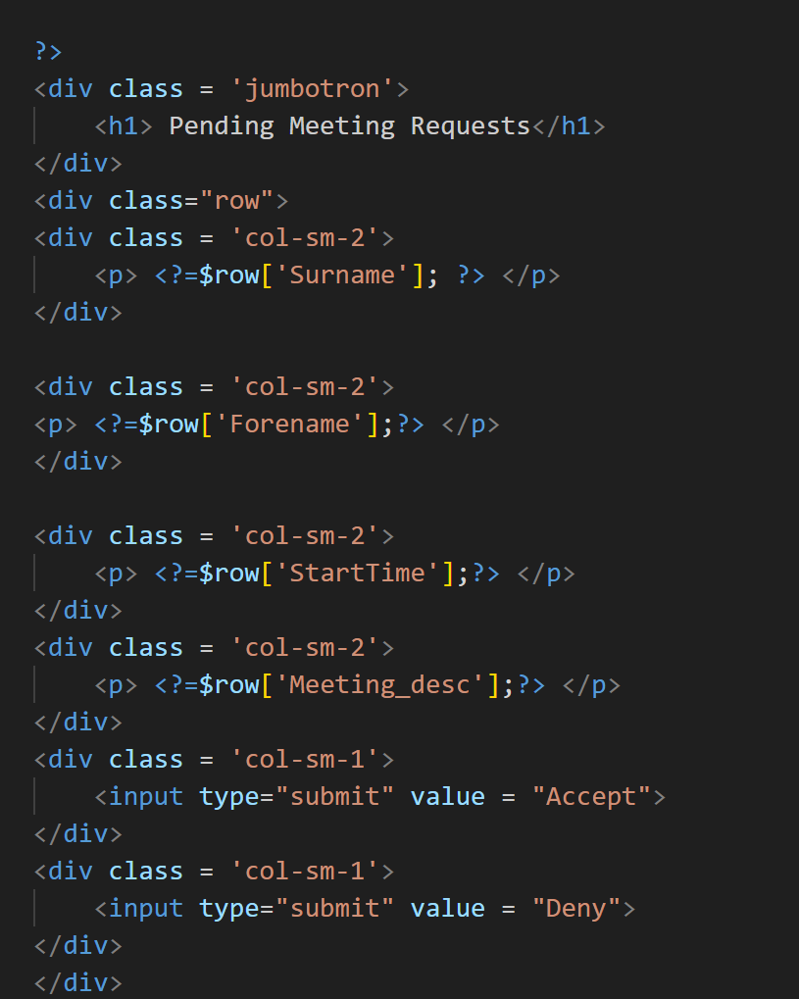

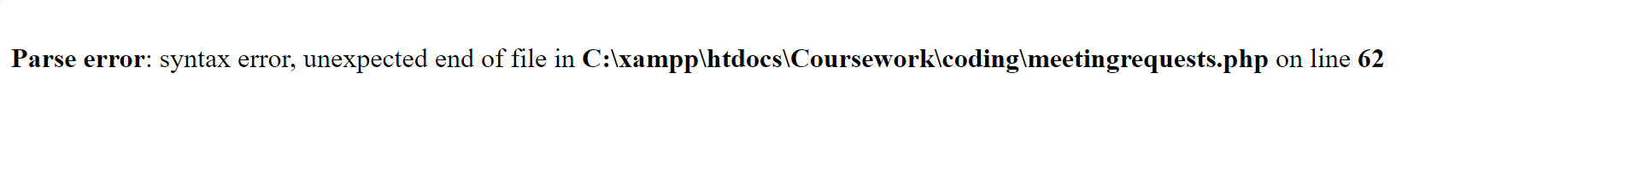However when I ran the code it gave me a parse syntax error saying that there was an unexpected end of file.

I then realised that I needed to add an endforeach in order to close the statement and make the php code ‘FOREACH $ROW IN $ROWS’ run correctly. So after adding it in, I was able to successfully display the pending meeting requests on the page with two buttons of either accepting or denying the meeting.

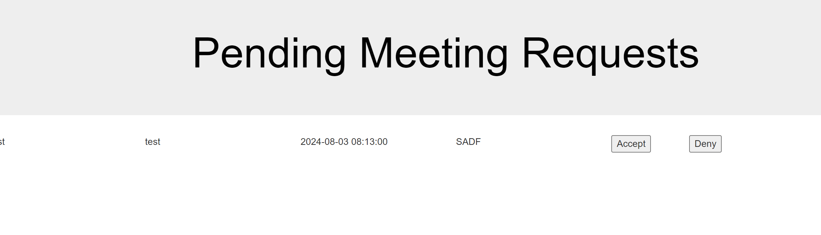

## Creating the Meetingrequestsprocess.php page

When I started to create this page I ran into a problem as I couldn’t figure out how to post the coaches choice of confirming or denying the meeting along with the details of the meeting in order to update the status of the meeting on the meetingrequestsprocess.php page. I then looked over the meetings table and realised that I had forgotten to create a unique identifier column for this table which would make it much harder to submit the meeting into the meetingrequestsprocess.php page.

Therefore, I had to go back and edit the table to create a primary key called MeetingID. I did this via the connection.php page and after I ran the new code, I successfully created a primary key for the meeting page.

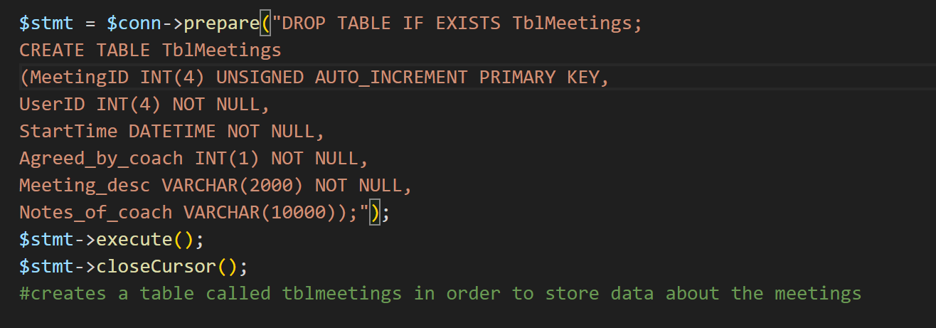

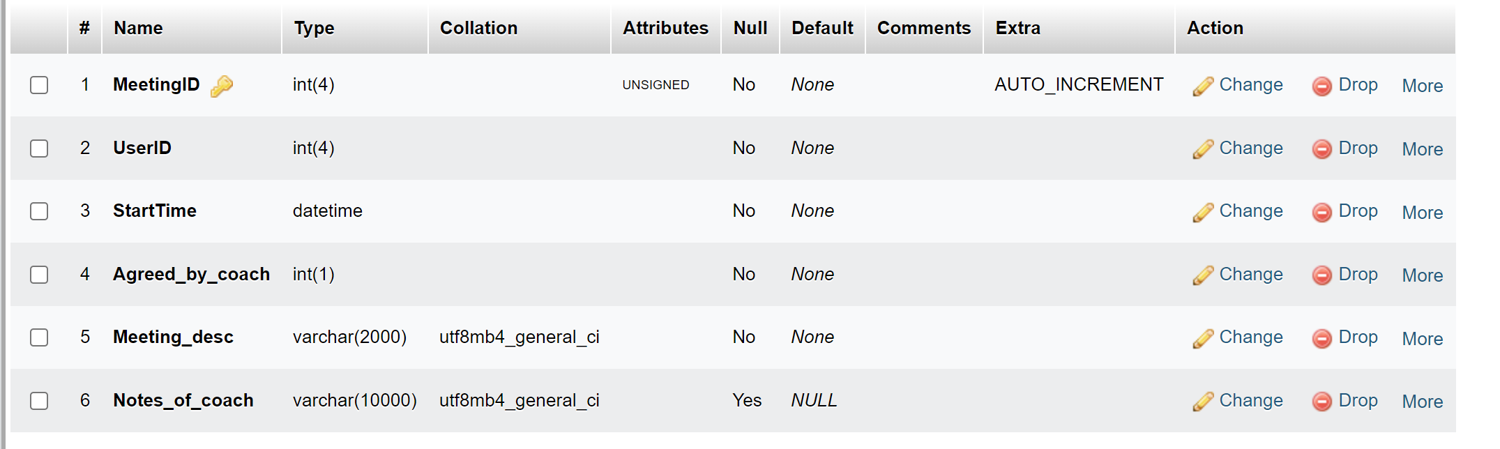

**Correcting meetingrequests.php**

To then post the updated details about the meeting, I needed to first edit the meetingrequests.php page so that the form submitted the newly created MeetingID field into the nest page as well as editing each line to be a separate form for a particular meeting.

First I changed the SQL code so that it now fetched the MeetingID field.

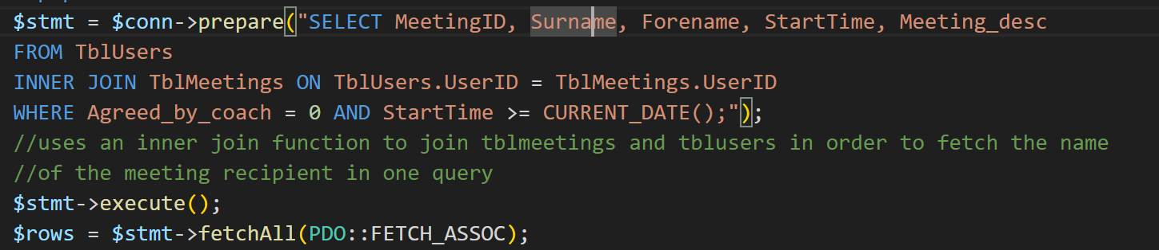

I then placed the form inside the php foreach loop so that each line that represented a meeting was being read as a separate form for a different meeting.

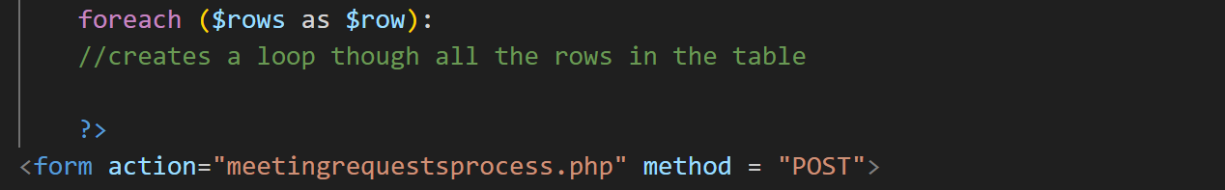

Finally, I created a new hidden input field so that I could submit the MeetingID to the next page automatically without the coach having to do anything on their own.



I also decided to change the input type of either accept or decline from a button to radio in order for the coach to make a clear choice for each meeting and to avoid accidentally submitting the choice by clicking the button. The meeting requests page now looked like this with a radio input field and a confirm button to post the choice to the next page.

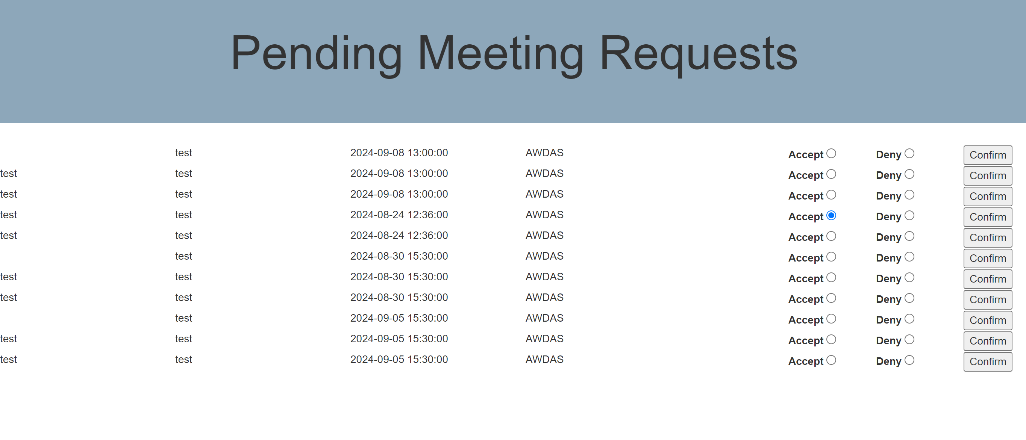

To be sure that the meetingID and other key details were being posted to the next page I used the print_r command to test the posted array. 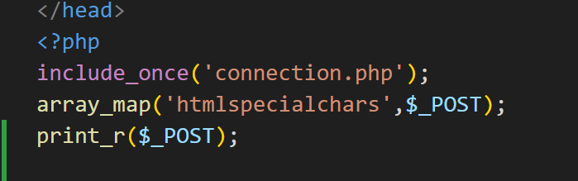

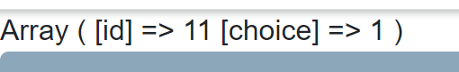

Fortunately all the required data was being posted to the next page so therefore I could now start creating the meetingrequestsprocess.php page.

**Creating meetingrequestsprocess.php**

I intend this page to update the meetings table, in particular, the Agreed_by_coach field to change the 0 to 1 if the coach has accepted the meeting. I also would like it to display a confirmation message for the coach so that they can take a note of it and remember their meeting. I used these two SQL queries which will update the table and fetch needed data for the confirmation message respectively:

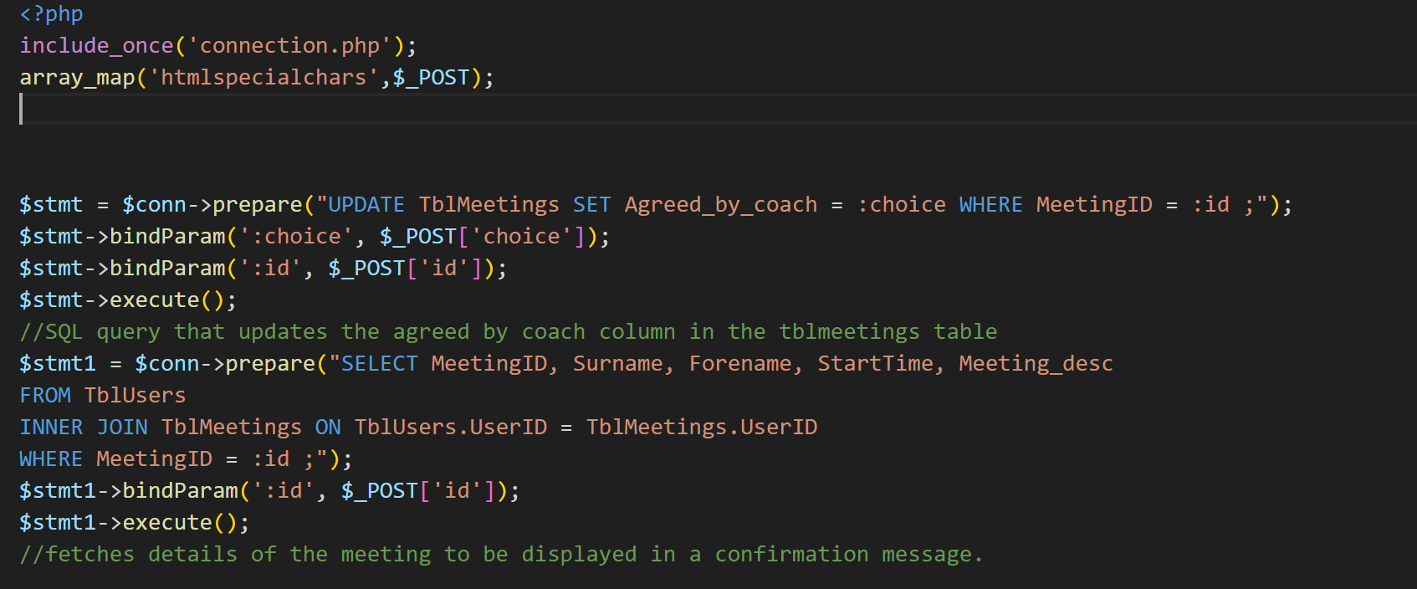

In order to generate a confirmation message I then needed to create a php foreach loop in order to convert the fetched array into separate elements to be displayed in the message. And for the actual message, I displayed it using some simple html so the rest of the code looked like this.

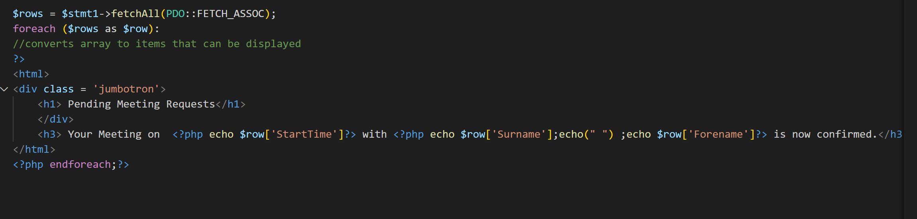

And after I had tested it by confirming one of the meeting requests the code turned out to run successfully.



Reflecting on the meetingrequestsprocess.php page I realised that it was missing one key detail, when looking back at the free times for meetings from the FreeTimes table, the times that were being booked by users were not being deleted from this table. Hence, users can submit meeting requests to time slots that were already taken by other users hence I needed an extra SQL query for my meetingsprocess.php page which would deal with that.

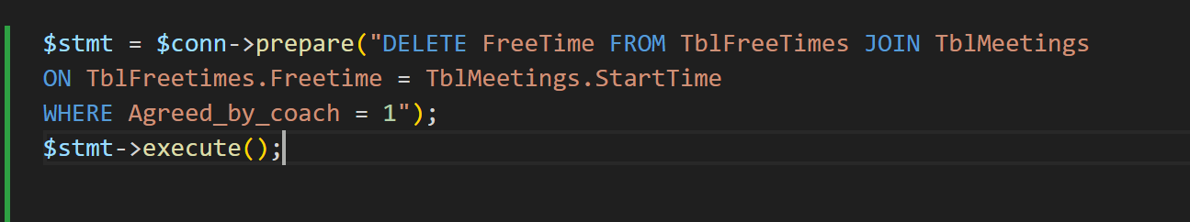

After running the shown SQL query which is supposed to have deleted all the free times that were now taken, the code output an error message which said that this statement was attempting to delete multiple elements in the table which was against the SQL rules.

My solution to this was to use a hidden input in the previous page which would post the particular meeting time to the next page. And secondly, to ensure only the meetings that were accepted by the coach were being deleted from the free times table. Therefore, in addition to using the hidden input, I needed to incorporate an if statement to make my code functional.

This would also consider the possibility of the coach declining the meeting which I have not yet considered.

**The hidden input on previous page:**



**The if …else statement:**

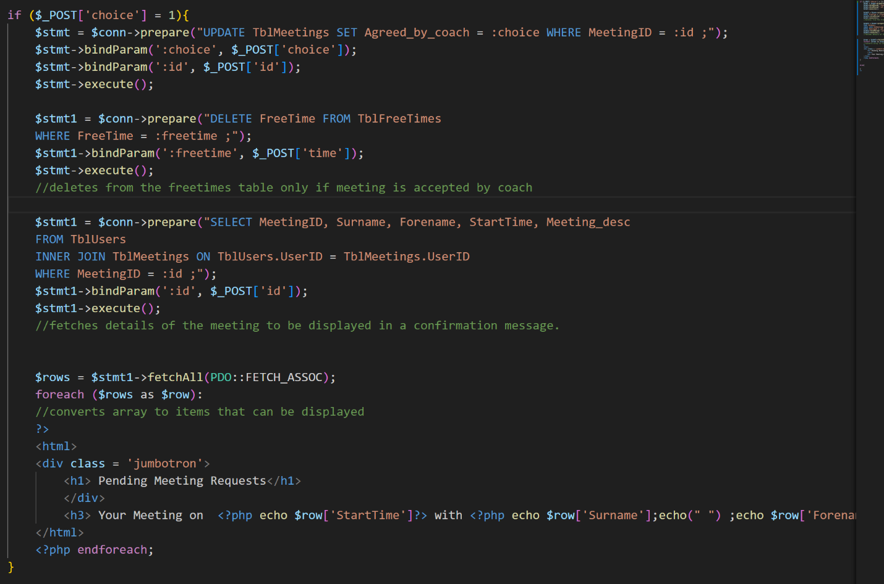

Now the confirmed meeting time was successfully being deleted from the freetimes table if the coach accepted the meeting. Now all that I had left was to write the else clause to consider the situation in which the coach would decline the meeting.

For the else clause I simply needed to delete the entire meeting request from the meetings table so that it didn’t show up on the meeting requests page again, which could easily be done with one SQL statement.

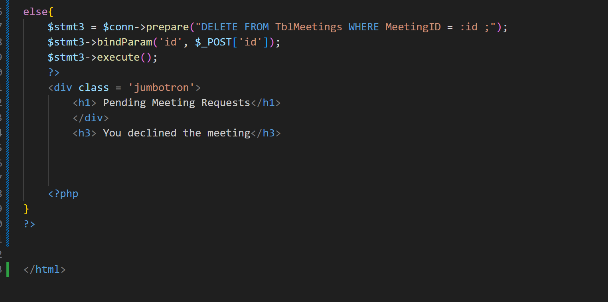

And when I tried to decline a meeting request, the if else statement worked perfectly.

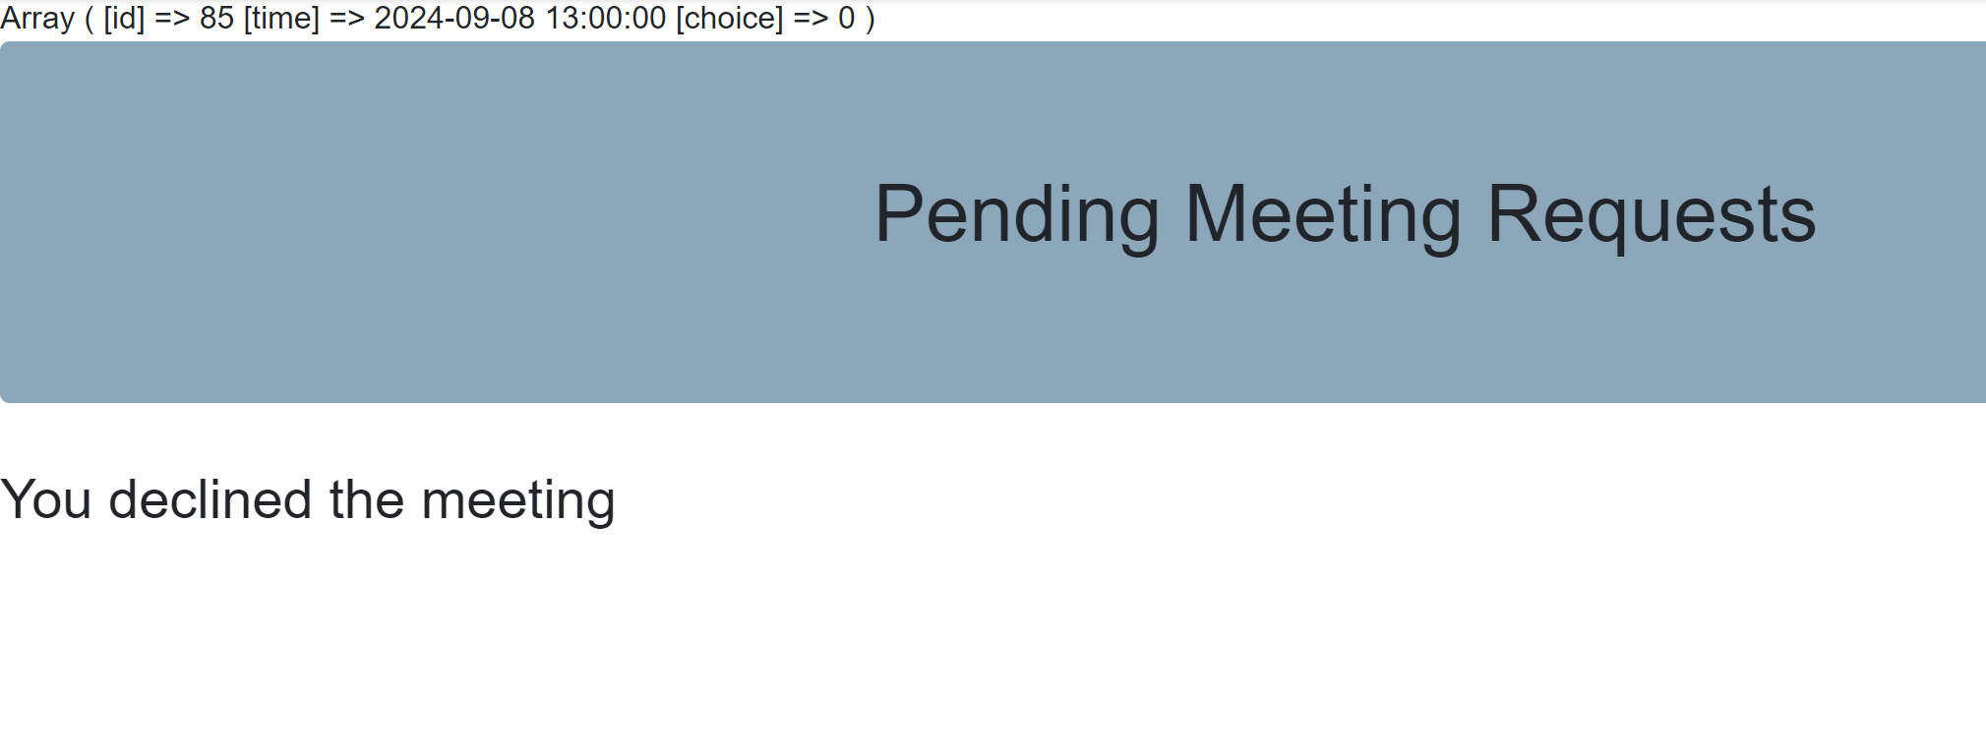

## Creating the usermeetings.php page

The aim is for the user meetings page to display the date and time of the user’s meetings in a neat way which is easy to read and easy for the user to identify their upcoming meetings. I will make the usermeetings.php page display the users’ meetings in the form of a calendar.

Therefore, as I had no knowledge of how to construct a calendar using php I searched for some templates on GitHub and found one that was easy to understand and did a very similar job to what I wanted mine to do. The GitHub reference for this calendar template is [emis2/calendar.php at master · strc12/emis2 · GitHub](https://github.com/strc12/emis2/blob/master/calendar.php#L170).

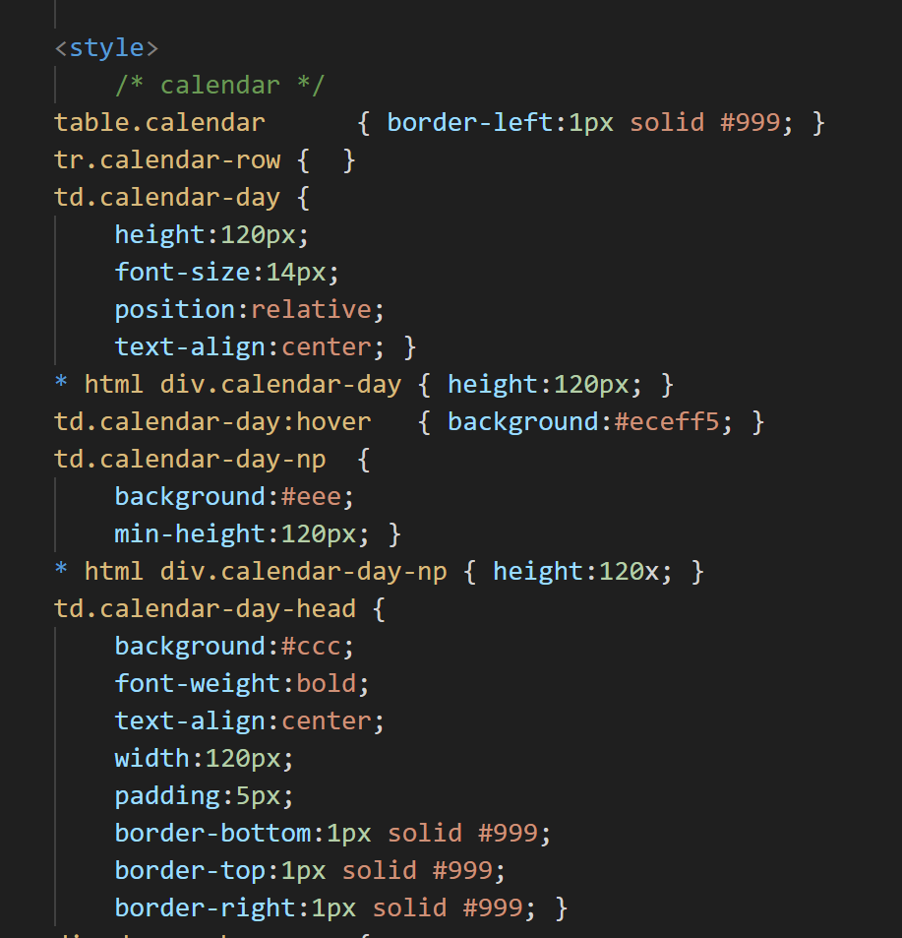

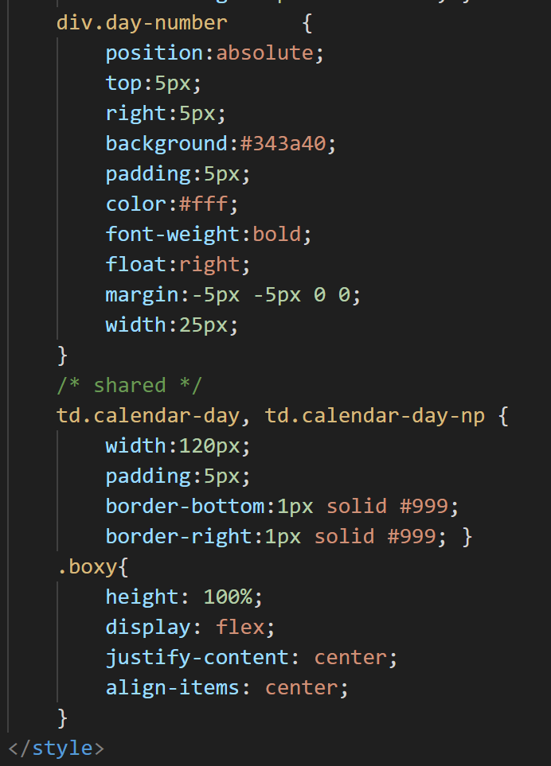

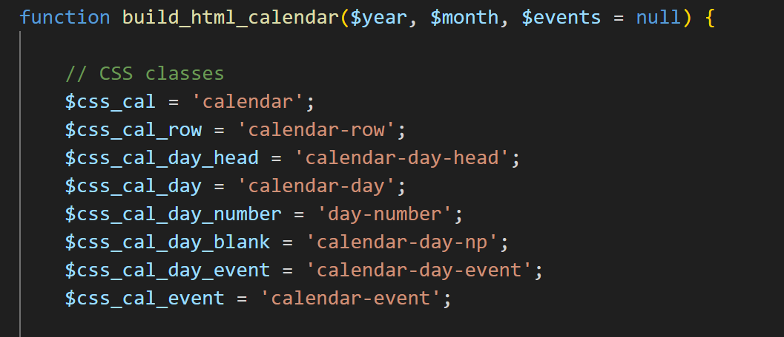

I then started to build the calendar using the HTML table features.

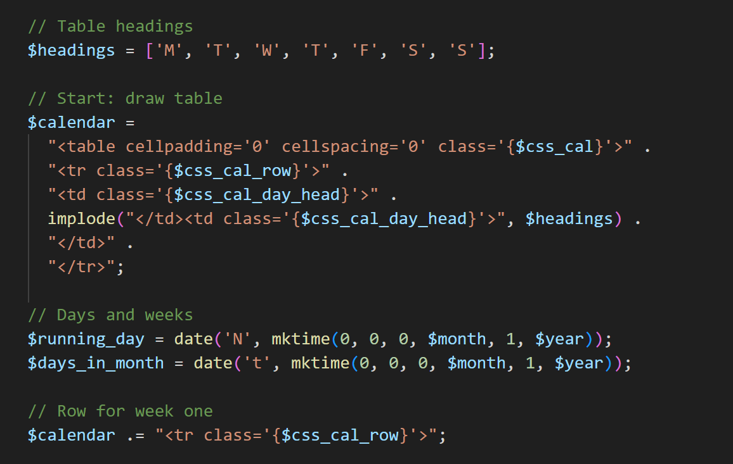

This code outlines the table headings which stand for the days of the week represented in an array called headings as well as the variable calendar which outlines the rows and the column headings.

$running-day represents the first day of a given month which is calculated using the mktime() function inside the date function which will give a numerical representation of the day of the week. Using the date function again we can get the number of days in a month using the ‘t’ format.

$calendar variable is further updated to generate the row for the first week.

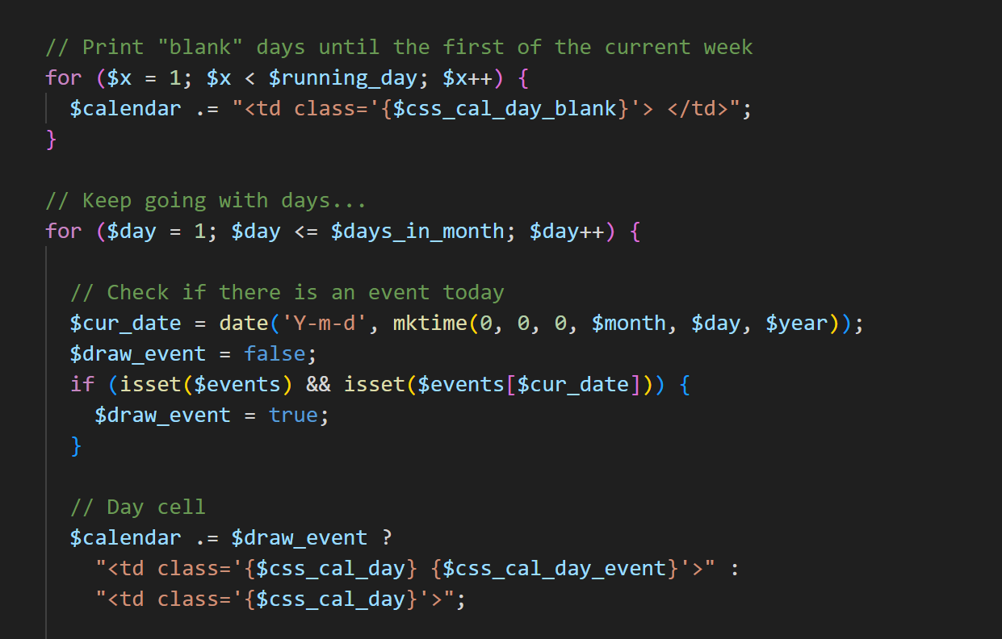

The first for loop here is used to populate the calendar with blank spaces before the first day of the given month. This is useful in the case of the first day of the month not being a Monday. The next for loop will iterate until the current day exceeds the number of days in the month.

The if statement inside the for loop will check if there are any events and if there are any events on the current date. If so it marks the $draw_event variable as true. The next piece of code creates the table cells for when there is an event.

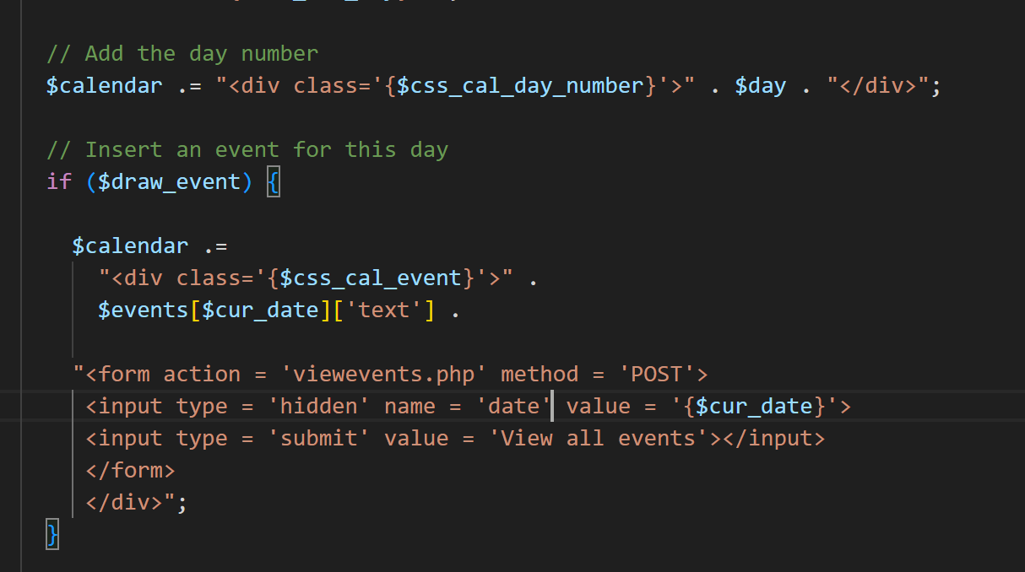

The day numbers are then also added to the calendar. The next if statement shows how $calendar needs to be updated if there is an event on that day. Here I created a form for each day during which there is an event to view all of the events during that day. The form will pass the variable current date so that on the next page, viewevents.php, all the meeting times on that date can be fetched from the database and be displayed in full detail to the user.

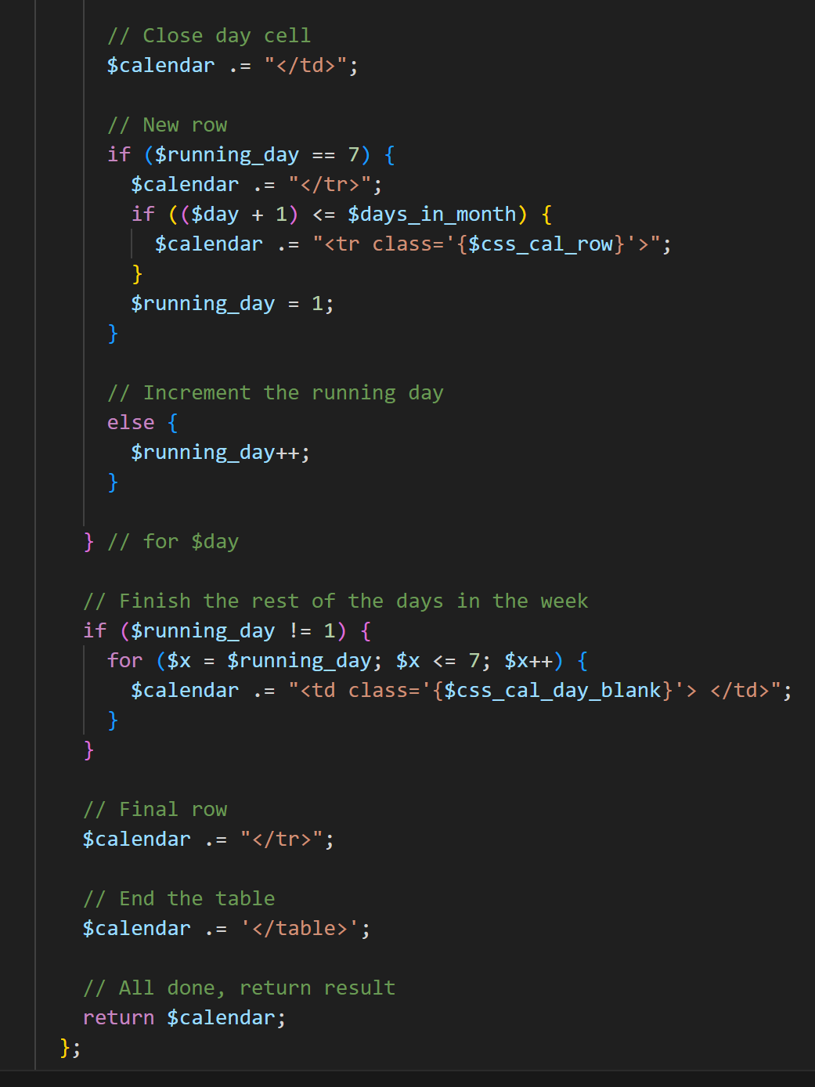

Next, the if statement will check if the current day is the 7th day of the week and if so, it will create a new row and reset the day to be the first day of the week else, the days are incremented until they reach the 7th day of the week. The rest of the days are then filled in using a for loop and at the end the calendar variable is called.

Next, I needed to fetch the meetings for the particular user that is logged in for them to be displayed in the calendar.

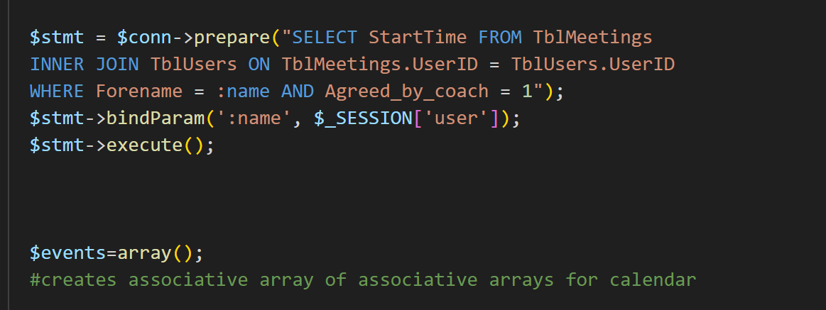

The array events will later be passed onto the function build calendar.

Next I had to separate the dates that were fetched into separate date and time variables and then using an if statement I needed to populate the $events array with the date and time of the meeting. Here the if statement checks if there is an array index in $events that matches the date fetched from the database. Then, it will populate the array with the time and pass it into the build calendar function.

The for loop makes the calendar iterate for the next 3 months and finally the HTML is set up to display the calendar. After running the code, the calendar was working however was not displaying the meetings properly.

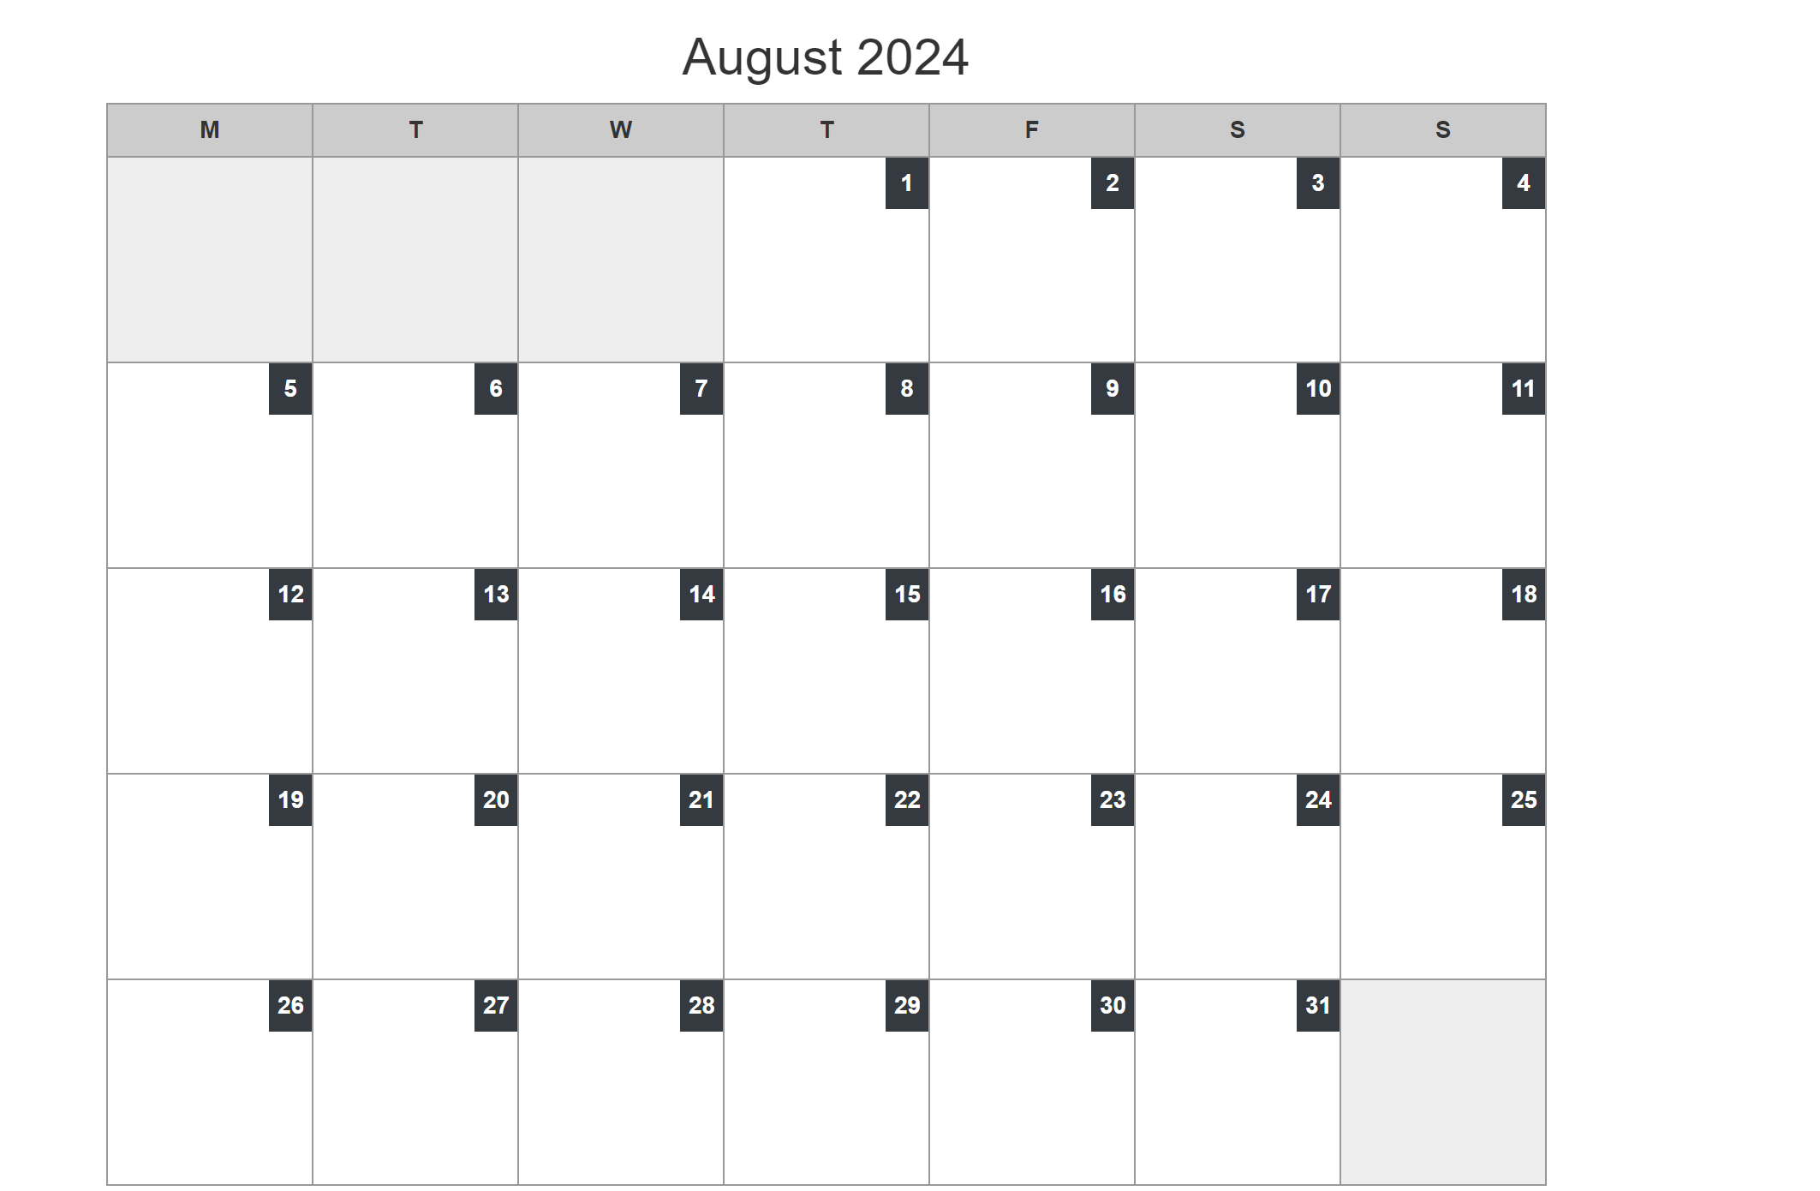

I looked back at the code to check for any errors and have found that the date was being passed in the wrong format which didn’t match the date format in the database. Hence checking for an index in the $events array would not be possible. Therefore I tried to change the formatting of the date to

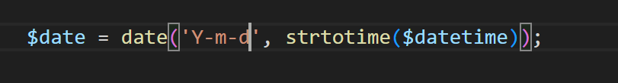

And after running the code again the meeting times were being displayed on the correct days.

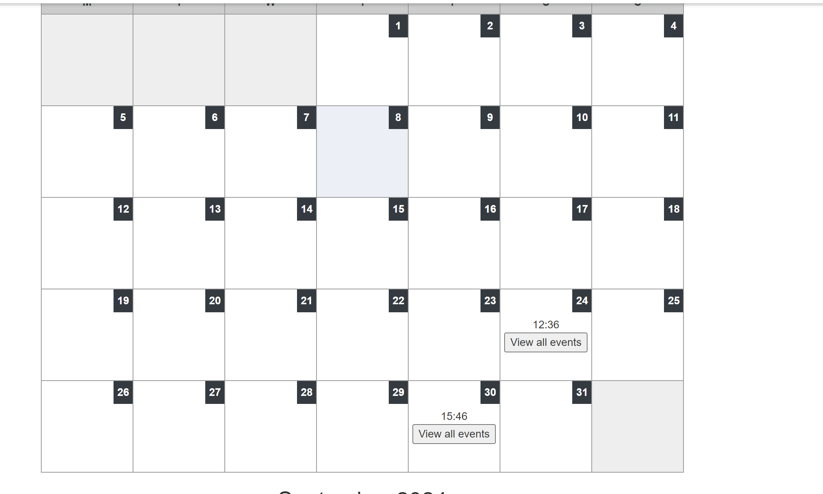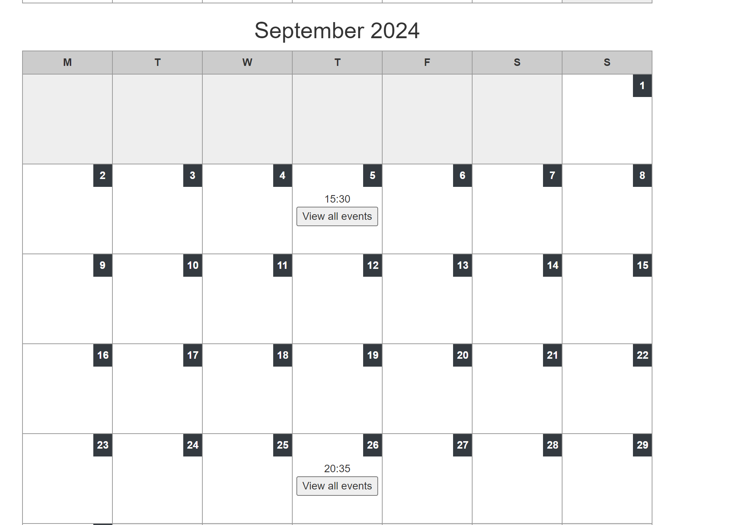

Redirects the user to viewevents.php

## Creating viewevents.php

Viewevents.php will be a page which will show all of the meeting times of the user on a particular date. First using the print_r in php I needed to check if the correct date was being posted into the viewevents.php page. And after running print_r($_POST), the correct date was being posted.

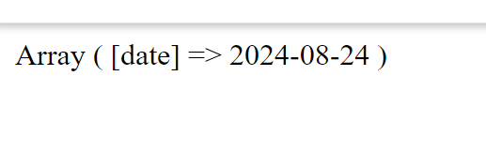

I now needed to fetch from the database all of the meeting times of the user and after that, I needed to compare each StartTime value to the posted date in order to then find the times of the meetings during that day. 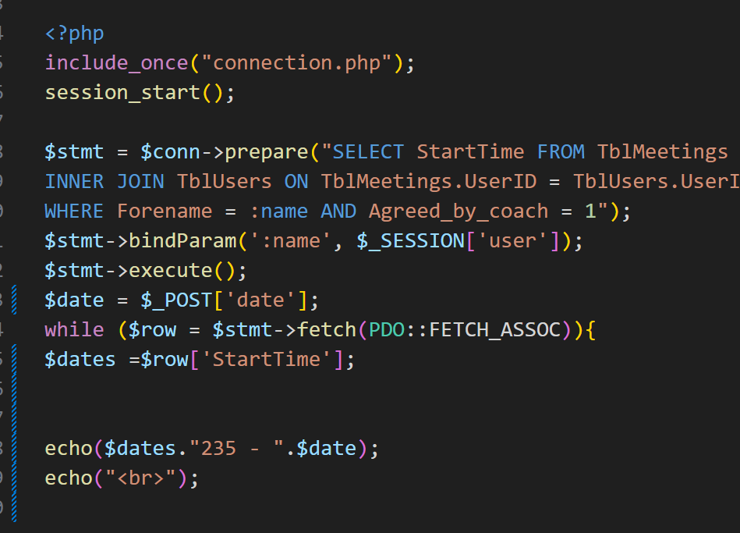

After running the following code to print all of the posted dates, I got a string output of all of the dates and times of the meetings that this particular user had.

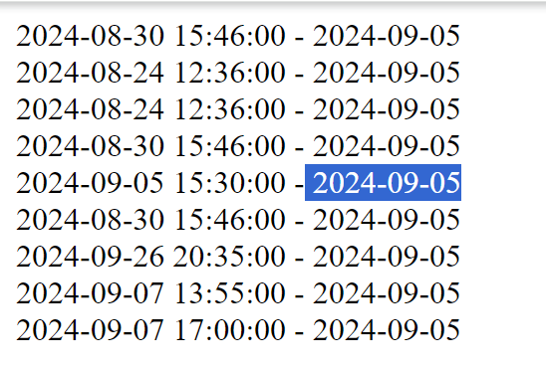

However, to find all of the times on that particular date I would need to search through each date and then find a way to print the adjacent time. In order to achieve this, I will first need to split up this string into an array of lines using the explode function in php.

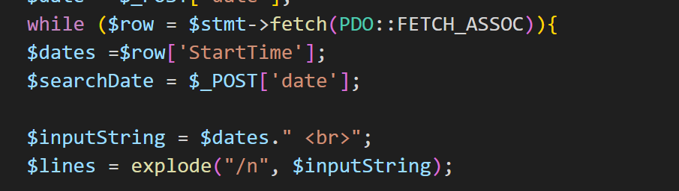

Here I also defined the $searchDate variable as the posted date that needs to be found as well as the $inputString as the $dates string but split up into separate lines.

The array $lines, is the array of dates as mentioned above.

Next, I needed to write a loop which searched through each line until a matching date was found. And if found it would extract the time from that array.

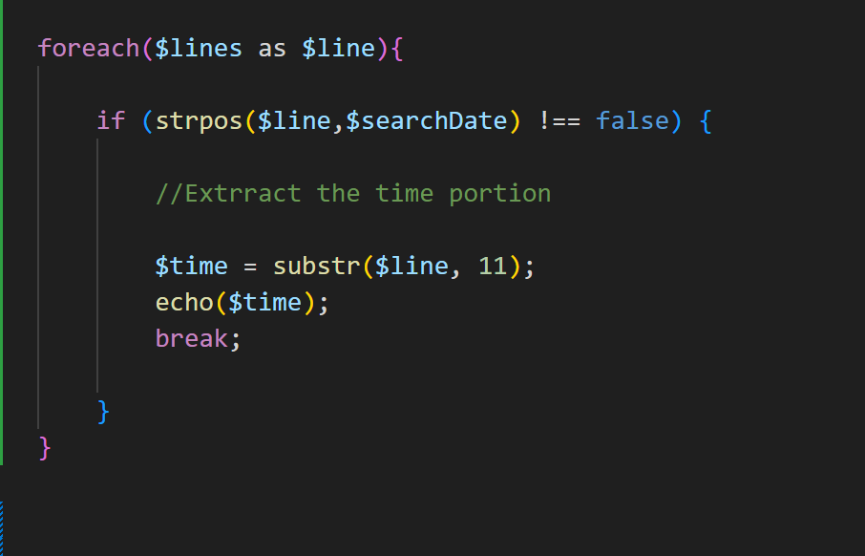

And after running this code to by clicking on one of the events in the usermeetings page, the correct time were being found even if there were more than one meeting on that particular day.

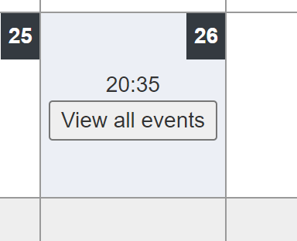

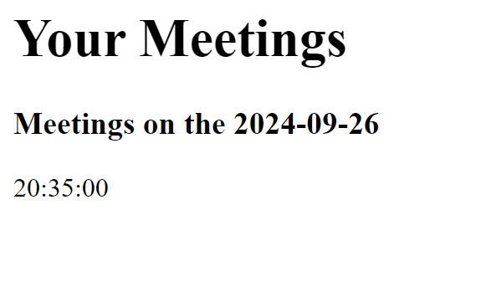

**Example with a day with two or more meetings:**

FinFinFI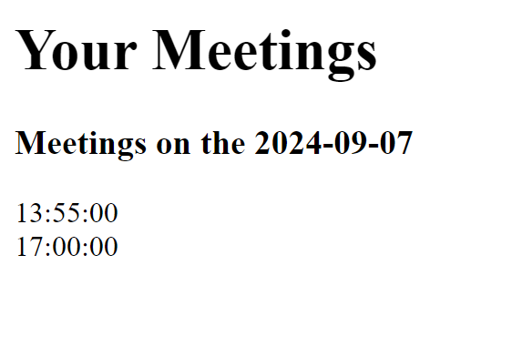

Finally to improve the formatting of the displayed message I changed the date format into words. 

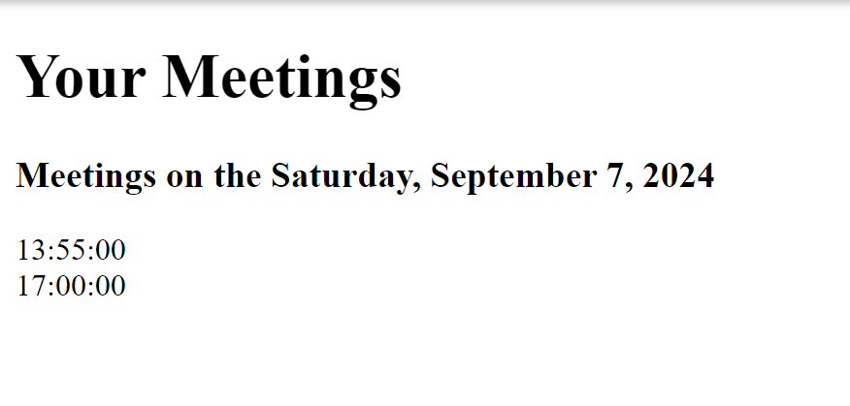

## Creating coachmeetings.php

The coach meeting page format will be the same as the usermeetings.php as it will also display their meetings for the next 3 months. However, the difference will be that the SQL statement will fetch all the meetings from the TblMeetings table as all of them are applicable to the coach. Therefore, all that I had to do when creating this page was to edit the SQL statement to select all the accepted meetings. Therefore I copied and pasted the entire code that was used on the usermeetings.php page and I changed the SQL statement from this:

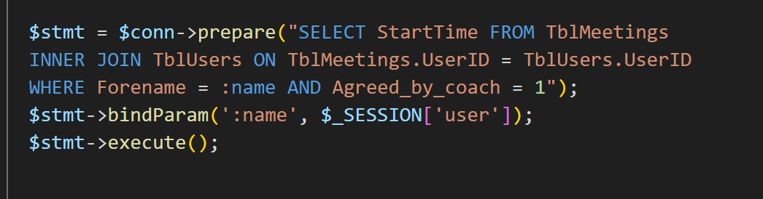

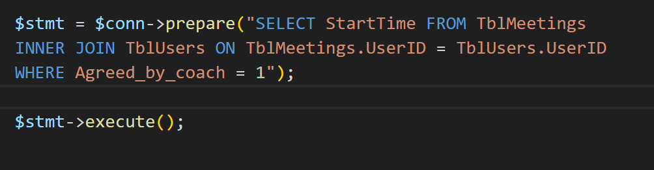To the following:

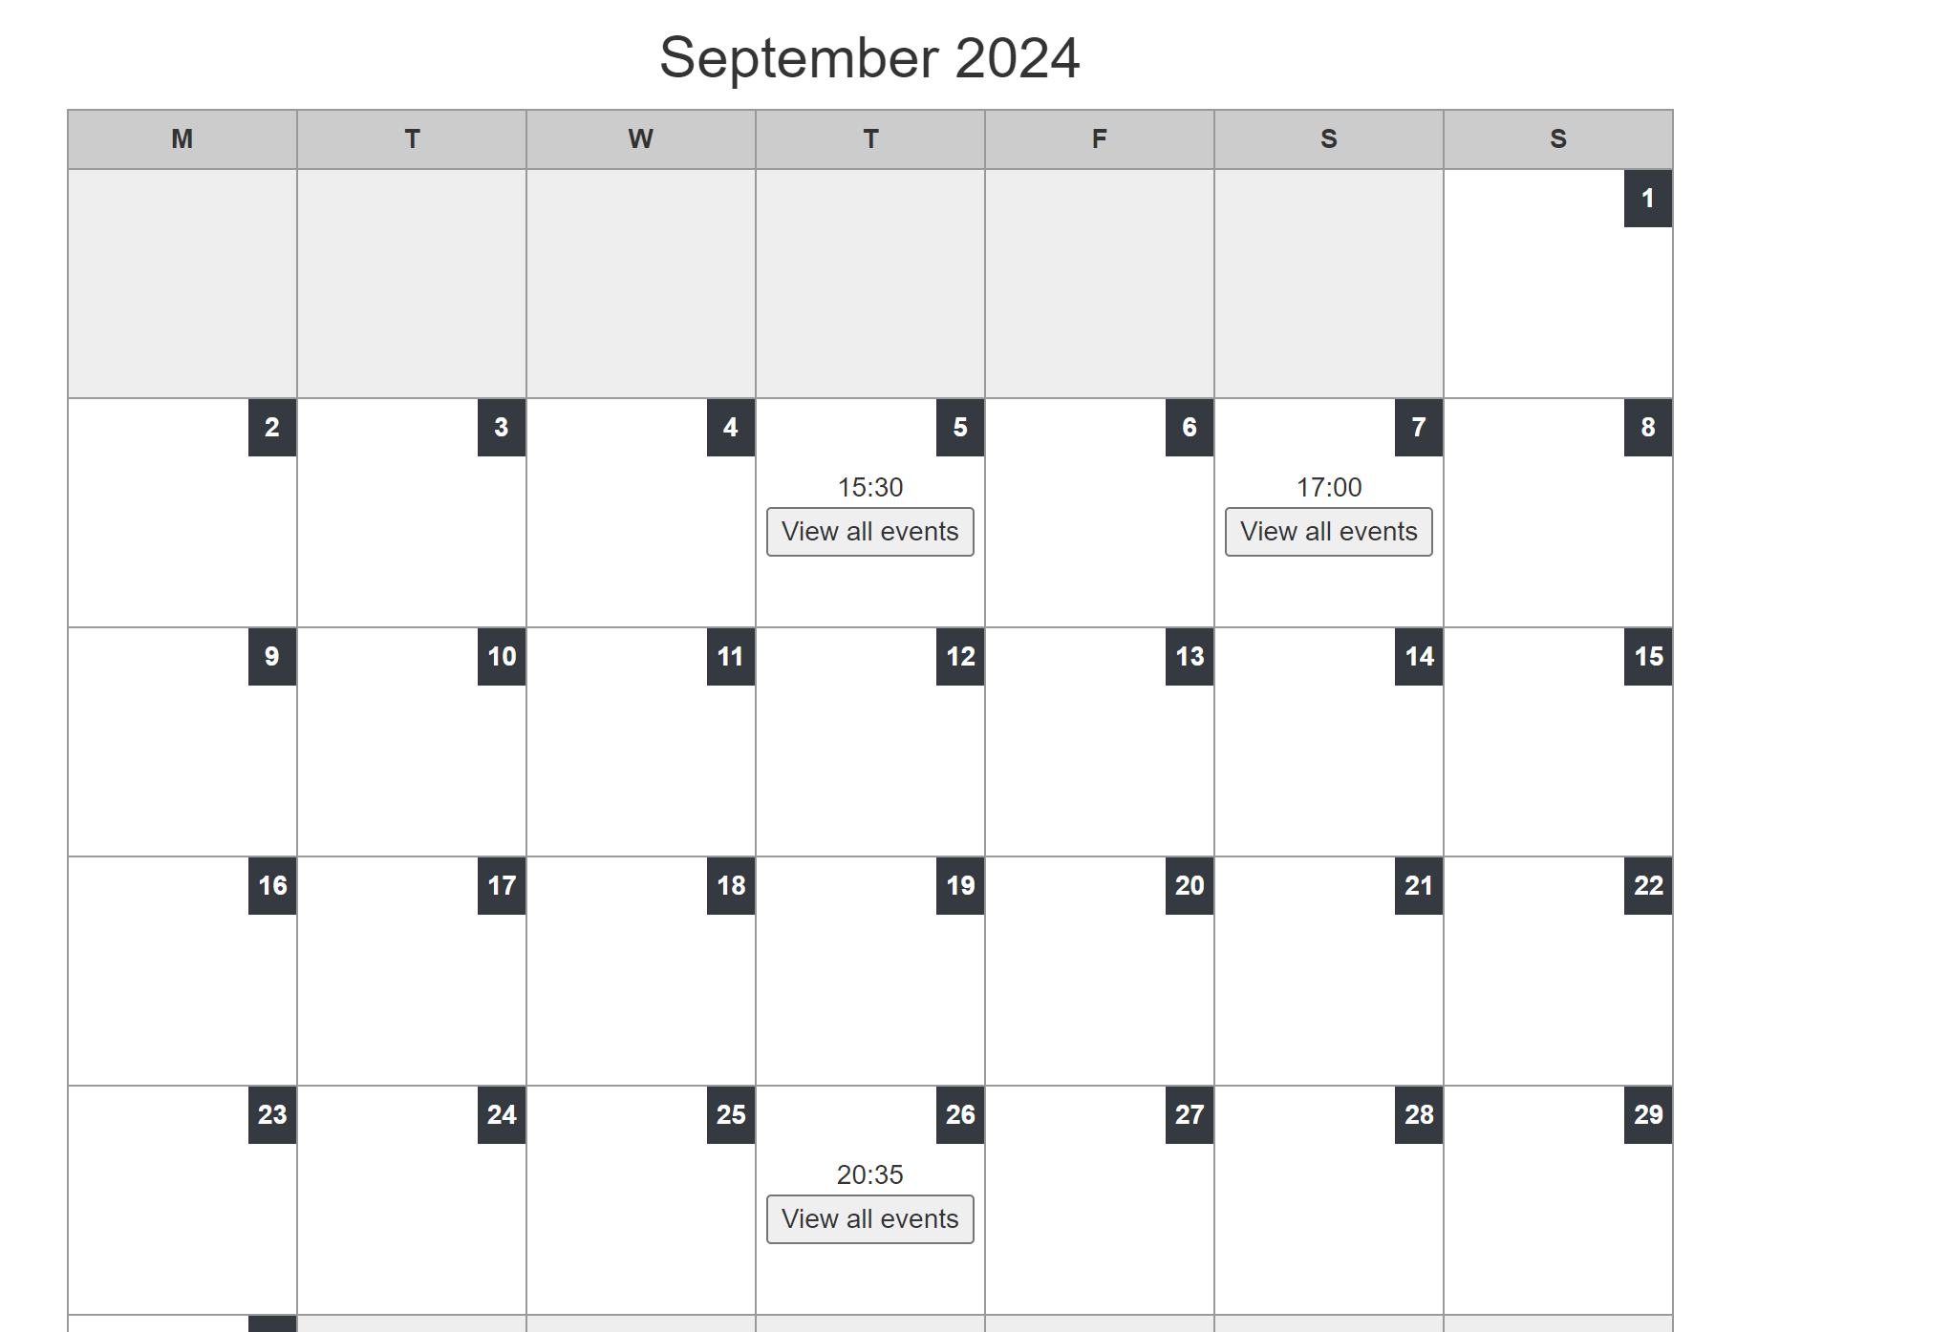And after running the code the calendar was displaying all of the coach’s meetings as required.

However I realised that the coach also needed a way to see who the meeting was with therefore I decided to change the calendar slightly so that the names of the meeting recipients were displayed along with the time of the meeting.

Therefore I further updated the SQl query to the following.

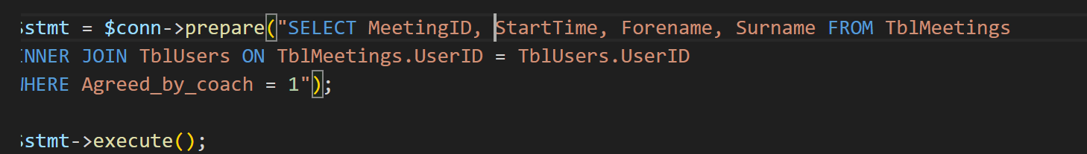

In order for the name of the recipient to also be displayed on the calendar I needed to change a few lines code in the calendar, in particular the code that updated the $events array so that it can store the full name of the recipient.

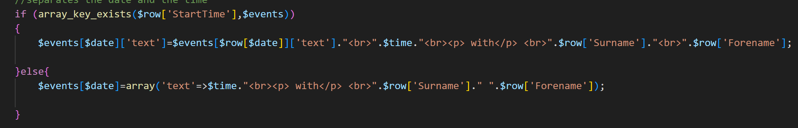

After running the code, the meeting calendar looked like this:

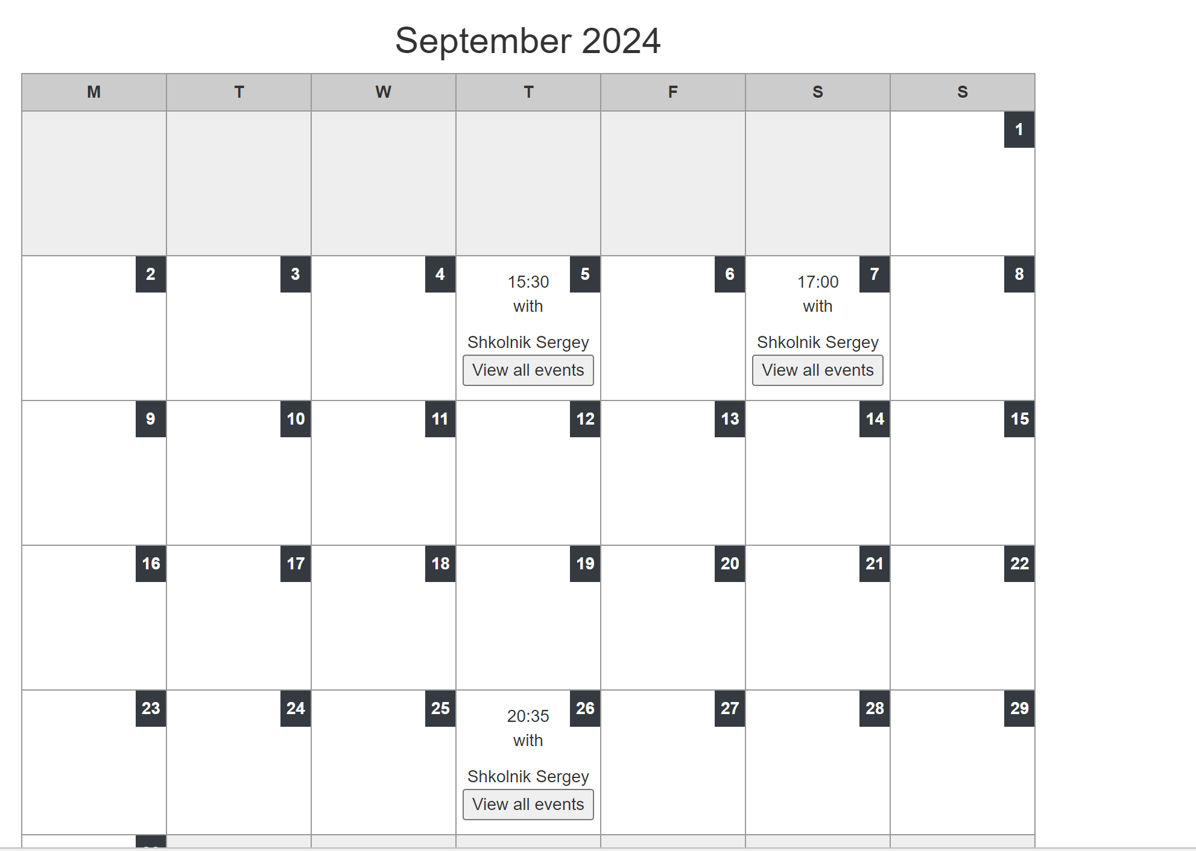



However, I now needed to update the viewevents.php page as I now needed it to display the names of the recipients of the meetings as well as the description of their particular meetings. However, as this is only applicable to the coach’s page, I decided to create an entirely new page for this called viewcoachmeetings.php.

## Creating viewcoachmeetings.php

Viewcoachmeetings.php will have the same function as viewmeetings.php as it will be the page which the coach will be directed to after choosing to view their meetings on a particular day. Therefore, it must display the details of the meeting including the surname and forename of the recipient as well as the description of the meeting. The formatting needs to be organised because if the coach has many meetings on a particular day, all this data must be displayed in a neat and easy to read format.

Firstly I need to write an SQL statement which fetches all the required details i.e. Surname, Forename Meeting time and meeting description. And then I would need to find the data that matches the posted date, just like in the previous page, after which I need to display the meeting data.

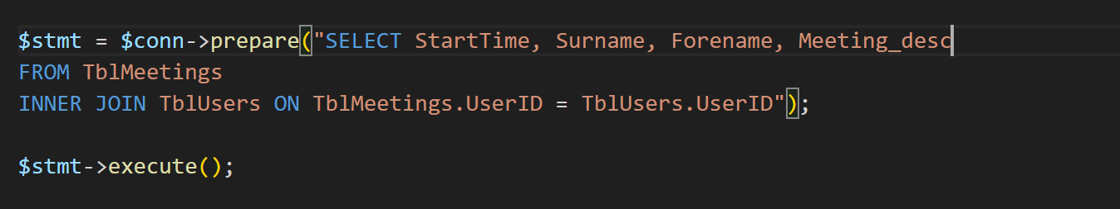

Using the above SQL statement I managed to extract a long string of data about all of the meetings which looked like this when I ran the code.

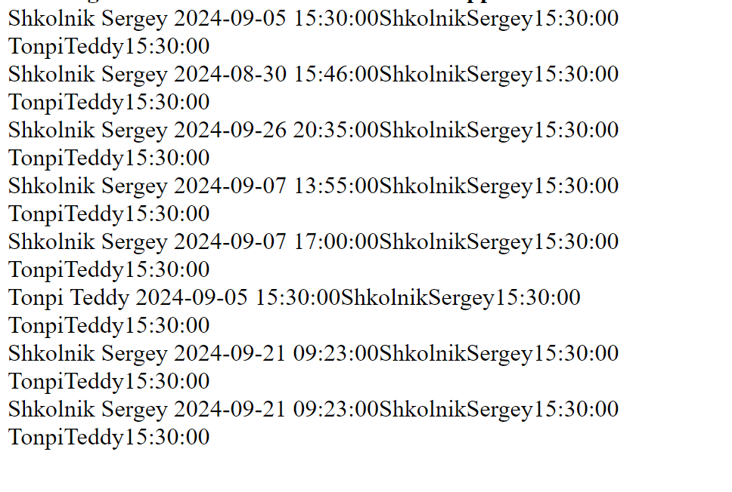

Clearly, as this is a very complicated string with no clear division, it would be quite challenging and time consuming to write code to split it up and extract the data from a particular date. Therefore, I needed to find a different solution on how to extract the required data.

To resolve this problem, I decided to use two SQL queries. As I already knew how to extract the correct time from a particular date, I decided to use this already written code that was used in the previous page, viewevents.php. However, before this, I needed to change my initial SQL statement to the following, so that it only extracts the start time of the meeting.

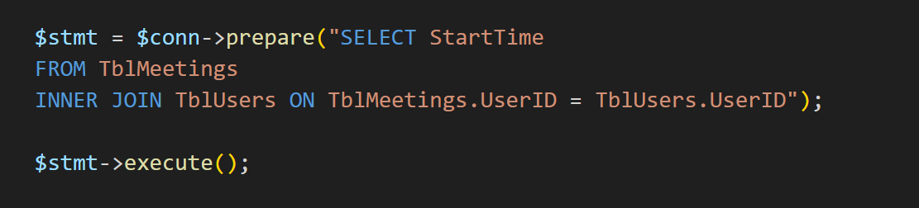

Next, I used the code from viewevents.php:

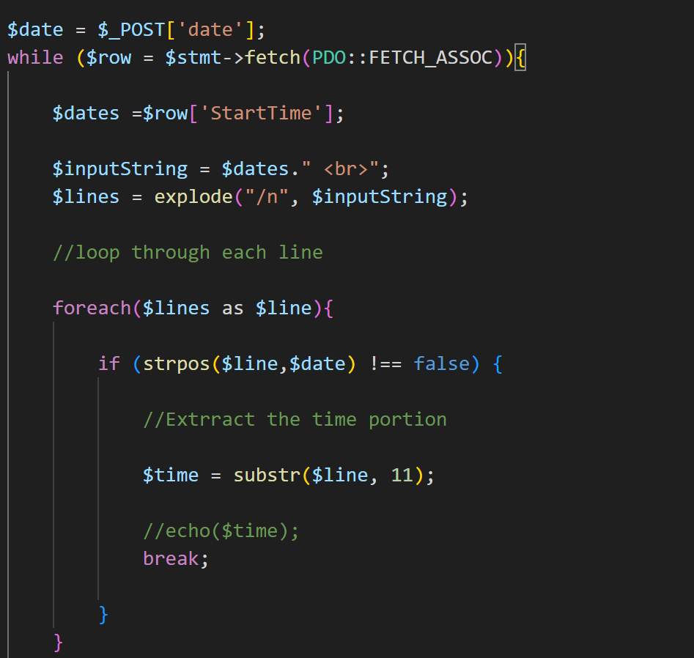

The above code is used to output the time of the meeting on a selected day where the input string of dates and times is exploded into different arrays. Then the for loop checks through each line and if a match is detected with the posted date the time adjacent to the date is outputted. Since I now have the time and the date of the meeting, I now have the DATE/TIME variable, equivalent to the one stored in the database.

Therefore, I can now use it to search the database and output all of the required meeting details. Therefore, I created a new variable called $fulldate to store the date and time in the format equivalent to the one in the database. And I also wrote the SQL query which will get all the relevant detail of the meeting.

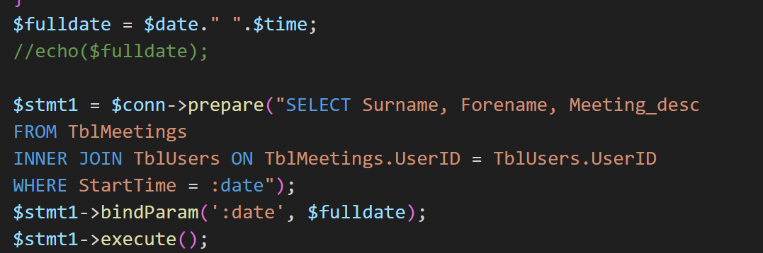

**Outputting the data**

To output all the data about the meetings I needed to get the data from the database as an associative array and then assign each of the types of data i.e. surname forename and description separate variables. After that I needed some kind of message to output all of this data.

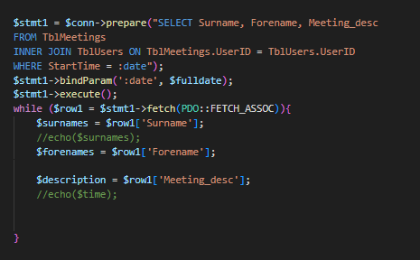

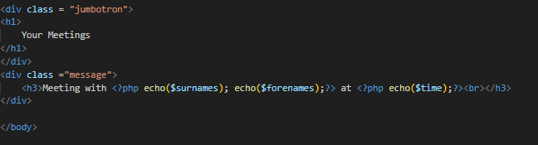

After running the code above, it seemed to be working for days that only have one meeting in them.

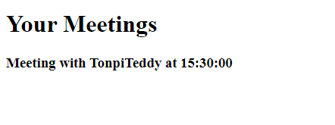

However, when I tried to click on a day which had two meetings in it, there was a problem as only one of the meetings was showing.



Here, there are two meetings on the 21st of September however when I click on this day in the calendar only one of them is being shown.

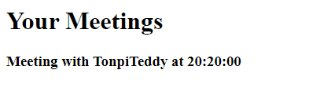

After looking back over my code, I realised that by defining the $fulldate variable I was limiting the SQL query to only fetching one data item with the exact DATE/TIME value as the $fulldate variable. Therefore I needed another way to get all of the data and compare the date value in each row.

**Correcting viewcoachmeetings.php**

I started by fetching everything from the TblMeetings table to have all of the data ready in advance.

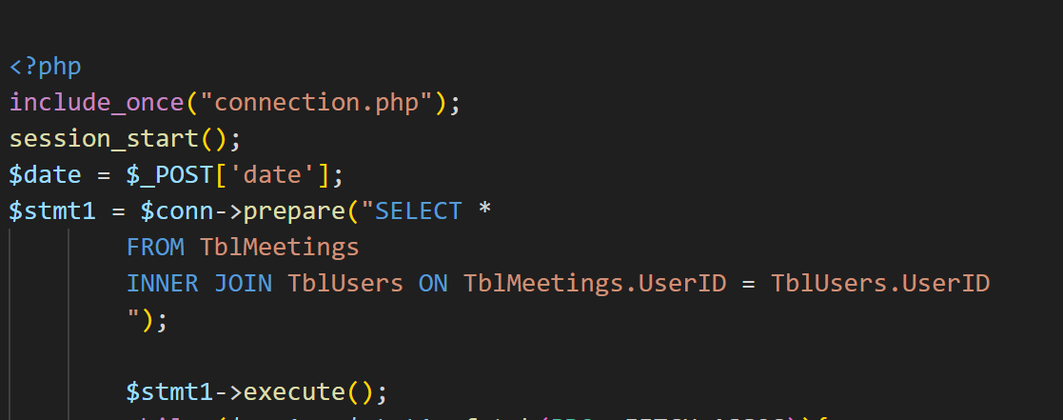

I now needed to check each $row[‘StartTime’] for the presence of the date posted from the previous page. To do that I needed to create a loop that checks each of the $row values and outputs the related data if the $date value is present within the string.

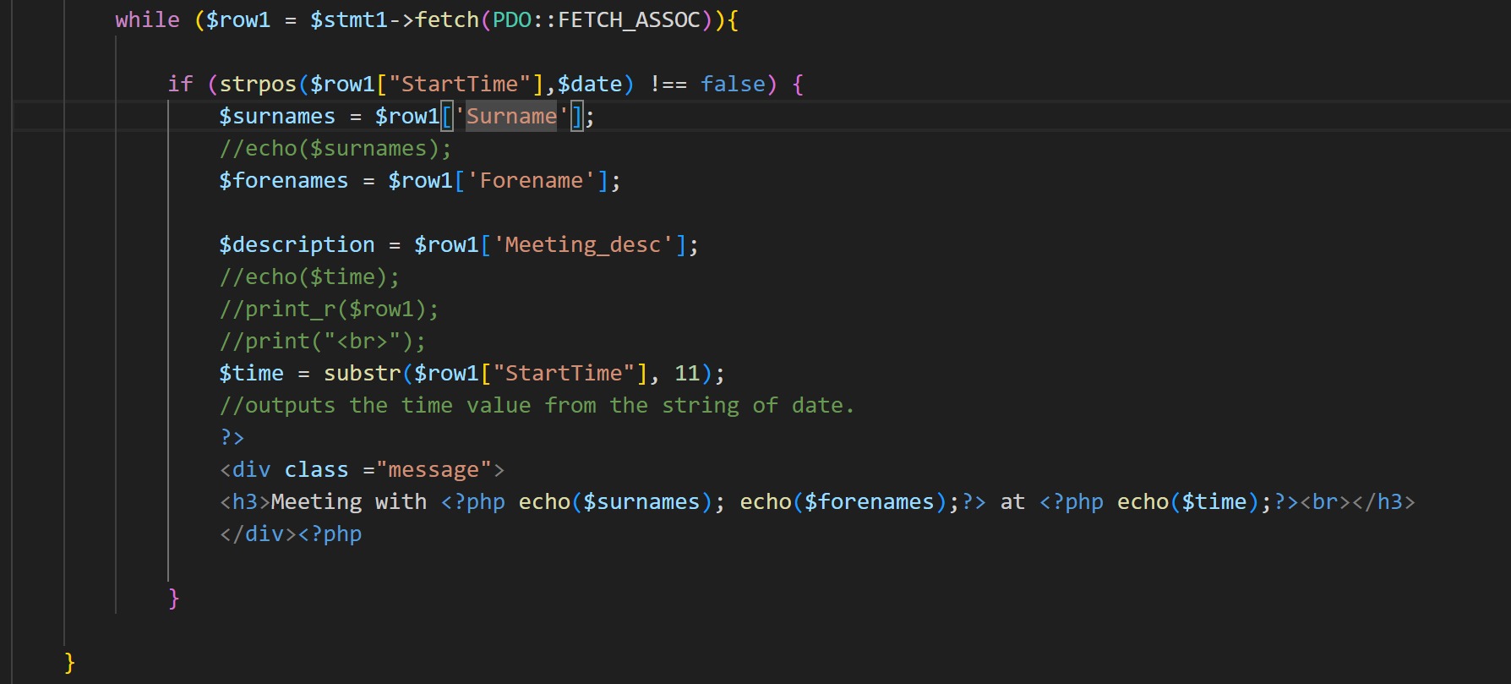

Here, the while loop will loop through each row and the if statement checks the presence of the date variable inside the $row1[‘StartTime’] string. If it is present, the name, forename and the meeting descriptions will be returned to the program.

Finally the output message will inform the coach about the full details of all of the meetings on that particular day. After trying this code, all of the relevant information about the meetings on that particular day were being outputted.



## Creating a chat system

I decided to create a messaging system which will be similar to the emailing system and every time a user will log in they will be able to view their messages or send a new message to the coach.

**Creating sendmessage.php**

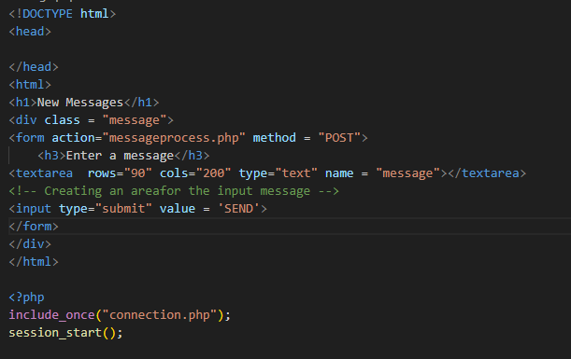

This code will give the basic template for sending a message. Here, I used the <textarea> tag to provide a lot of space for the user to enter a message in case it is very long.





## Creating messageprocess.php

While thinking about how to store the message and looking over the TblChats table, I realized that I needed to pass a UserID into the database. However, now I did not have a userID as a session variable which could be used in the code. Therefore I looked back over the login pages and understood that logging in using just a name would make fetching a unique session variable impossible if two users with the same name exist. Therefore, to resolve the error I needed to change my tables and create a unique username for logging in.

By changing the install.php page I added an extra row called Username:

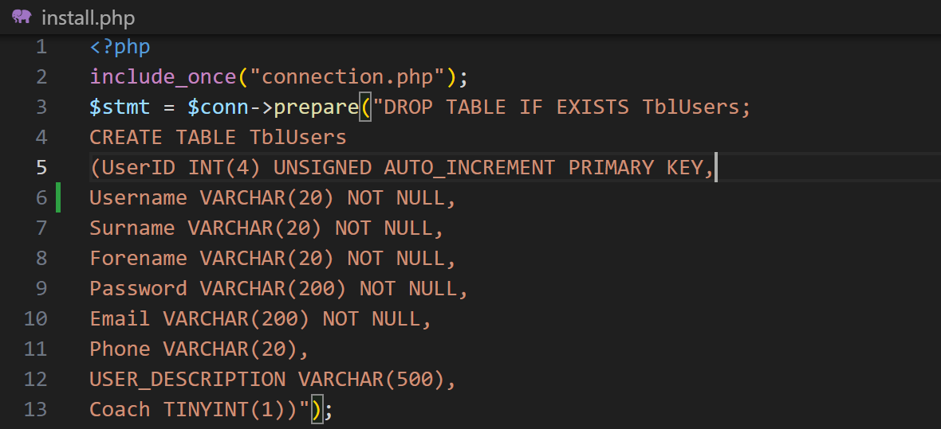

After running the install.php page the table has been updated to have a username row.

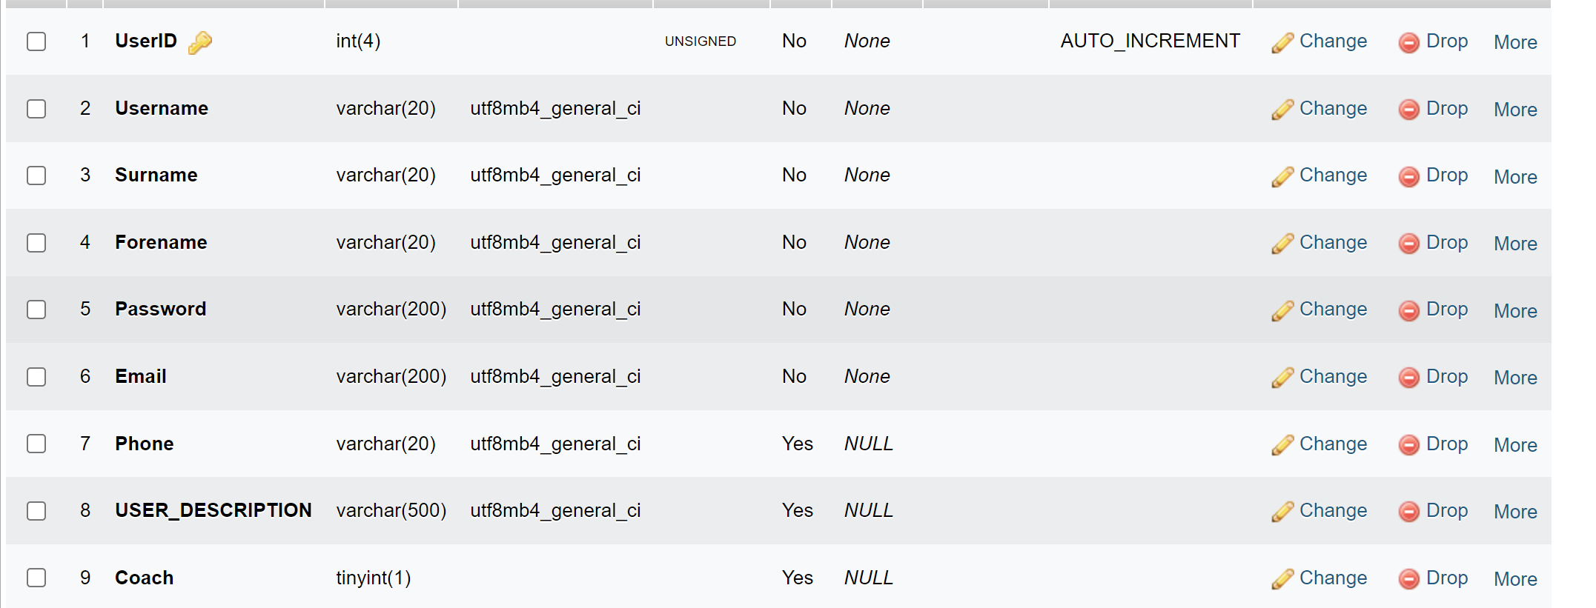

Now I needed to update the sign up and the log in pages so that they also requested a username. I also needed a way to make sure that the username was unique which would involve an if statement in the addusers.php page.

**Changing the signup.php code:**



**Changing the addusers.php code:**

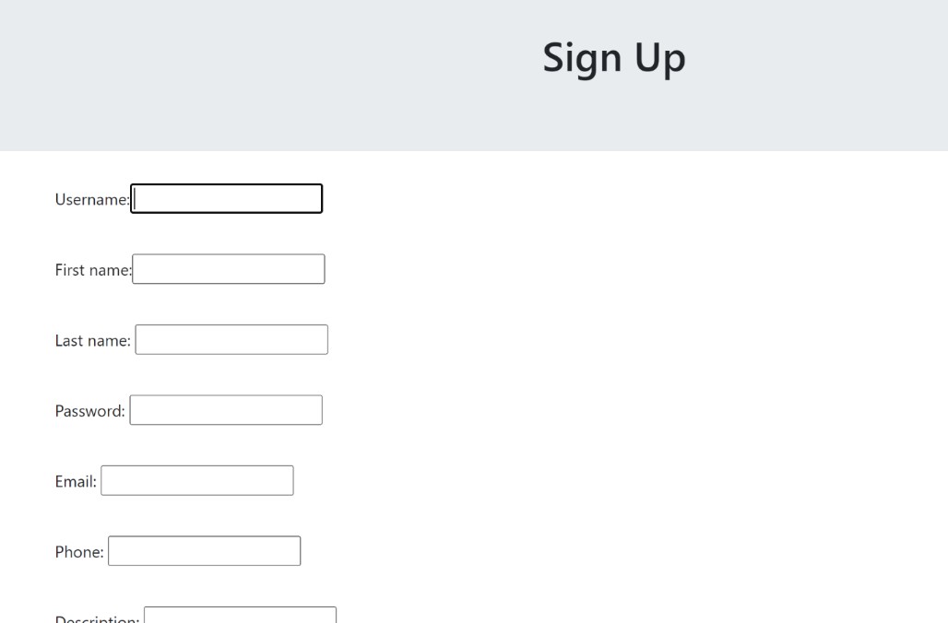

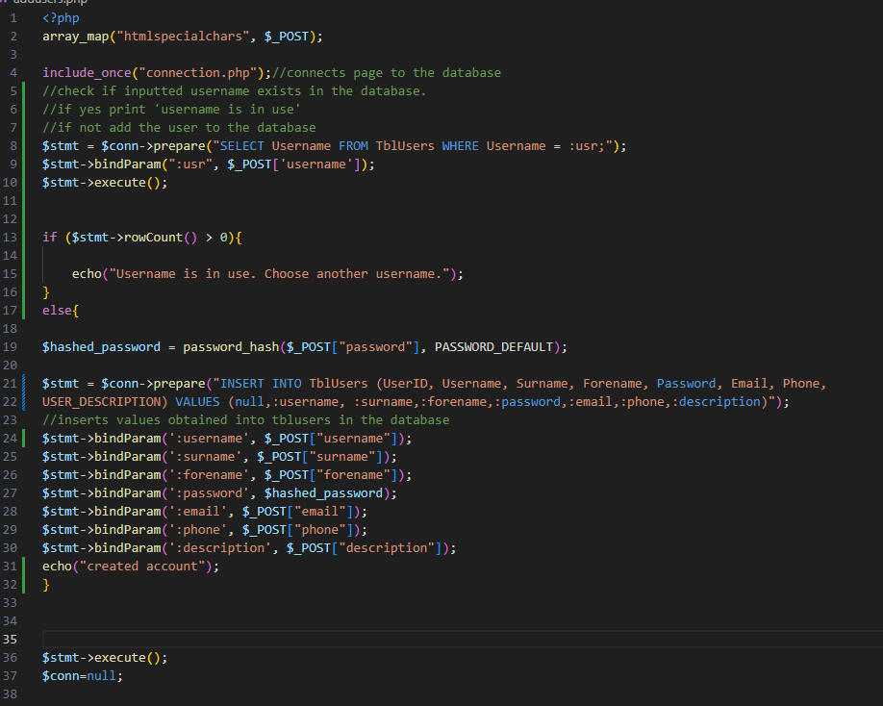

**Changes in the addusers page:**

I needed to make sure that duplicate usernames were not added to the table as this would make it hard to identify each user uniquely. Therefore, I needed to change the code so that it checks the inputted username before it adds it to the database to avoid duplicates. For this I used an SQL query to fetch similar usernames and an if statement to check whether the number of rows is zero. If number of rows is greater than zero, it means that there is a duplicate hence user will not be added.

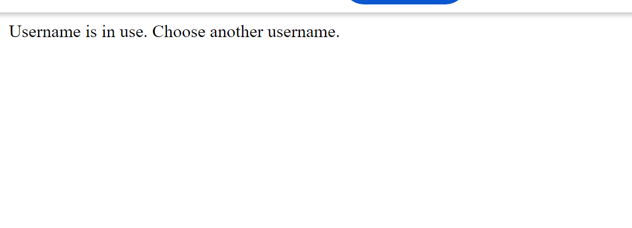

Now that I had a unique username for each one of the users, I could proceed to make a chat system by using session variables of the unique usernames. To do this, I also needed to change the TblChats table so that it stores the Username of the sender. I also needed the table to have a unique identifier so I will also create a MessageID row.

**Changing TblChats**

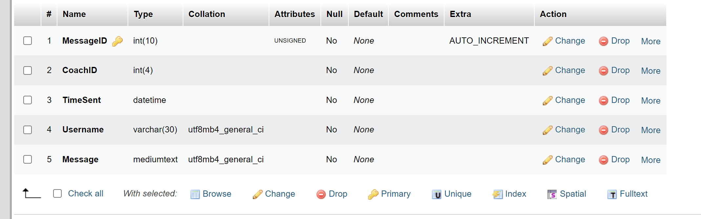

I also must change the install page so that it creates the table with these new row names.

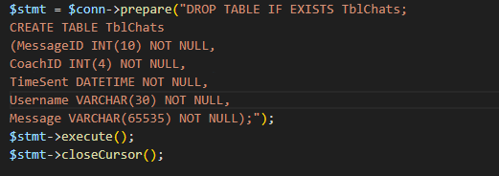

There was one more thing that I needed to change in my database which will help me differentiate between a message from the user and a message from the coach. I needed to add a column called FromCoach to TblChats which will be either true or false depending on whether the message was being sent from the user or the coach. Due to this, I will also delete the CoachID column as this will no longer be needed.

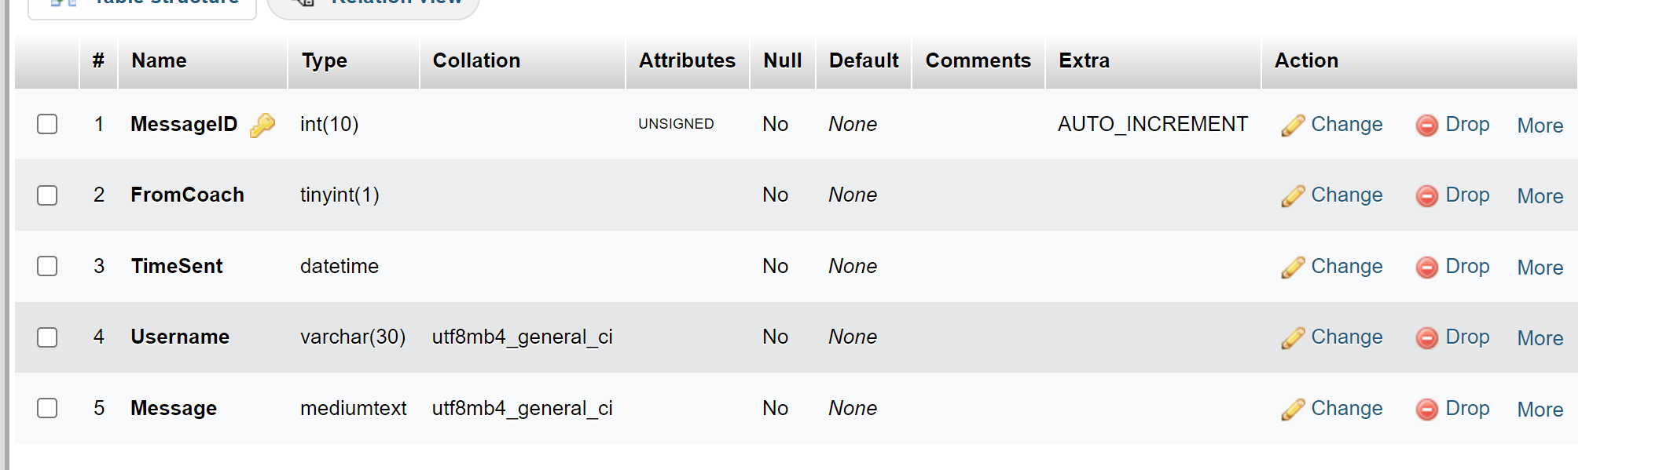

**Creating messageprocess.php**

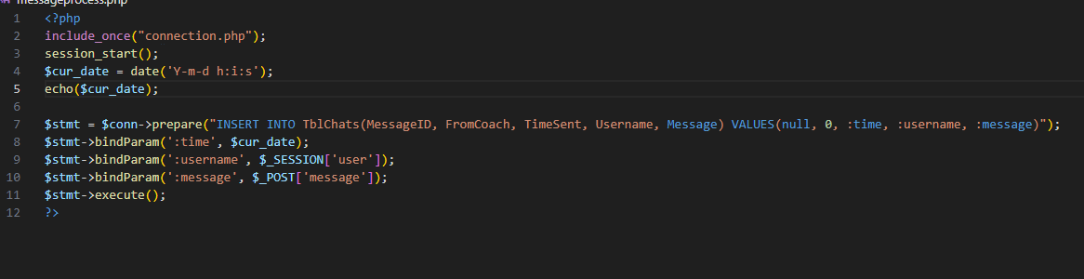

The messageprocess.php page will process the message that was inputted into the usermessage.php page and upload it to the database. Here, I am using the built in date function to get the time at which the message was sent. After running the code above, I got the problem of the time not being quite correct. The time that was being shown was:

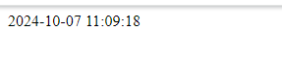

Whereas at the time of testing it was 10:11 am. Hence, I concluded that I was in the wrong time zone which made me research the correct time zones for UK. After this, I manually set the time zone to Europe/London which made the code show the correct GMT time.

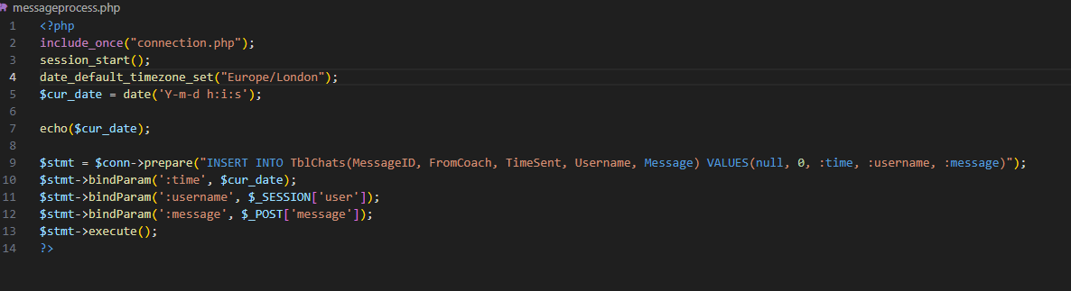

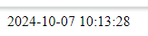

The message was successfully being uploaded to the database.

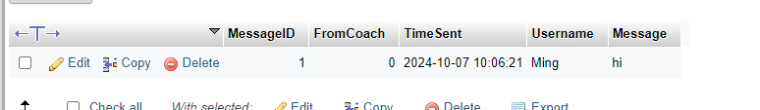

## Creating coachmessage.php

Coachmessage.php will be a page which will allow the Coach to send messages to the users. It will have a similar structure to the usermessage.php page however the coach must be able to choose which user they want to send a message to. Therefore I will create a way for the coach to search for a user that they want to contact.

In order to create a way to search for a particular user I created a small search bar which will take an input from the user and send it to a separate page which will search the database for matching values of either the username or the forename and surname.

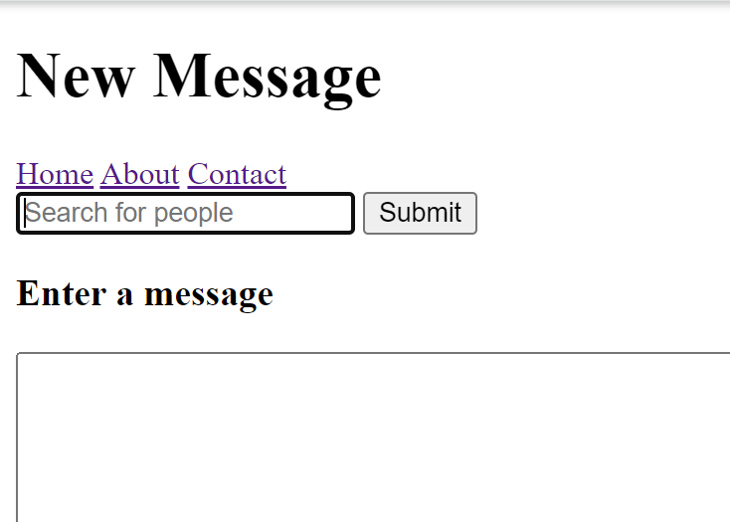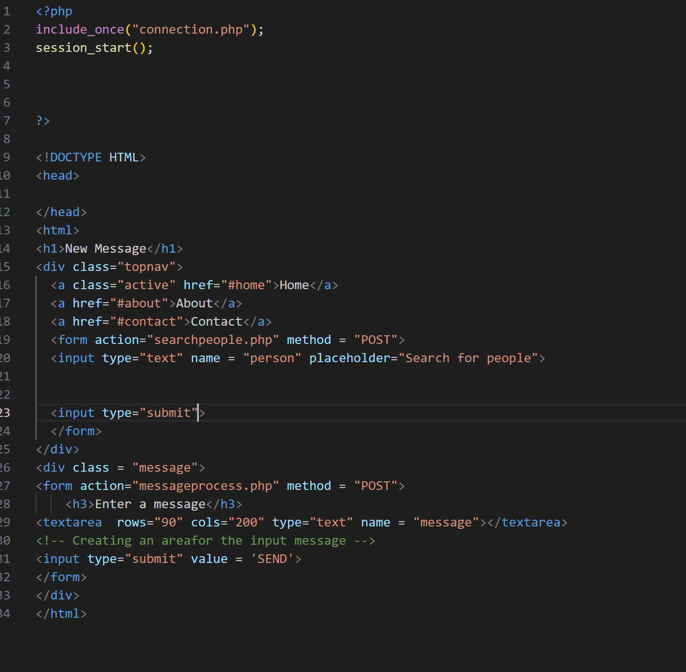

Now I needed to create a page which outputs the results of the search in a dropdown menu.

## Creating searchforpeople.php

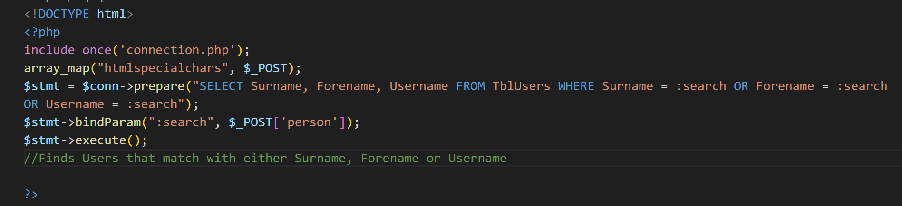

Using the above SQL query, I searched the database for users which have the same Forename, Surname or Username as the one that the coach had searched for. Now all that was left was to create a drop-down menu with the options of the ‘valid’ users.

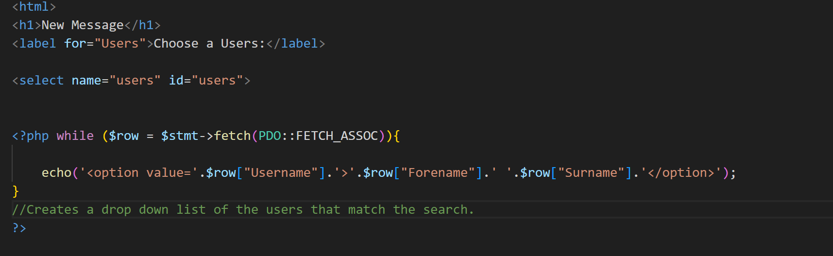

The above for loop creates the same number of options as there are users that match the description of the coach’s search, putting them all in a drop-down list. Finally, I still needed to have the option of sending a message to the selected user, so I needed to put back the space for a message.

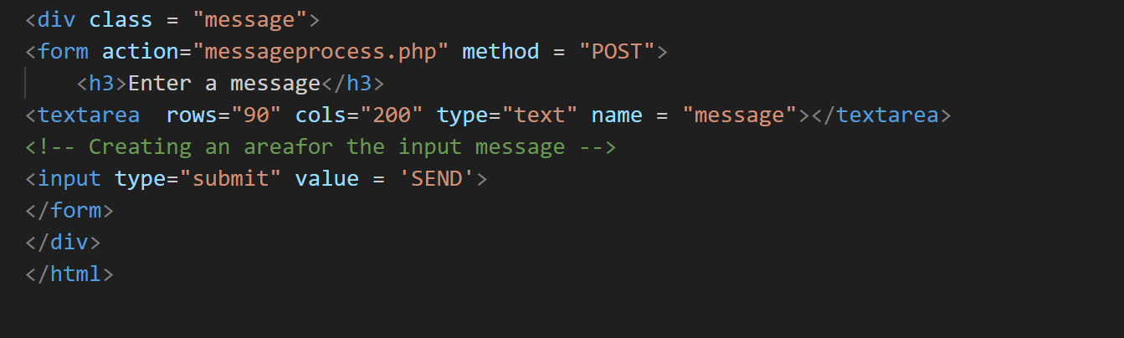

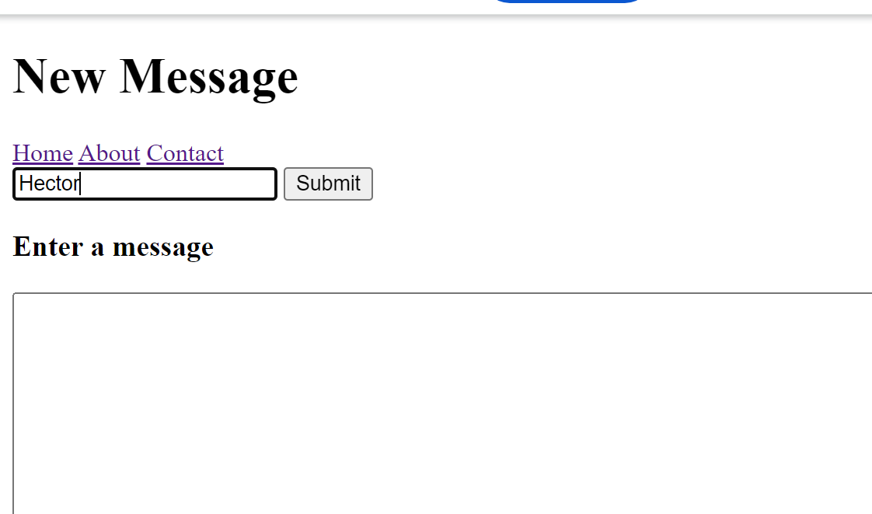After I completed the code I tested the functionality of this page:

Searching for a user on coachmessage.php

After Clicking submit the following result appeared:

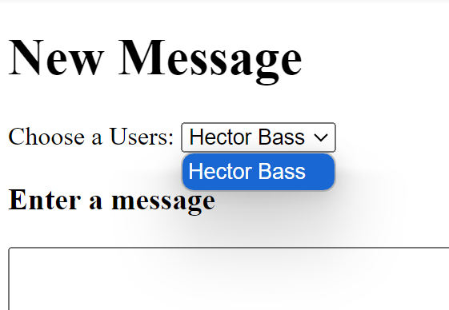

## Creating coachmessageprocess.php

There will only be one difference between the coach and normal message process and it will be that the coachmessageprocess.php page will have 1 in the FromCoach field in order to differentiate the two types of messages. The username field however will be populated by the username of the user which the coach has selected.

Before starting to create this page, I realised that I had an error in the previous page which will prevent me from posting the username. I went back to the search for people page and changed it to the following 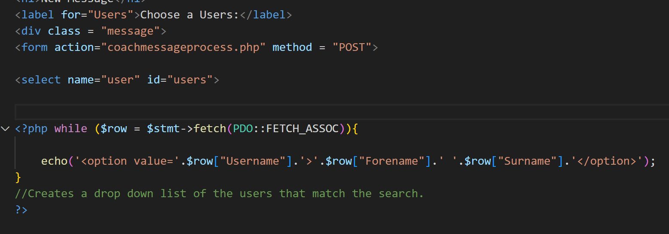

I changed the code so that it included the user select option in the form which would be posted to the next page. I tested this to see if the username and the message were both being posted, and it turned out to be a success.



**Coachmessageprocess.php**

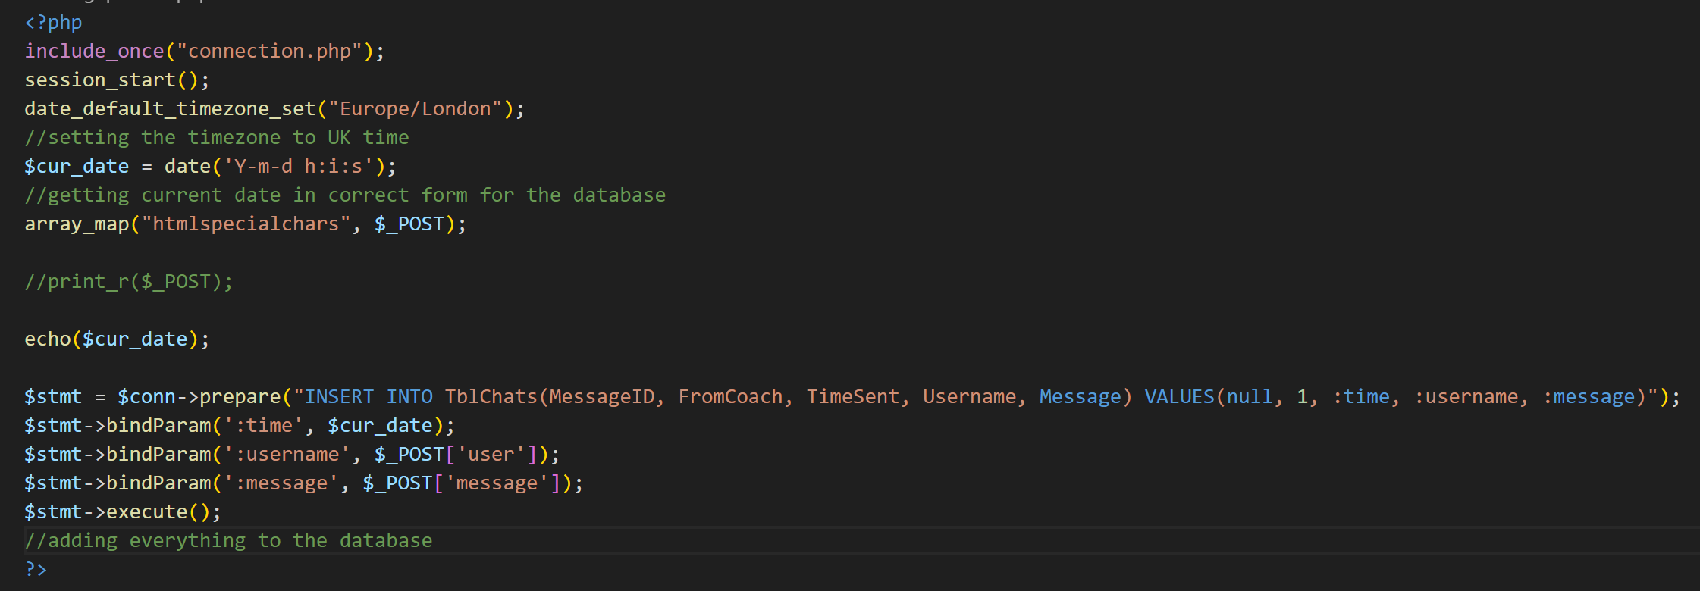

Now the posted message and the username were being successfully uploaded to the database via the code shown above.

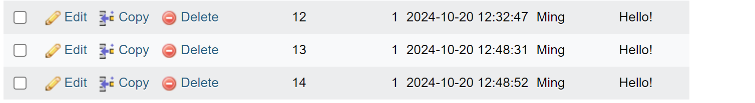

## Creating displayusermessages.php

The purpose of displayusermessages is to select all the messages that have been sent to a particular user by the coach and show them to the user that is currently logged in.

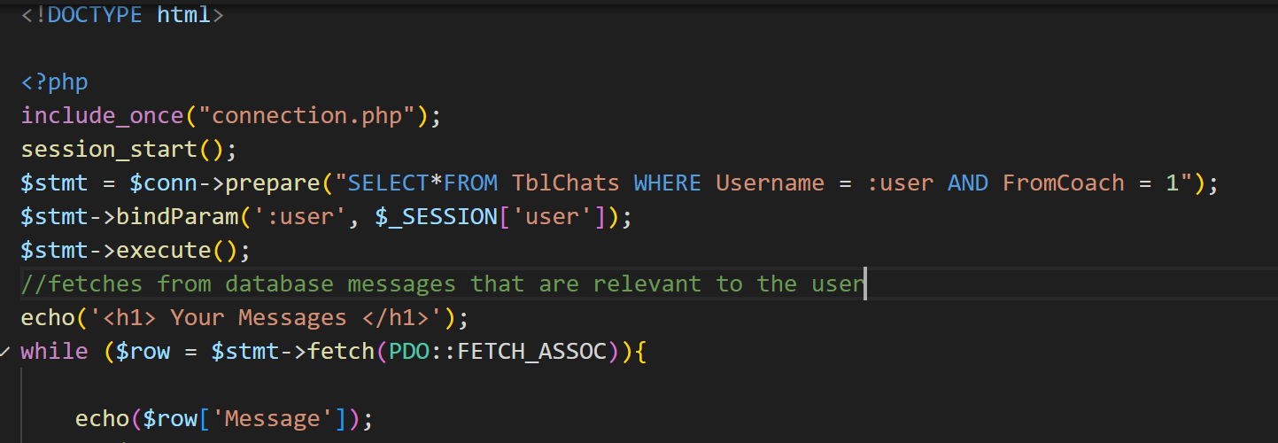

The above SQL statement retrieves the messages sent from the coach to the user that is currently logged in and I tested the code to verify that the messages are being fetched correctly.

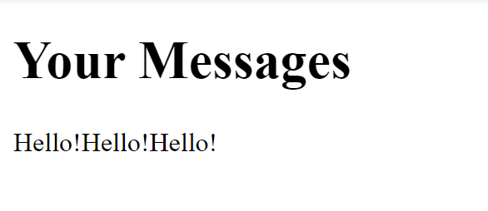

I now wanted to create a way to inform the user about the number of messages that they have which will require me to count the number of rows that are being retrieved from the database.

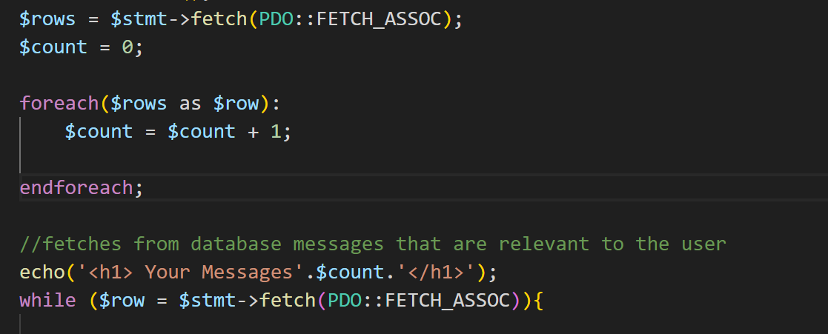

The code above was my first attempt at doing this task which was unsuccessful because it was giving me the wrong number of messages.



However, the real number of messages was 3. I realised that the php foreach function in my code was counting the total number of rows in the database instead of the number of rows that were retrieved by the SQL query. Hence, I needed to find a different approach to tackle this problem.

I removed the foreach function and kept the loop with the count variable to see I that made a difference to the number of messages being outputted.

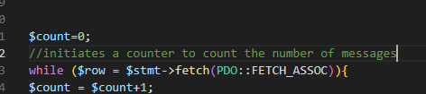

Testing the code proved that the number of messages was correctly being outputted.



Now I needed to create the layout of the displayed messages which would go as follows:

Date/Time Message

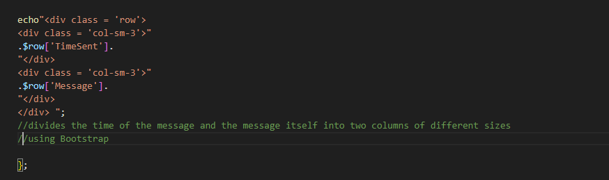

Testing the code above, the messages were being outputted as expected.

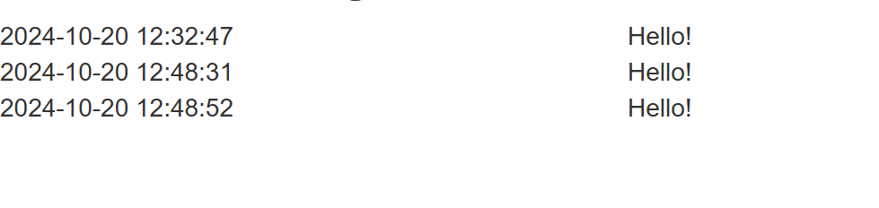

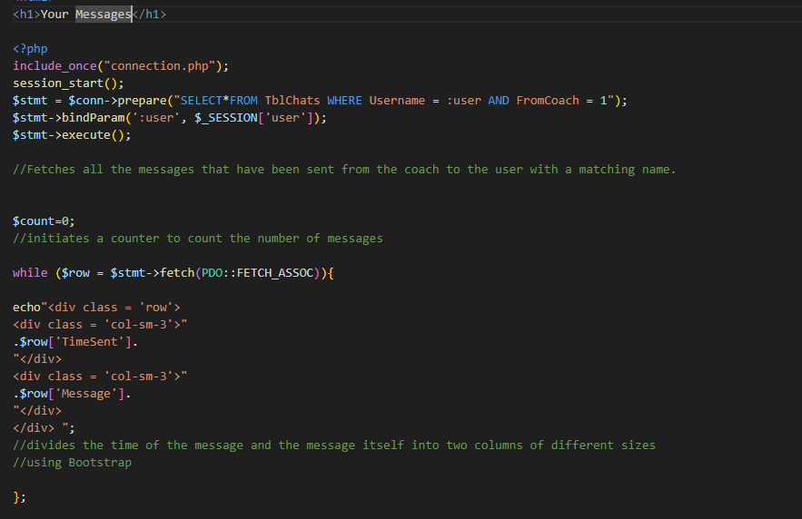

I now had a new issue which needed to be resolved that involved the ordering of my code. Because I wanted to display the number of messages in the following format:

Your messages (number of messages)

The counter inside the while loop should come before the title so that the correct number of messages could be displayed. However, if I were to put the while loop before the title, the title would be at the bottom of the page which would also be a problem.

To fix this issue I decided to use two separate while loops, one for the counter which would come before the title to count the number of messages. This would be followed by the title displaying the number of messages and then another loop which would loop through and display each message and time.

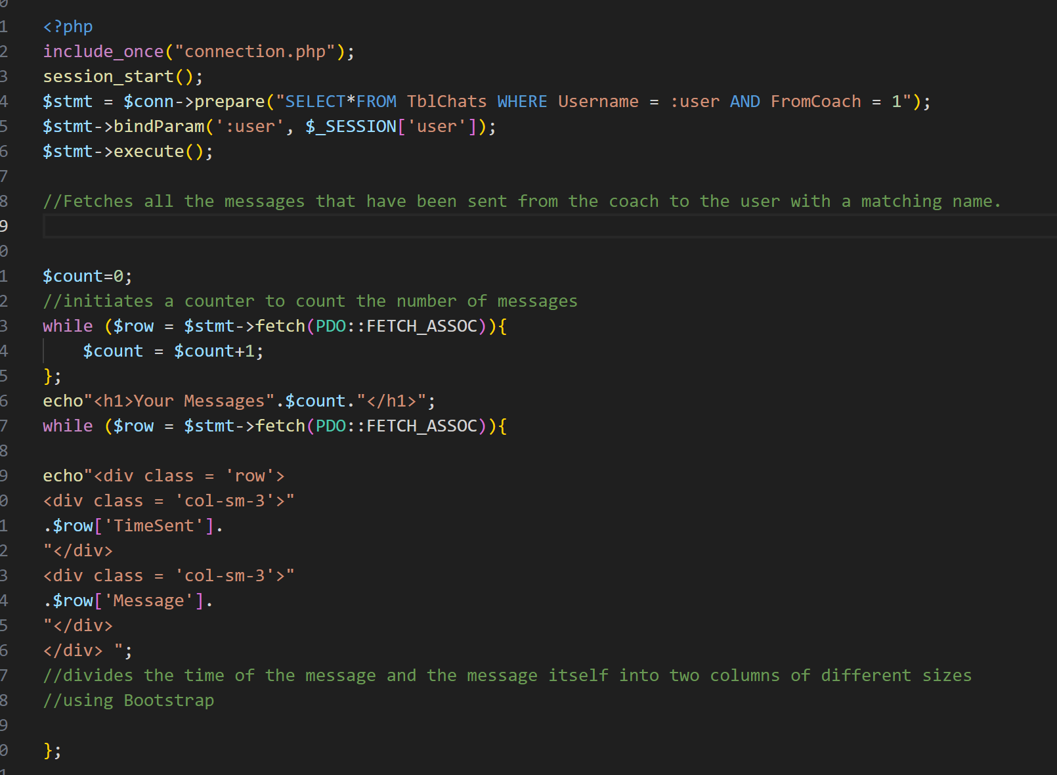**Two separate while loops…**

**Testing the code…**



Unfortunately, although the number of messages was correct, the messages themselves were not showing. However, after adding in another SQL query after the first loop, all was working.

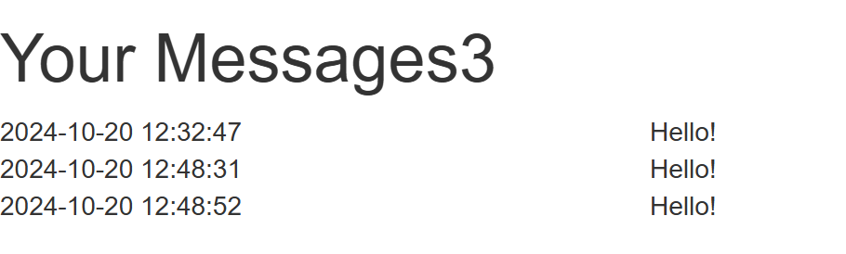

## Creating displaycoachmessages.php

The displaycoachmessage page will be the same as the displayusermessage with slight key differences such as displaying the message sender as well as selecting the messages that are not from the coach i.e FromCoach = 0.

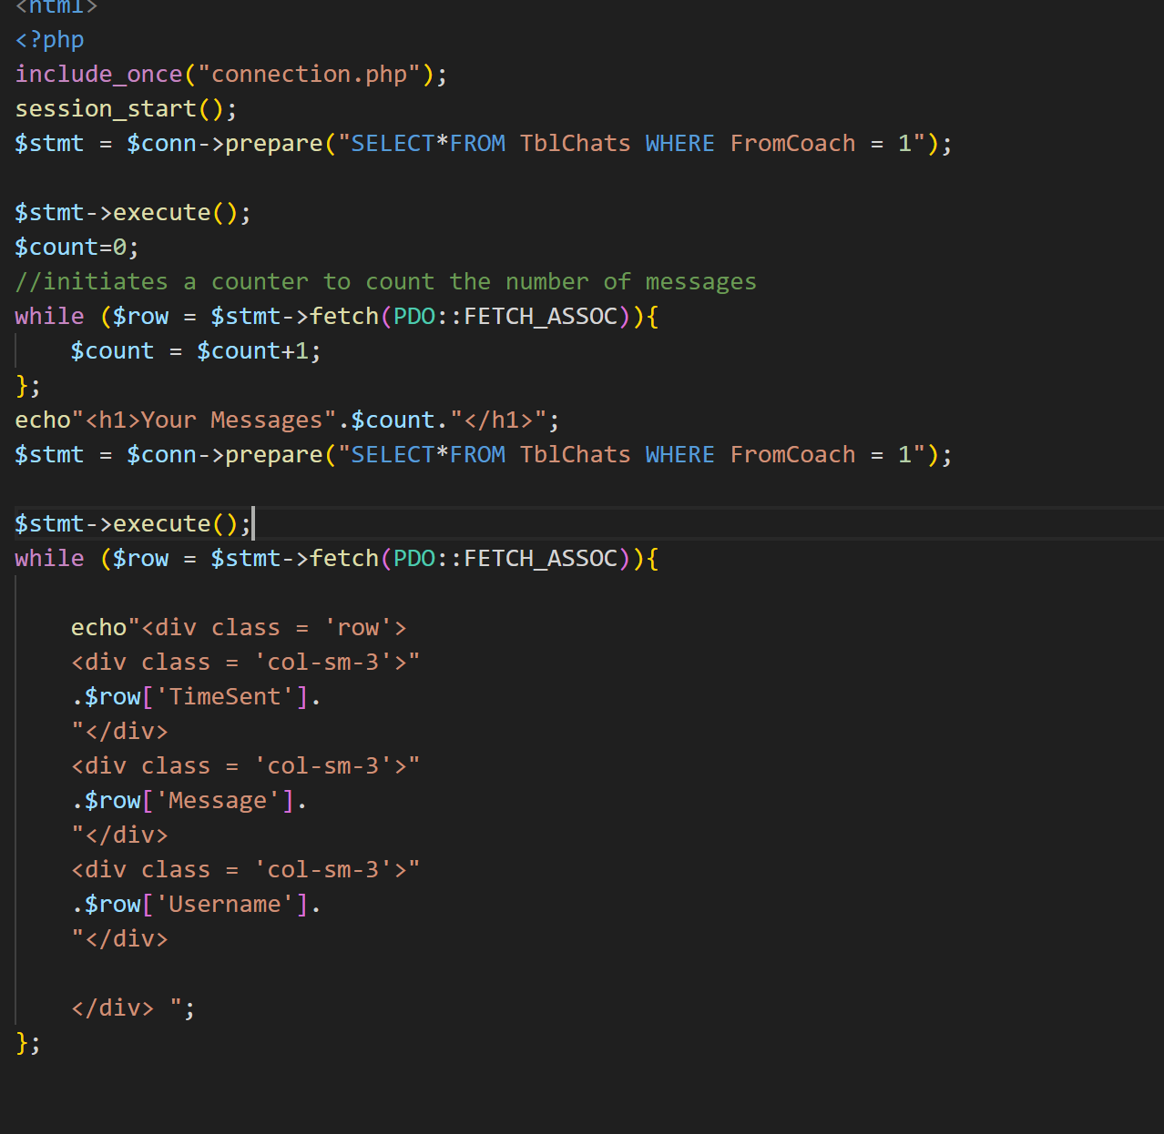

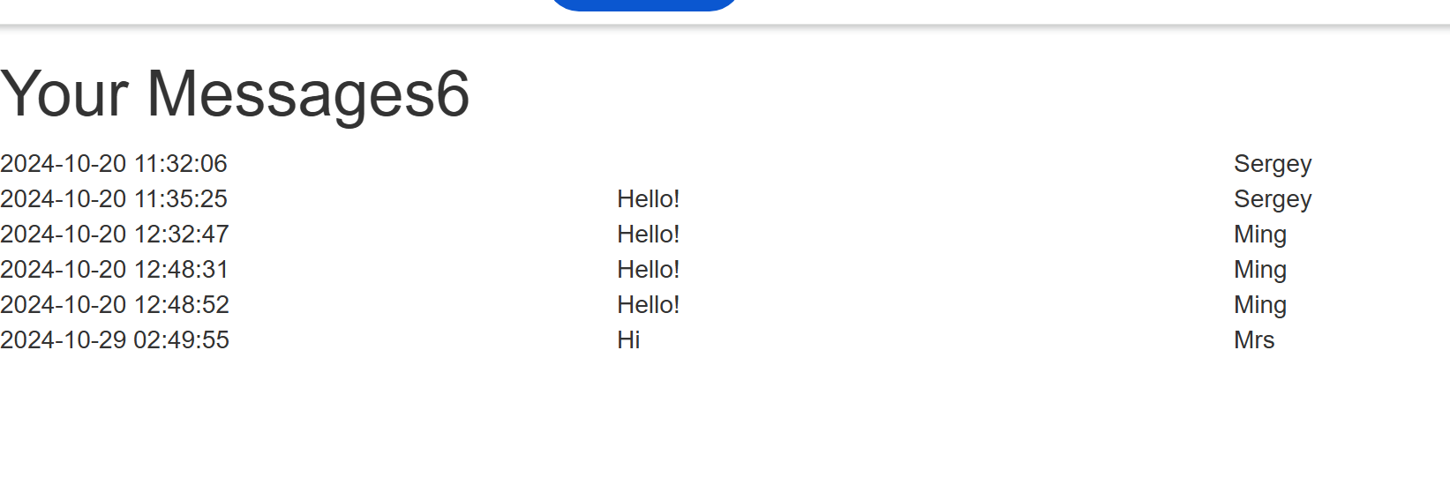This code was successful in displaying all the messages and the number of messages:

However, there was one problem as I wanted the code to display the surname and forename of the message sender instead of the username as this would make it easier for the coach to identify the sender. Hence, I needed to change the SQL statement so that it also fetched the surname and the forename from TblUsers.

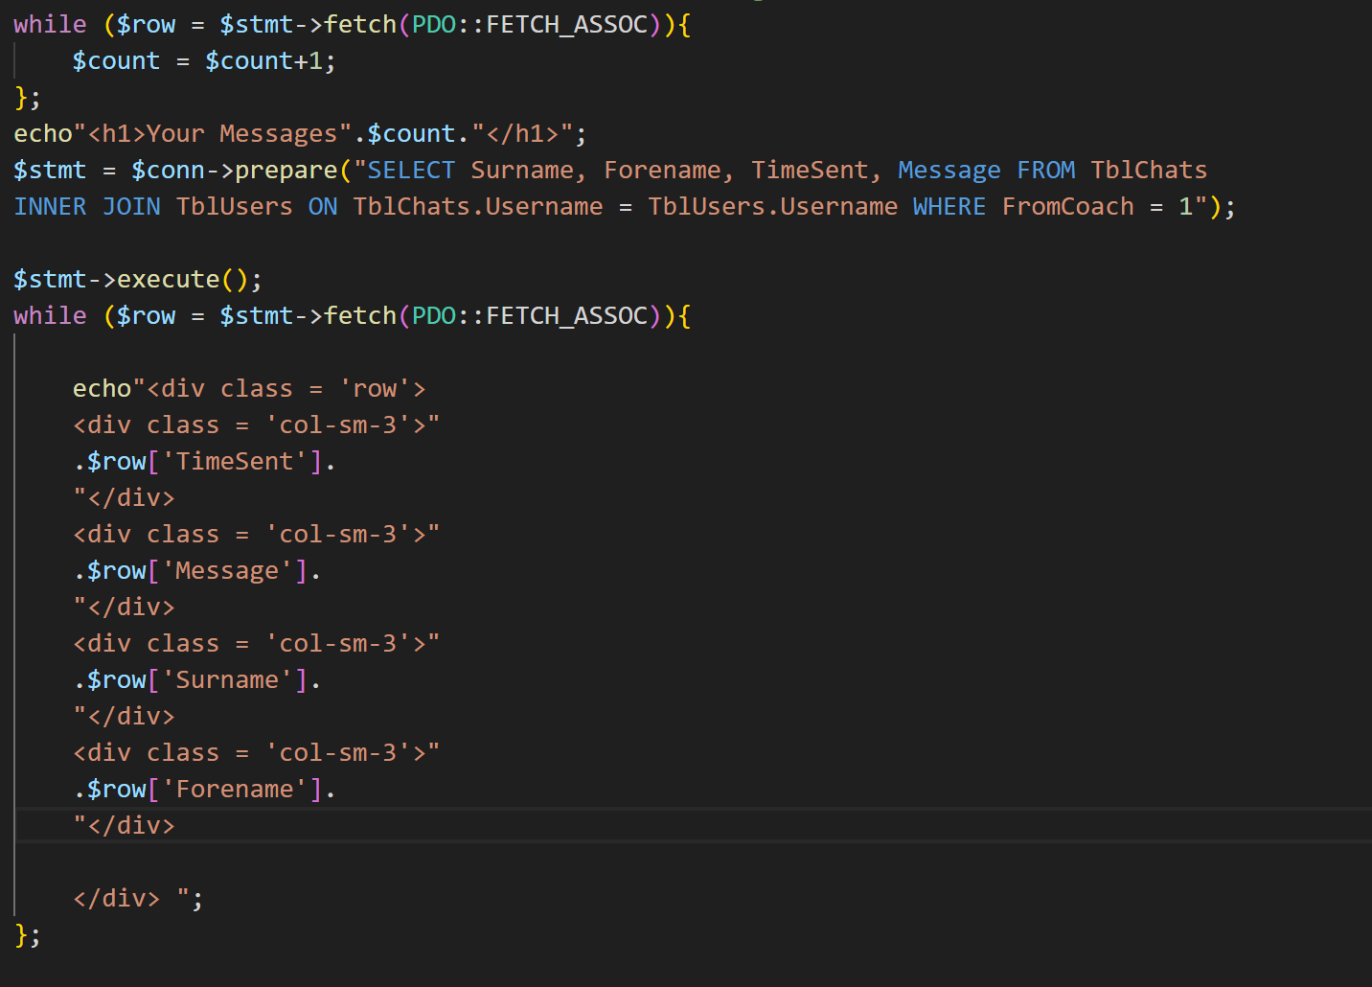

Changing the SQL Statement:

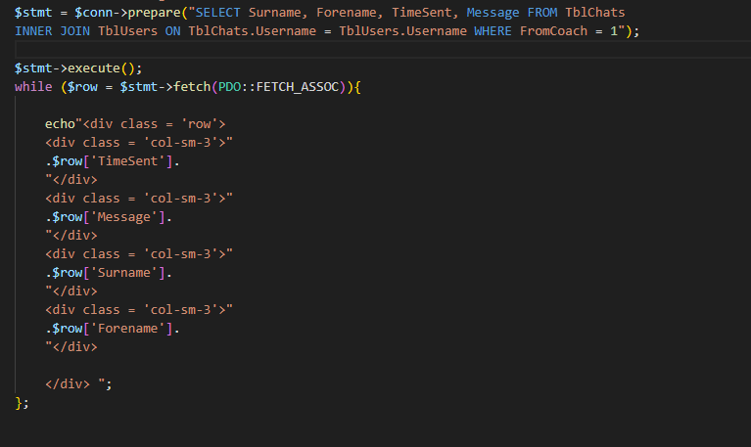

Here, I used a JOIN query to get the Surname and Forename in one SQL query and then I displayed the Surname and Forename in a separate column. After testing the code, it gave me the following output which assured me that the code was working well.

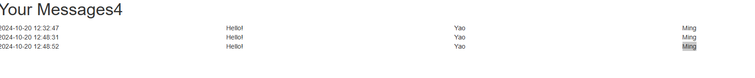

## Improvements to the View Meetings Pages

Although my viewmeetings pages were working, they did not have the required functionality, for example the space to view the entire message was limited to only one line and the design and usability were quite poor. This made me decide to implement some key changes.

1. I wanted to make each message clickable so that they can be viewed on a separate screen/ tab.
2. I needed to change the overall structure of the page.

I started by converting the structure of the page from columns and rows into a table structure.

Table Structure in usermessages:

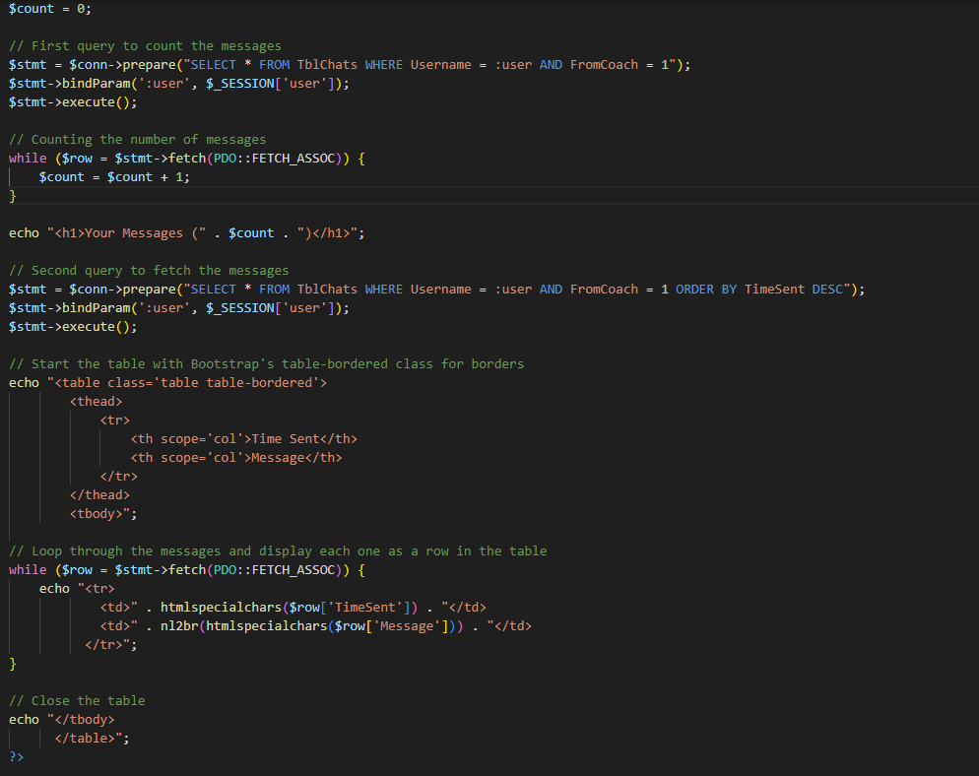

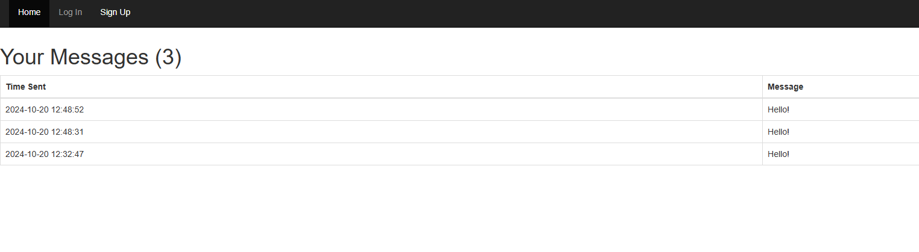Result:

Table Structure in coachmessages:

